HAIR CARE

**Group Members**

|  |  |  |
| --- | --- | --- |
| *S.no* | *Student ID* | *Student Name* |
| 1 | Student1501474 | HUDAIBIA |
| 2 | Student1503573 | UMAMA |

**Project Advisor**

Miss. Muniba Atiq



**Aptech Computer Education**

Korangi Center

**ACKNOWLEDGEMENT**

First of all we would like to thank ALLAH the almighty who make us able to complete this project.

After that we would like to express profound gratitude to our internal project advisor, Center Senior Faculty, ***Miss. Muniba Atiq***, for her precious support, back-up, supervision and useful suggestions throughout this project. Her moral support and continuous help enabled us to complete our work successfully. We are also highly thankful to the ***Center Management*** for their valuable suggestions, healthy analysis and support throughout this project.

We are grateful to the faculty members of Aptech Korangi Center who were always there to help us despite of their personal workload.

We are as ever, especially indebted to our parents for their love and support throughout our life. We also wish to thank our classmates, friends and all the individuals or groups that were involved in this project by any mean.

- HUDAIBIA

- UMAMA

# **E-Project** **Synopsis**

## Introduction

Hair care is a crucial aspect of personal grooming and hygiene that encompasses various practices aimed at maintaining the health, cleanliness, and aesthetic appeal of one's hair. Whether short or long, curly or straight, hair plays a significant role in defining an individual's appearance and confidence. Proper hair care involves a combination of cleansing, conditioning, styling, and protection routines tailored to one's hair type, texture, and specific needs.

Healthy hair is not merely a matter of aesthetics; it also reflects overall well-being. Factors such as genetics, diet, lifestyle, environmental exposure, and hair care practices all contribute to the condition of the hair. Neglecting proper care can lead to various issues such as dryness, breakage, split ends, dandruff, and even hair loss.

In recent years, there has been a surge in awareness regarding the importance of natural and organic hair care products, as well as sustainable practices in the beauty industry. Consumers are increasingly seeking out products free from harmful chemicals and embracing simpler, more environmentally friendly hair care routines.

This introduction serves as a gateway to explore the multifaceted world of hair care, covering topics ranging from the basics of hair anatomy and physiology to advanced styling techniques, product recommendations, and DIY remedies. Whether you're looking to revamp your hair care routine, troubleshoot specific issues, or simply learn more about caring for your locks, this guide aims to provide comprehensive insights and practical tips for achieving healthy, vibrant hair.

## Objective

# The Objective of this program is to give a sample project to work on real life

# The objective is not to teach you HTML/JavaScript/Dreamweaver/HTML5 but to provide you with a real life scenario and help you create basic applications using the tools.

# You can revise the chapters before you start with the project.

# This project is meant for students who have completed the module of HTML5. These programs should be done in the Lab sessions with assistance of the faculty if required.

# It is very essential that a student has a clear understanding of the subject. Students should go through the project and solve the assignments as per requirements given.

# Kindly get back to eProjects Team in case of any doubts regarding the application or its objectives.

## Technology Used

In order to meet the requirement of our project we have used following underlying technologies.

* JavaScript
* HTML5
* CSS3
* Bootstrap 5

Figure 1: Technology Used in Project

## Website Features

* We have used bootstrap framework so as to make our website responsive. Although it is not as responsive as professional websites are, but we have tried basic implementation of a responsive website.
* Smooth hovering effects have been used.
* Color combination is according to Logo.
* Result section have been made in such a way that user can search his result by any search parameter.
* Downloading of various book is available for user.

## Site Requirement

Since we have used bootstrap framework, it might have certain compatibility issues. We used the latest version of the framework and yet it has certain limitation. Below-mentioned is the compatibility chart for bootstrap. We highly recommend this website to be opened on “Google Chrome” due the best compatibility available. [5]

|  |  |  |  |  |  |
| --- | --- | --- | --- | --- | --- |
|  | ***Chrome*** | ***Firefox*** | ***Internet Explorer*** | ***Opera*** | ***Safari*** |
| Android | * Supported | * Supported | * Supported | * Supported | * Supported |
| iOS | * Supported | * Supported | * Supported | * Supported | * Supported |
| Mac OS X | * Supported | * Supported | * Supported | * Supported | * Supported |
| Windows | * Supported | * Supported | * Supported | * Supported | * Supported |

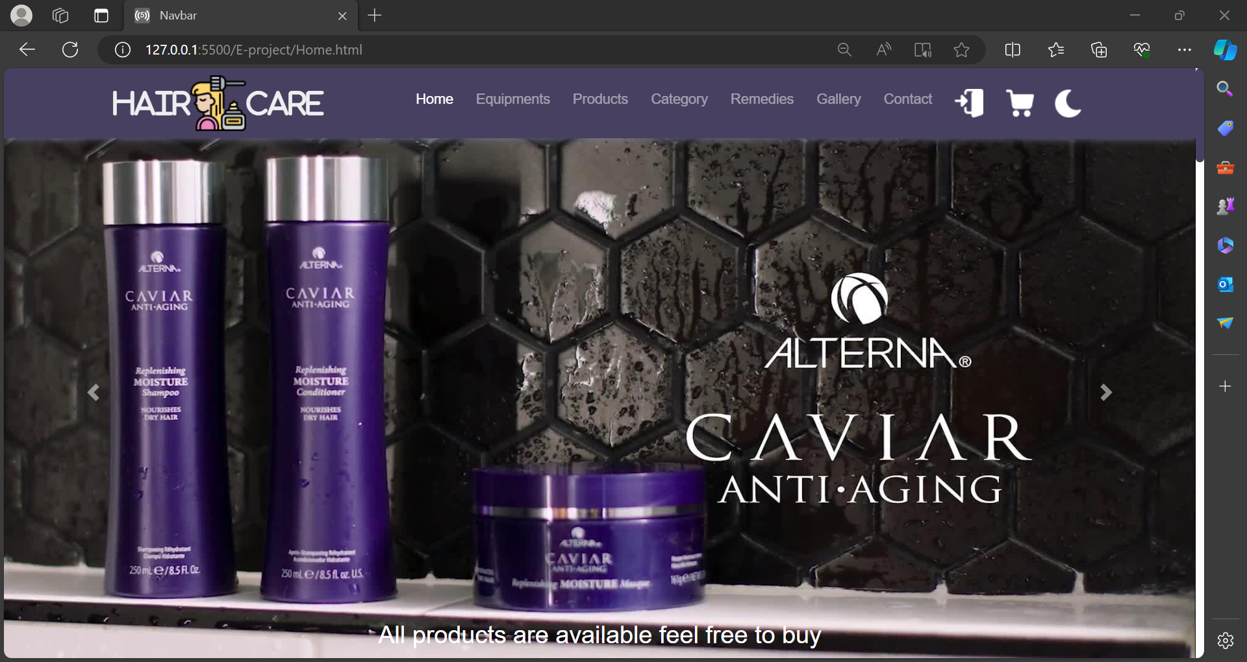

~~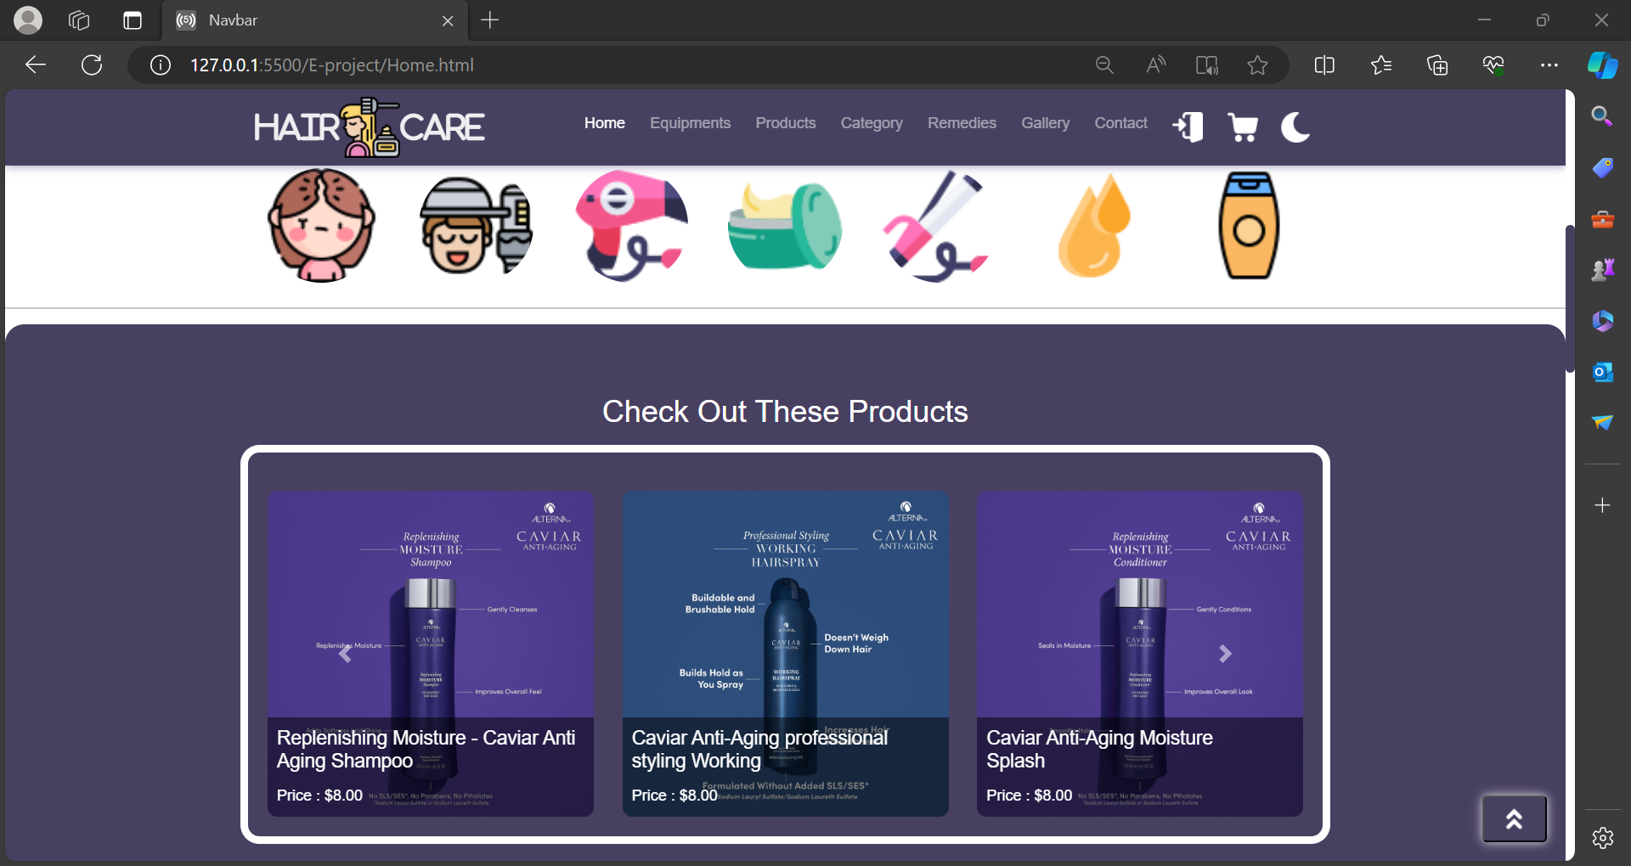~~

~~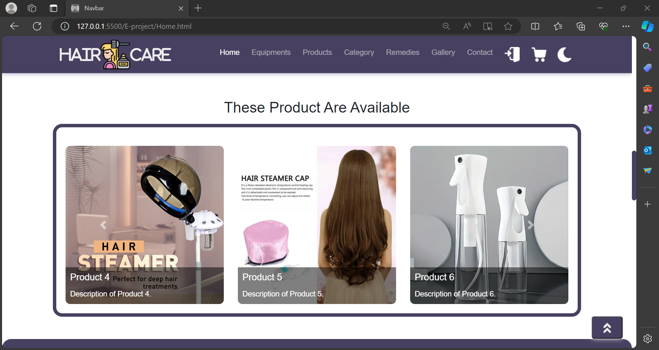~~

~~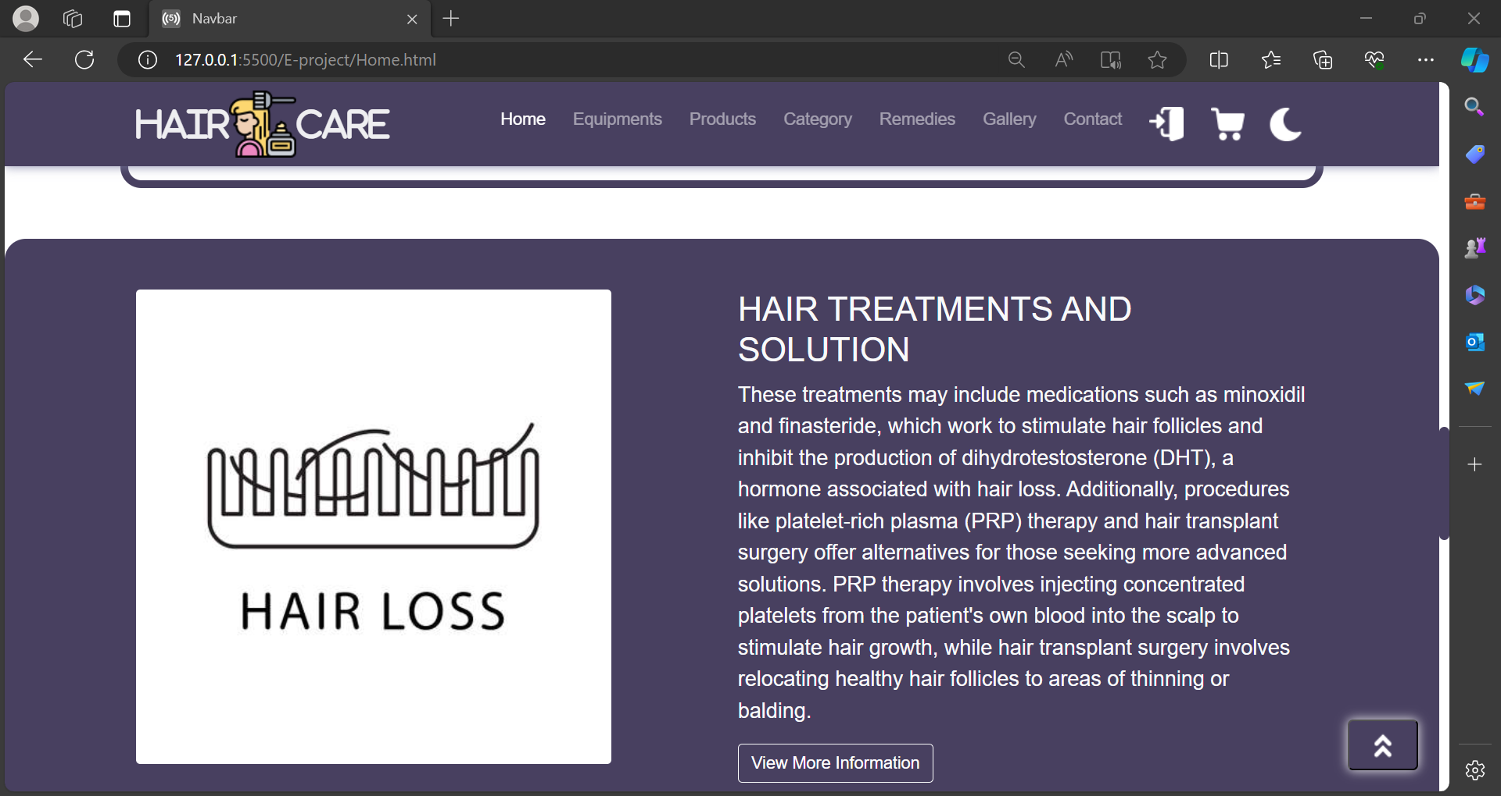~~

~~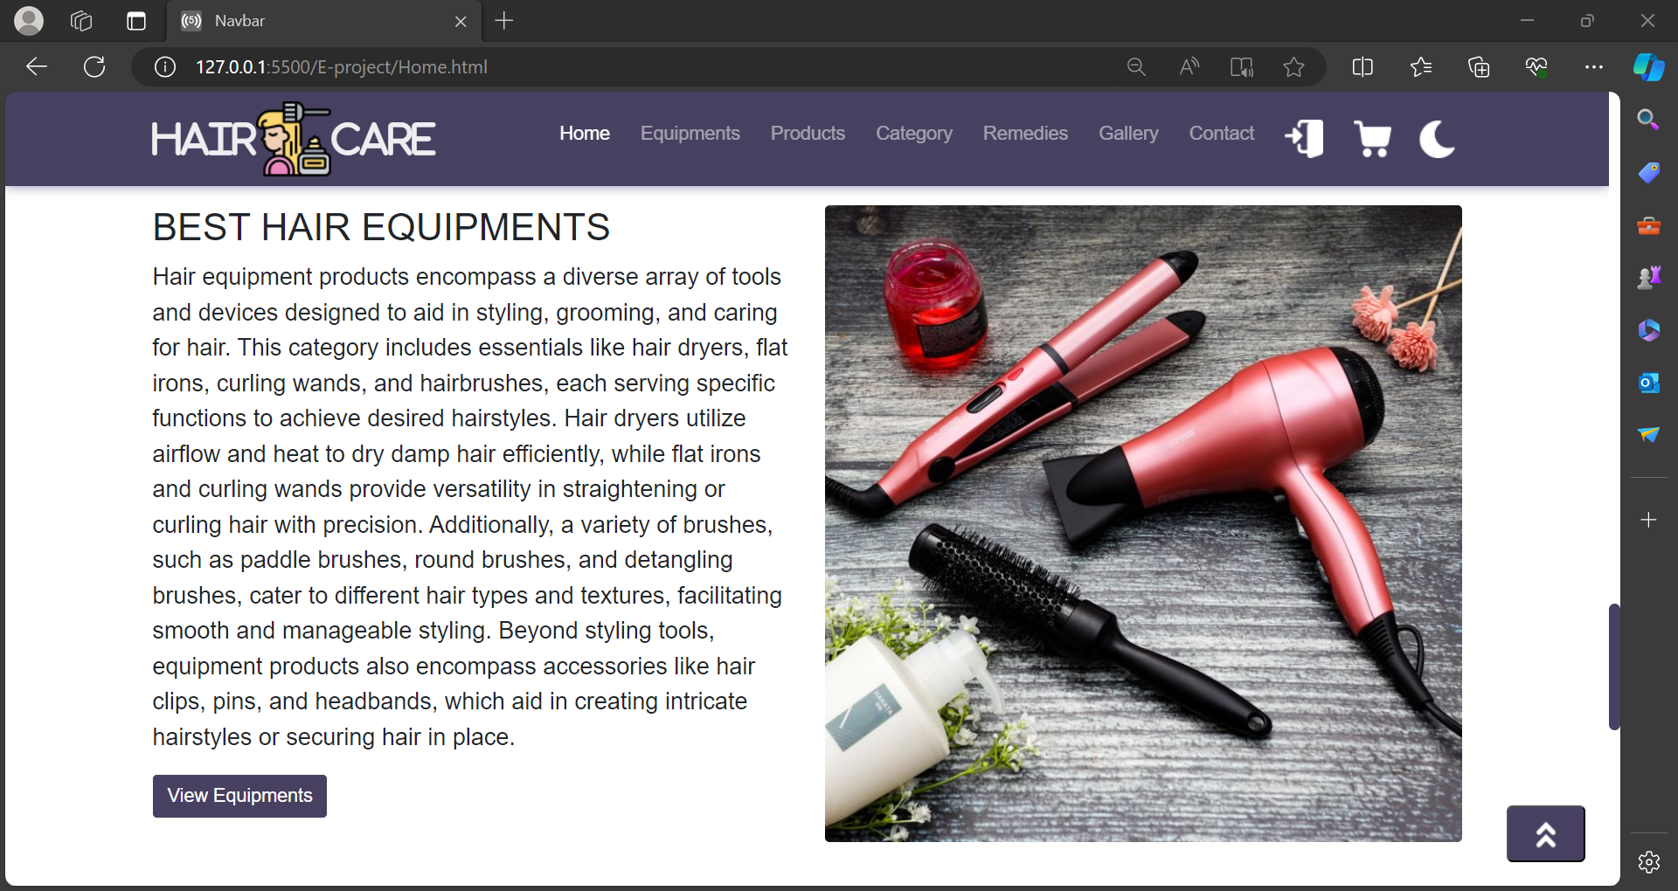~~

~~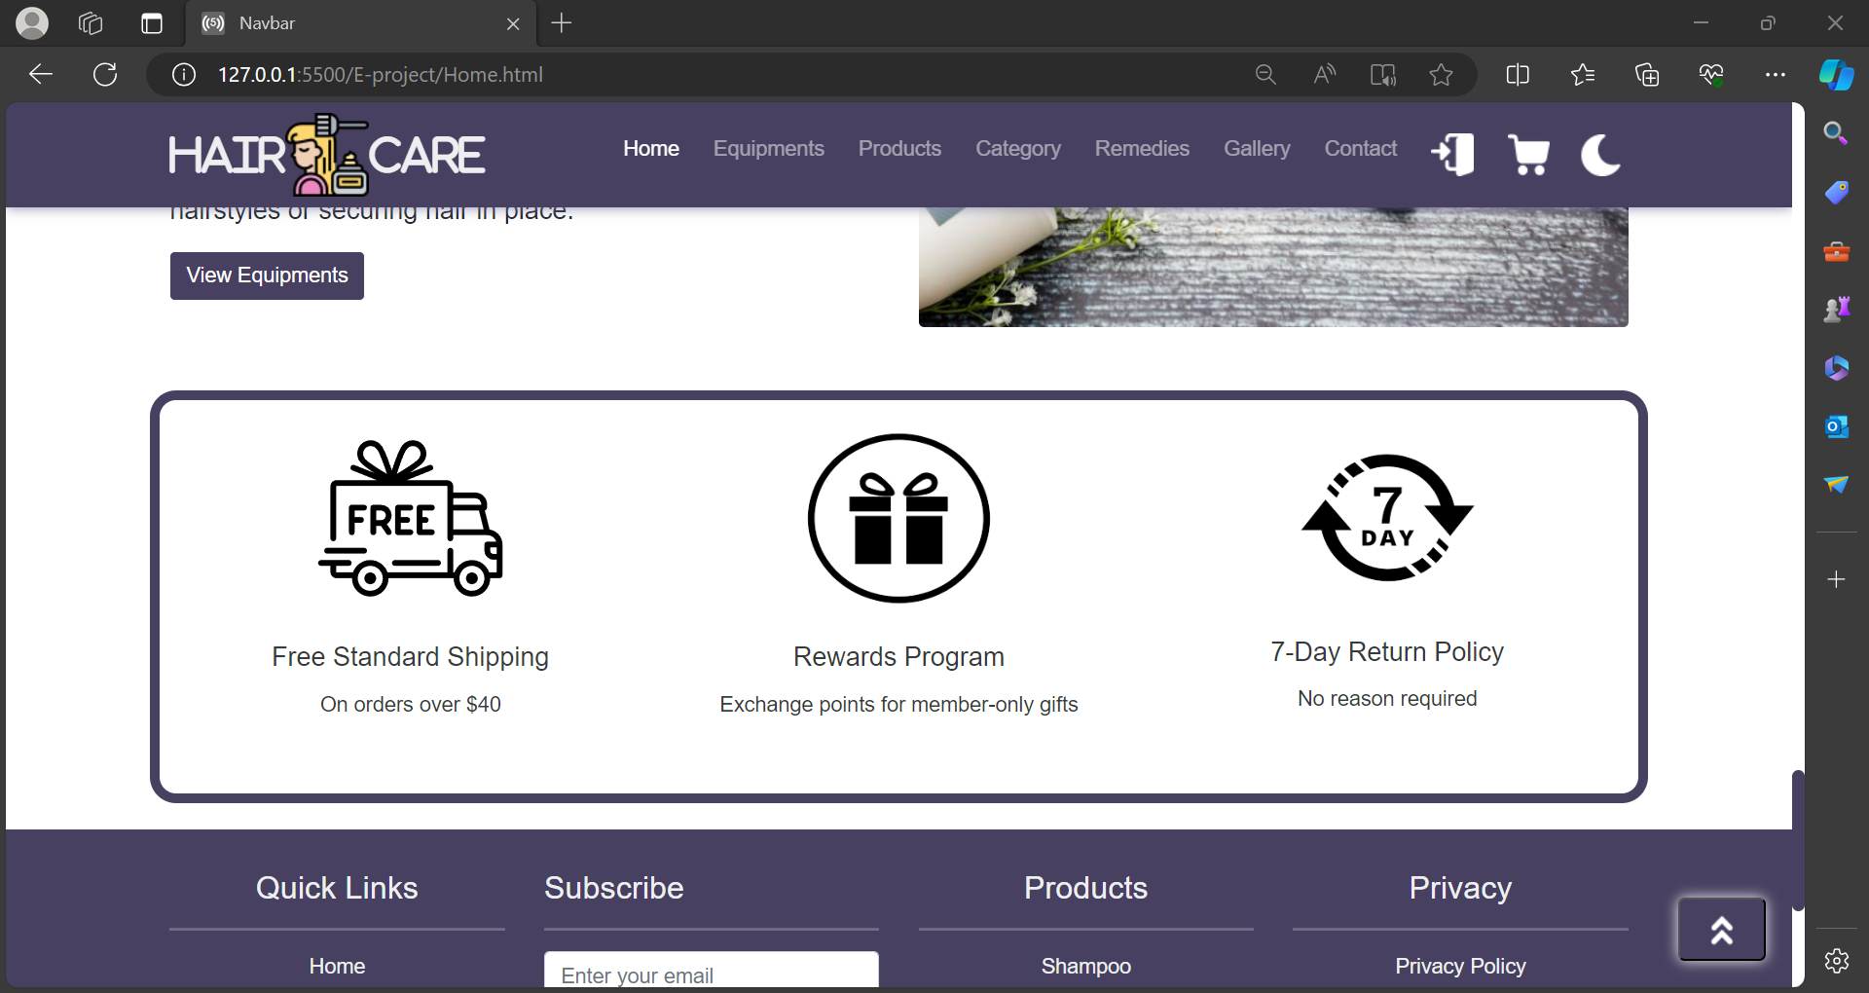~~

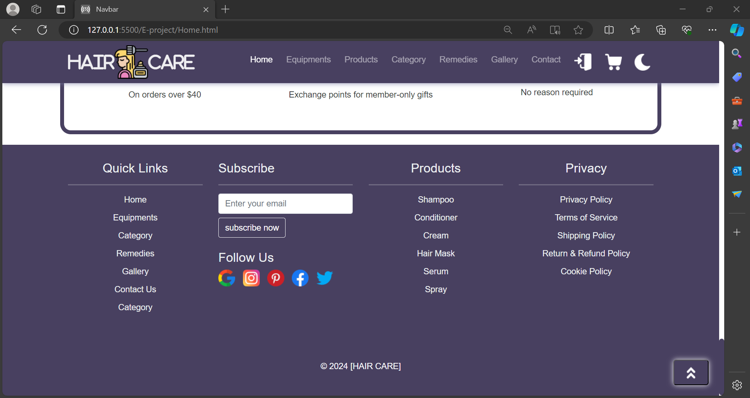

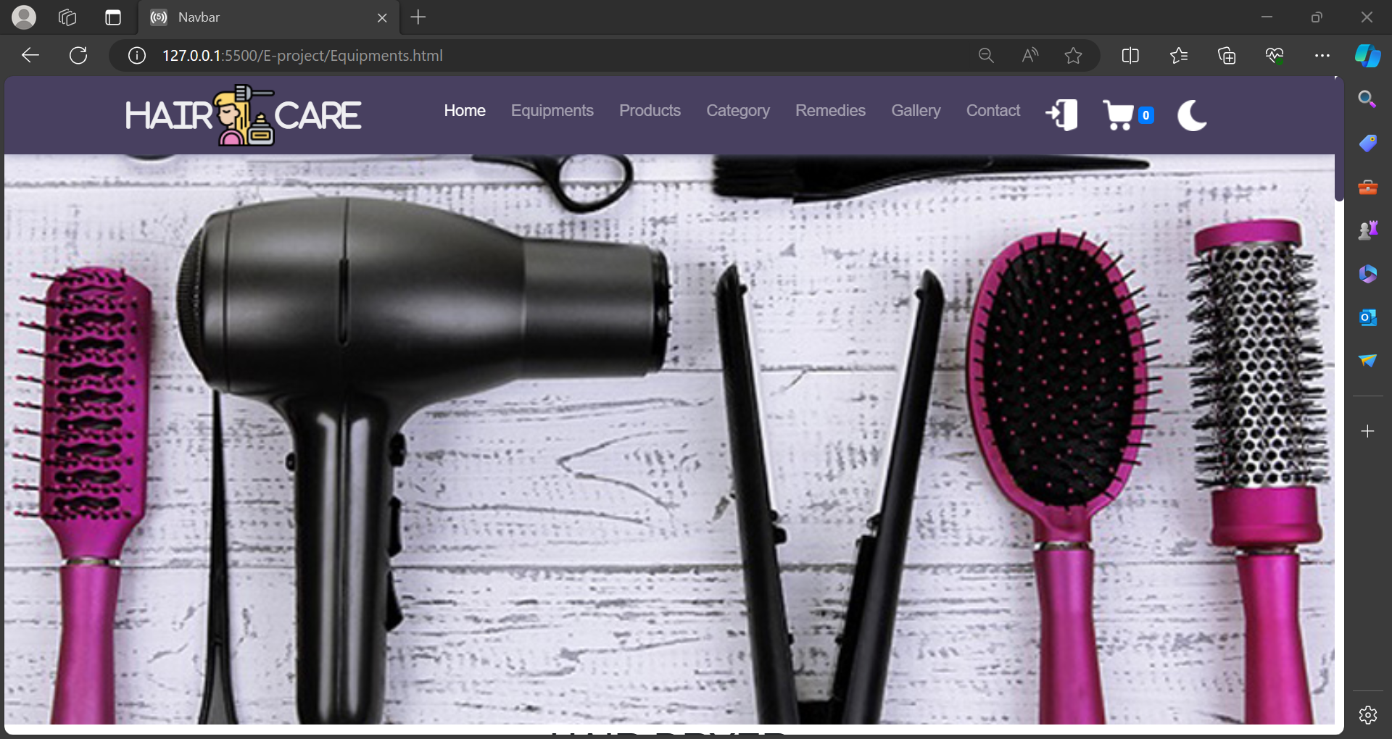

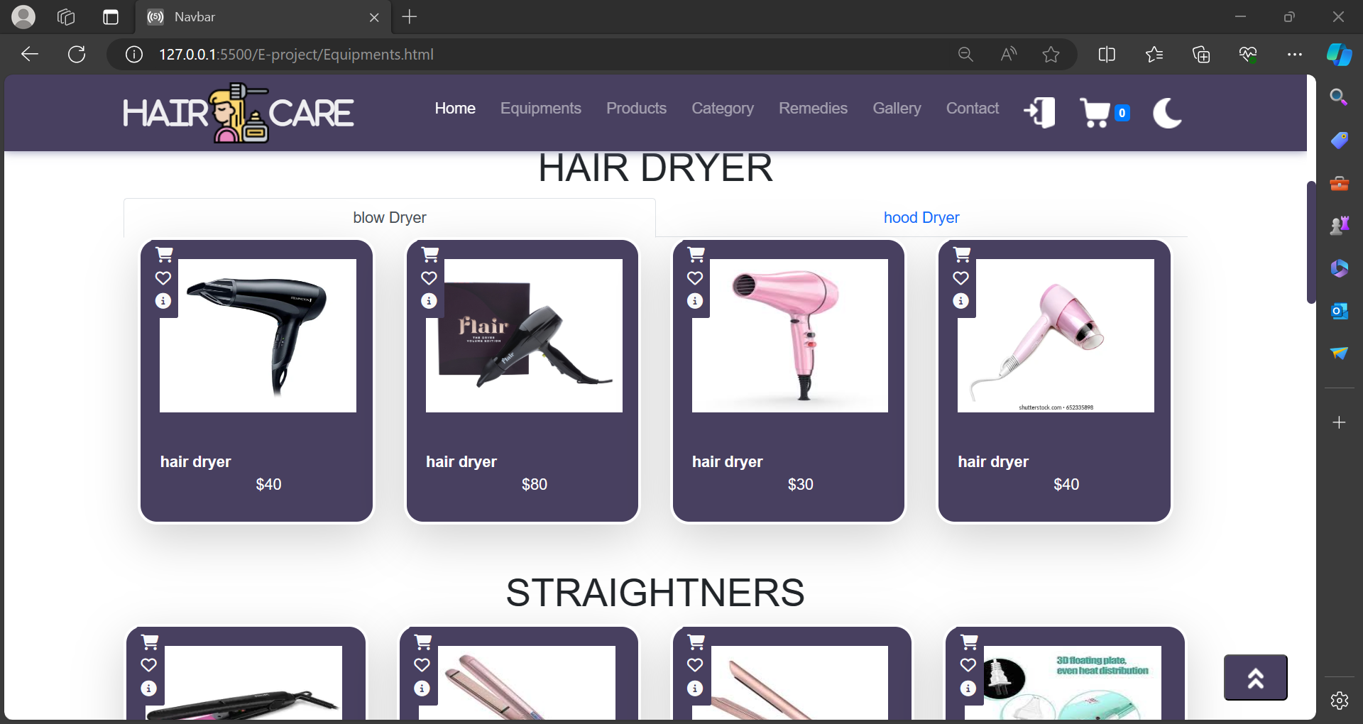

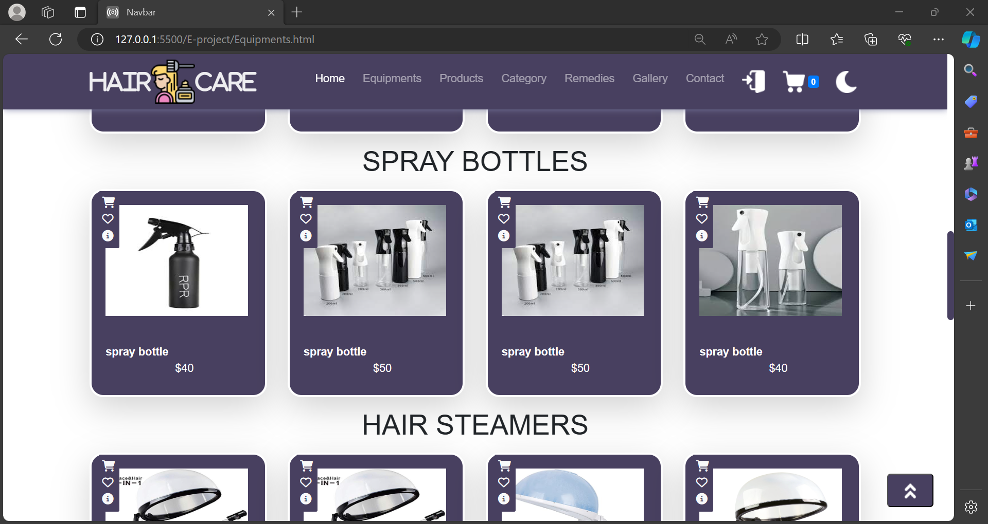

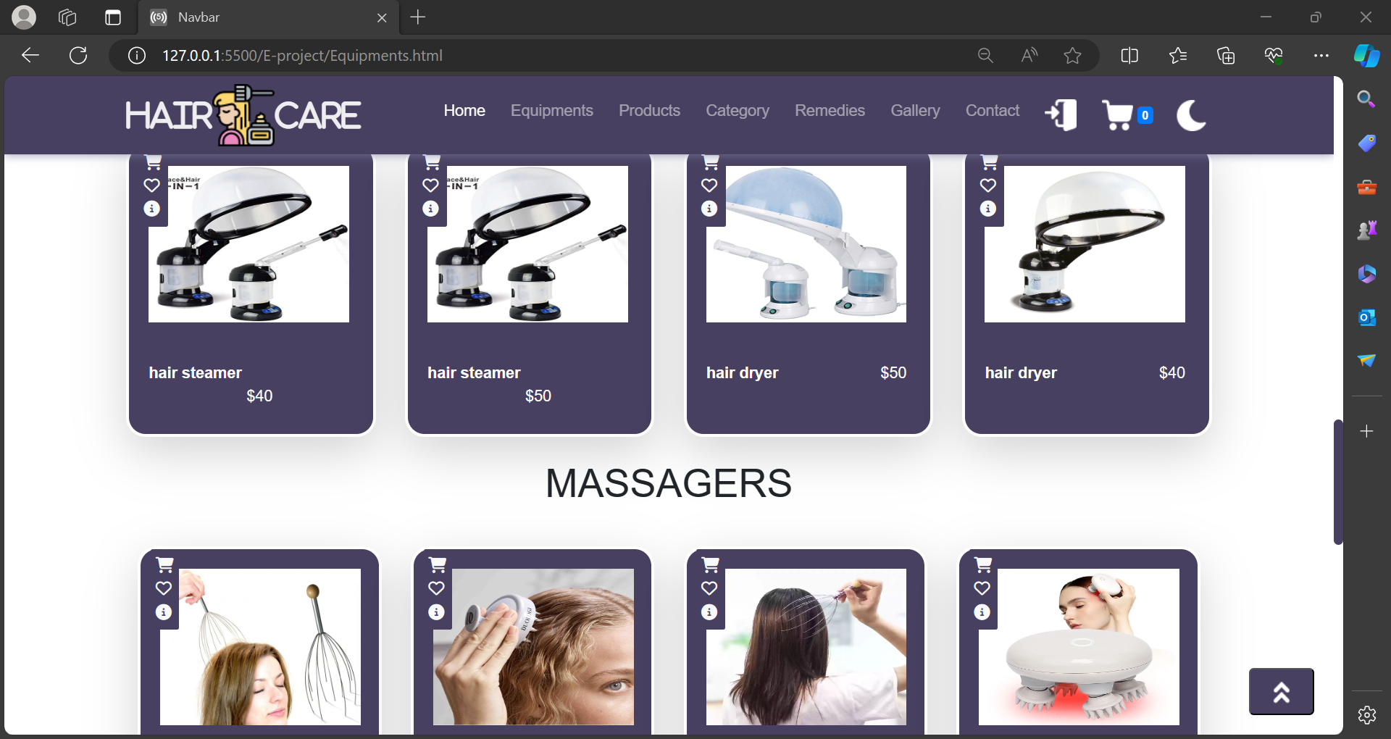

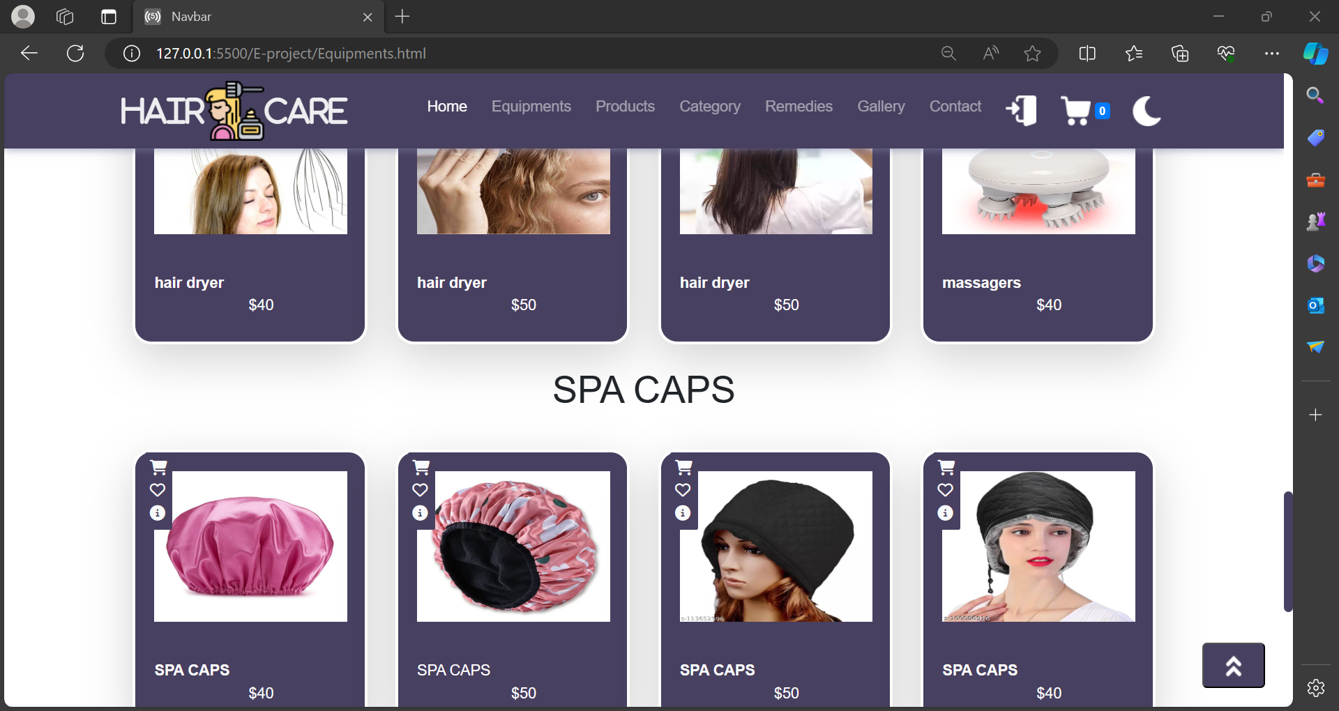

~~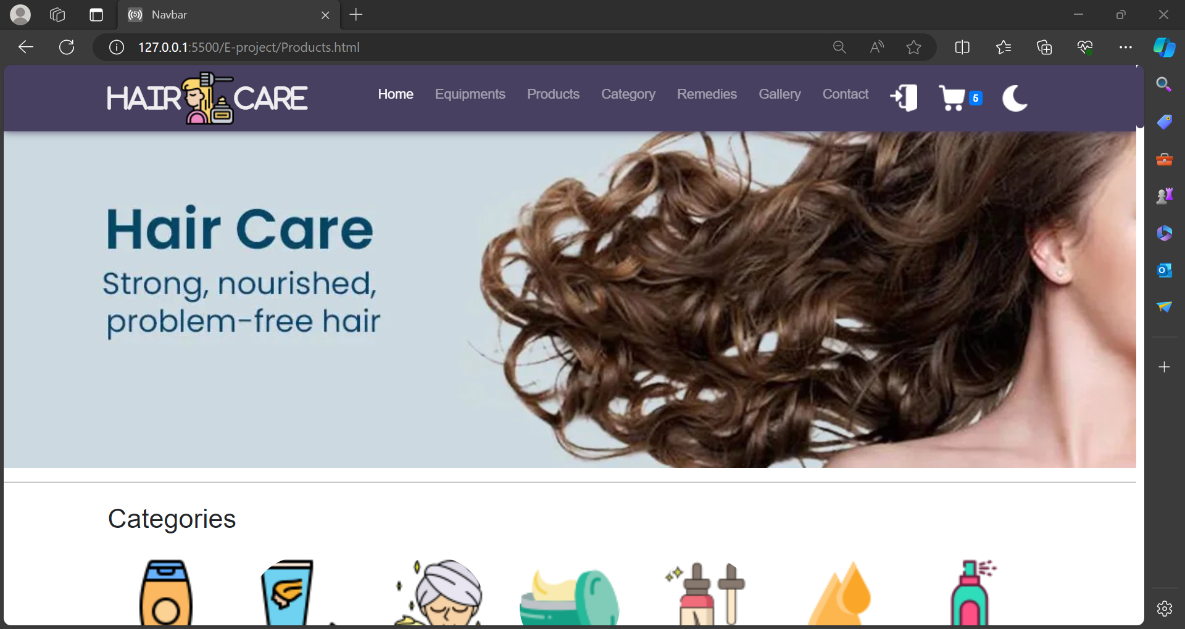~~

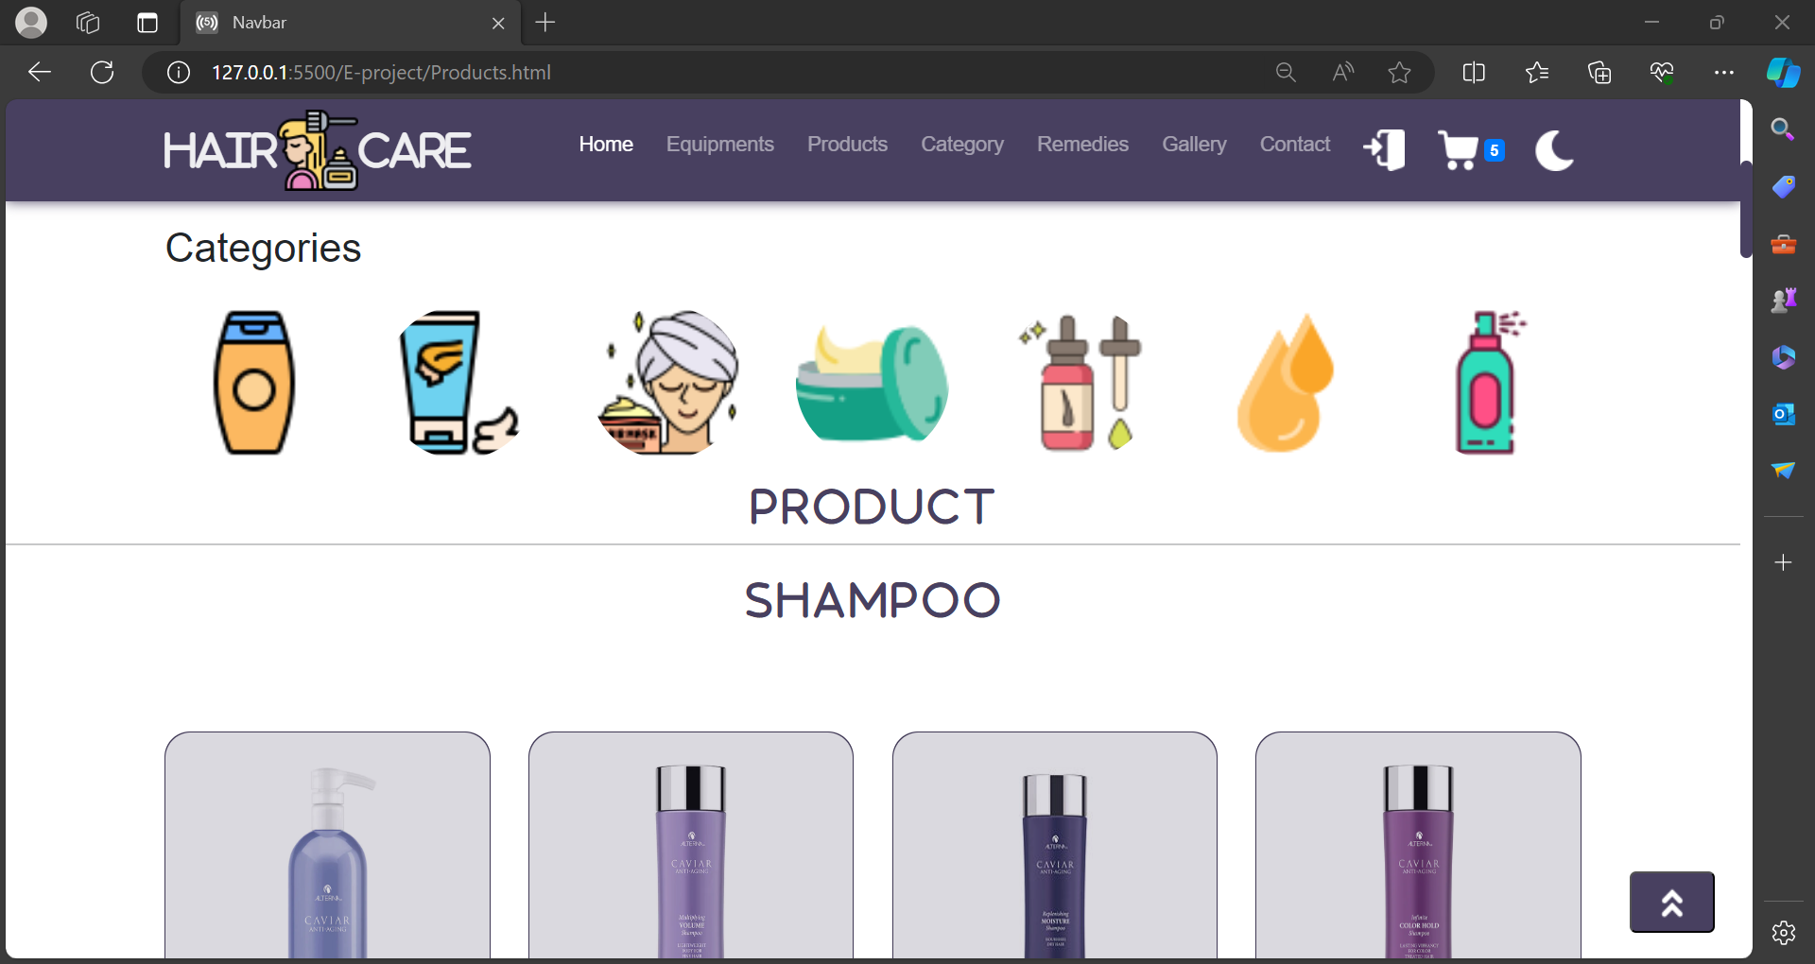

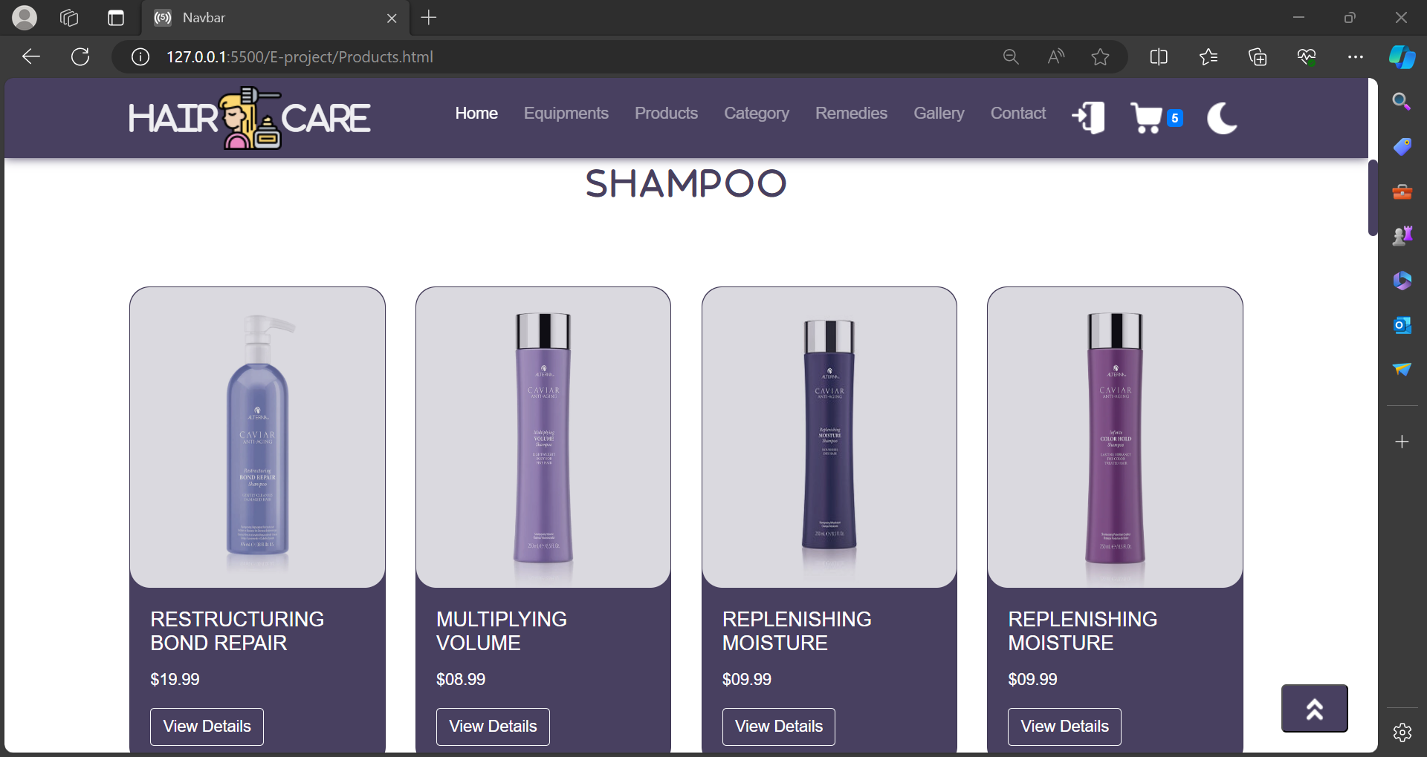

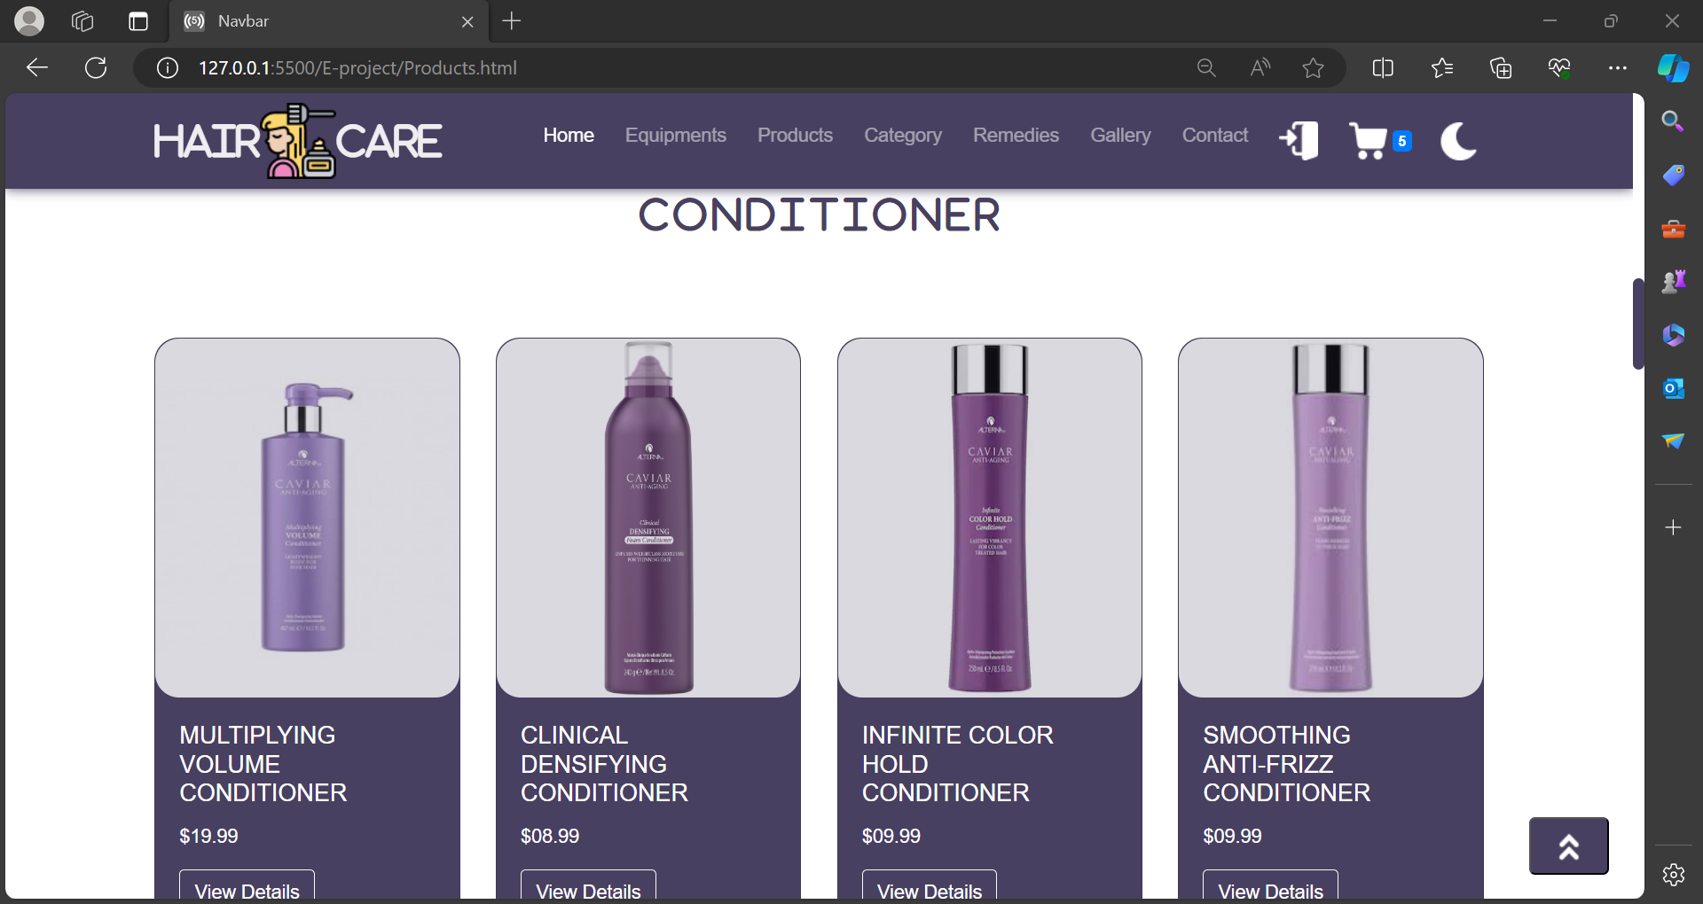

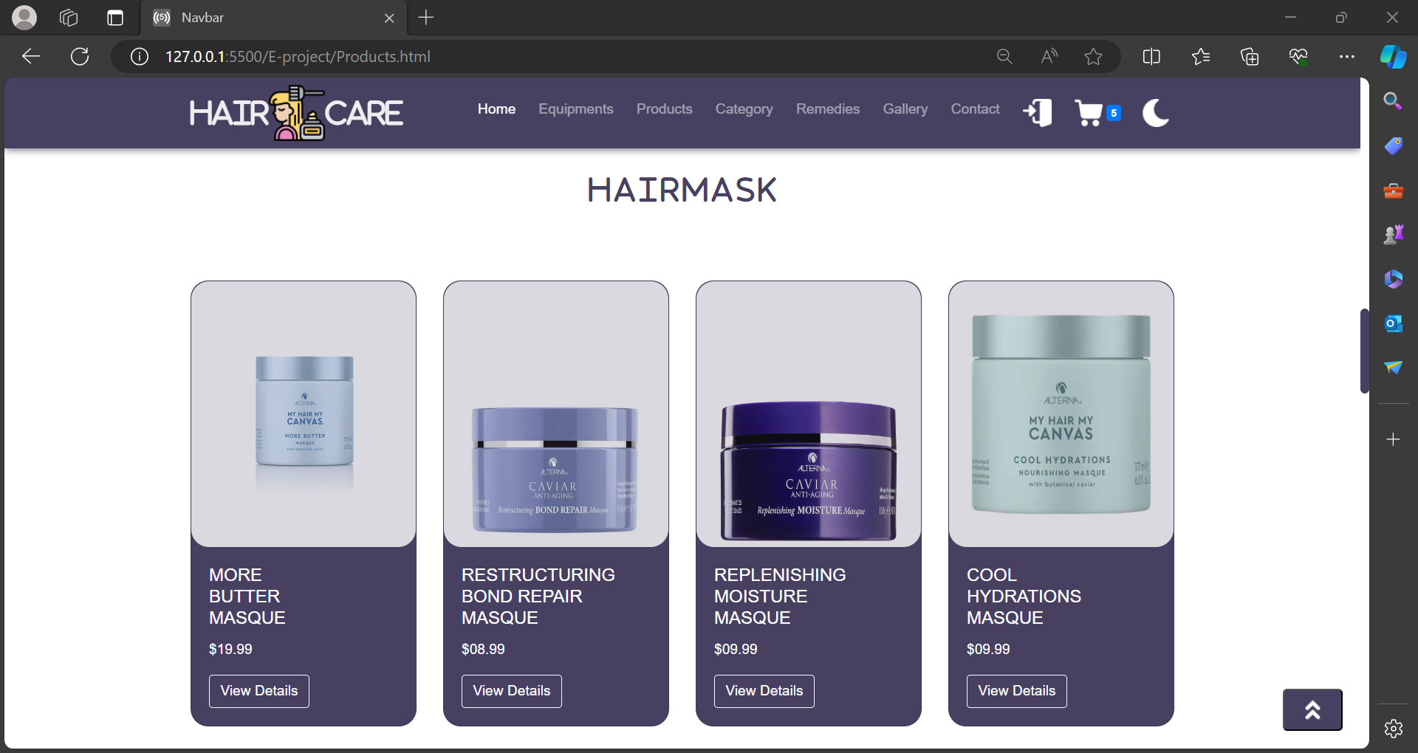

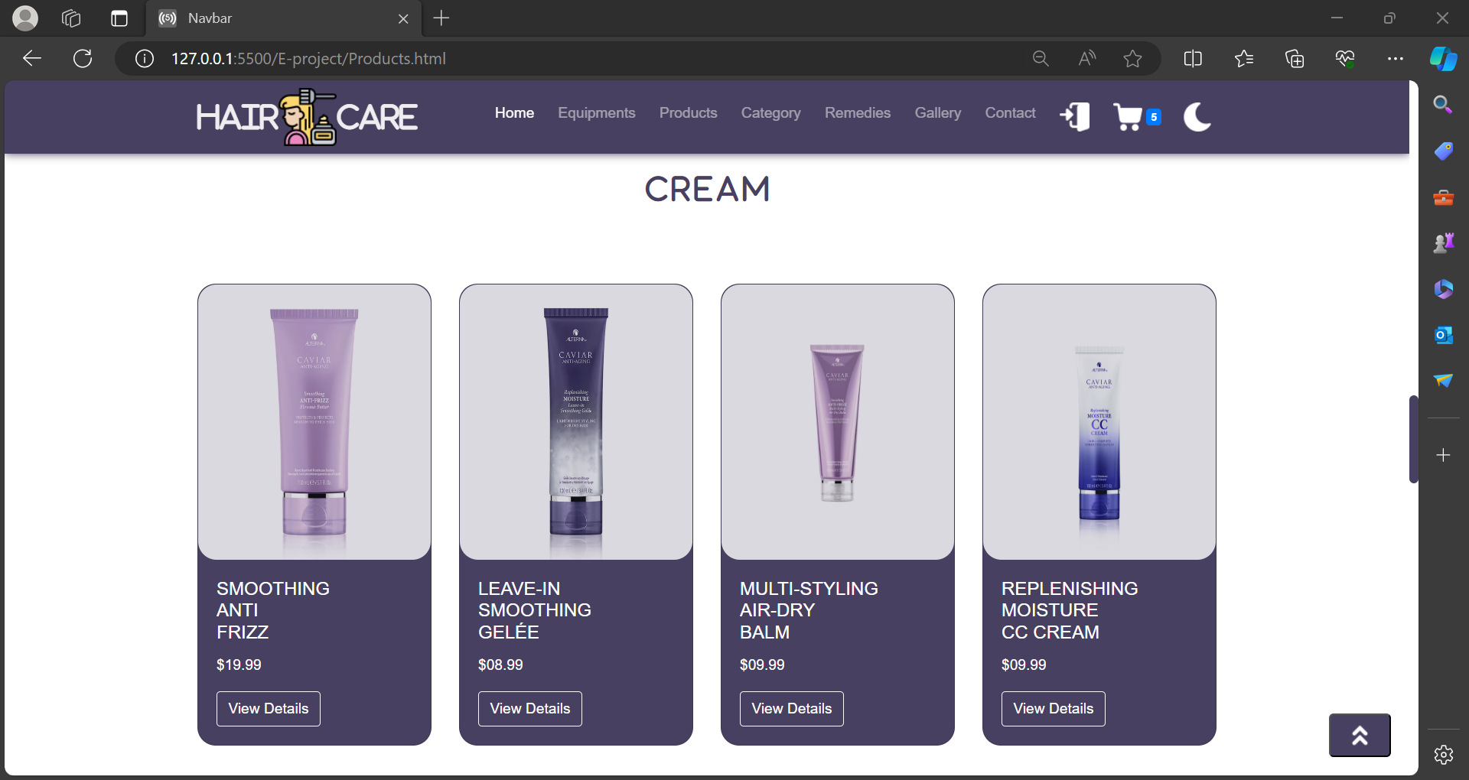

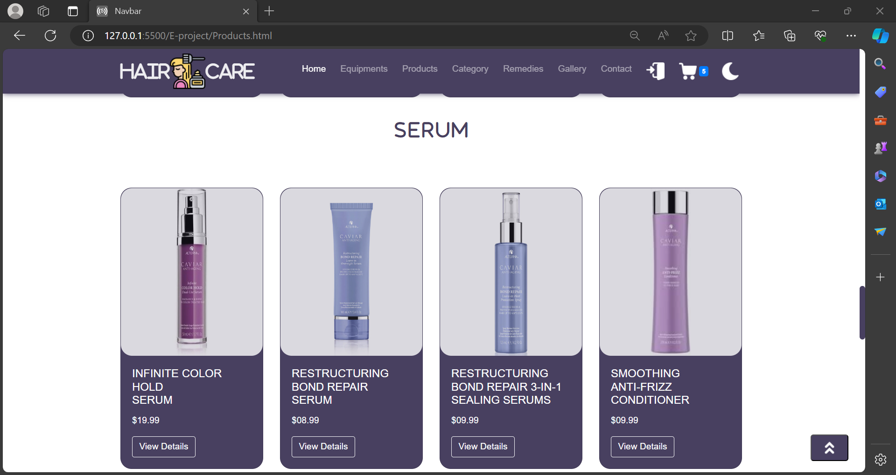

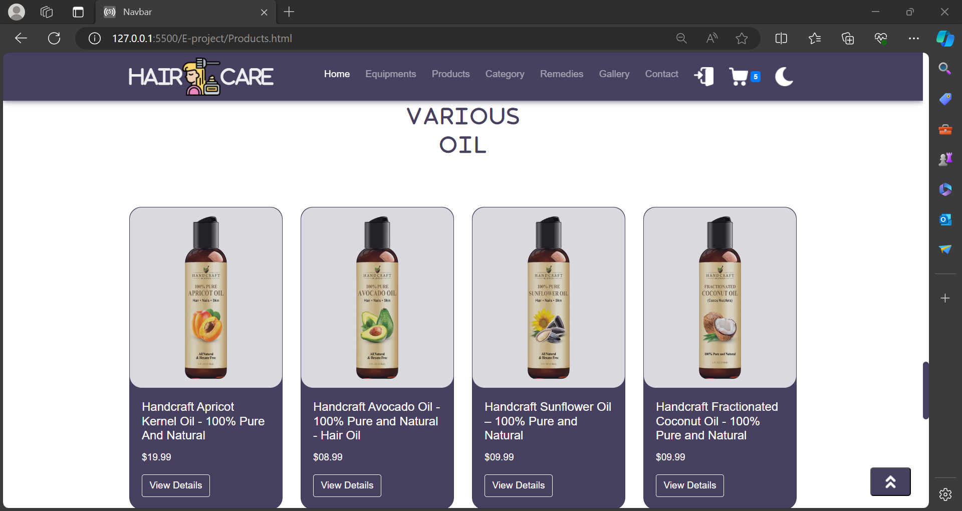

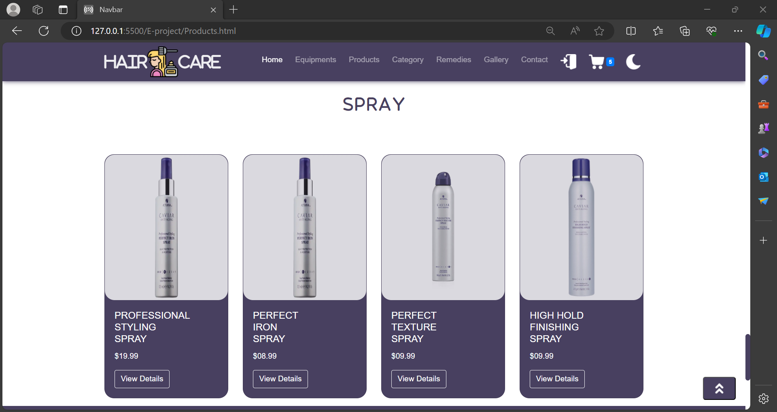

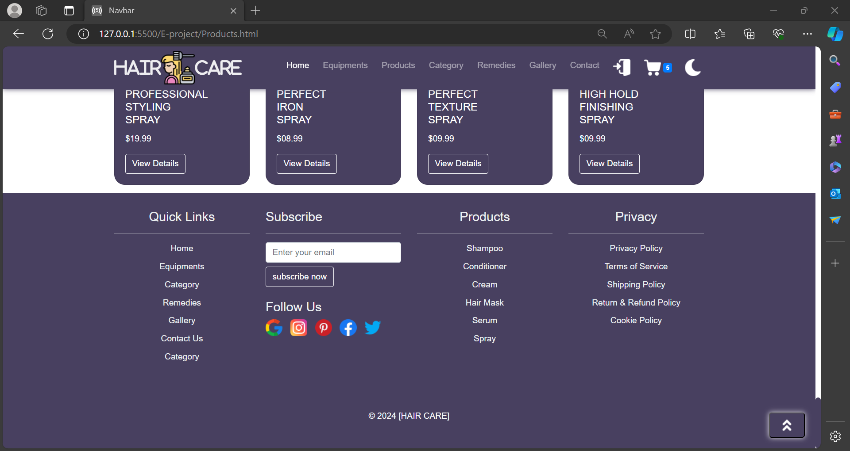

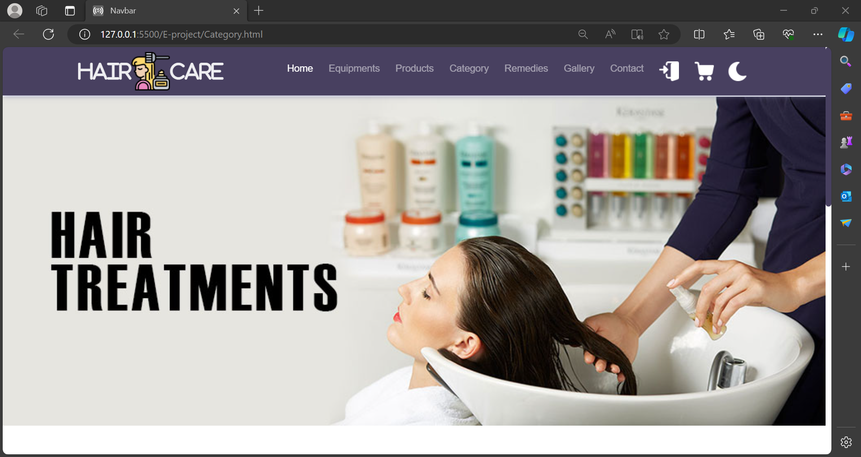

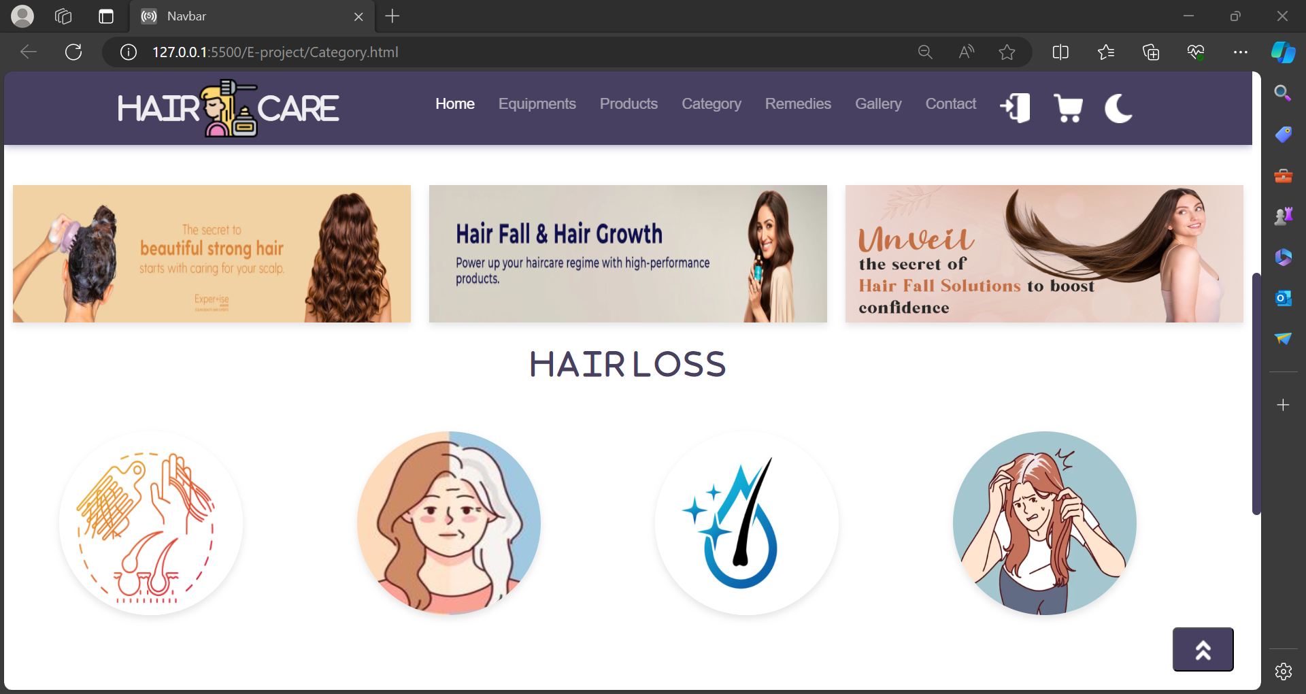

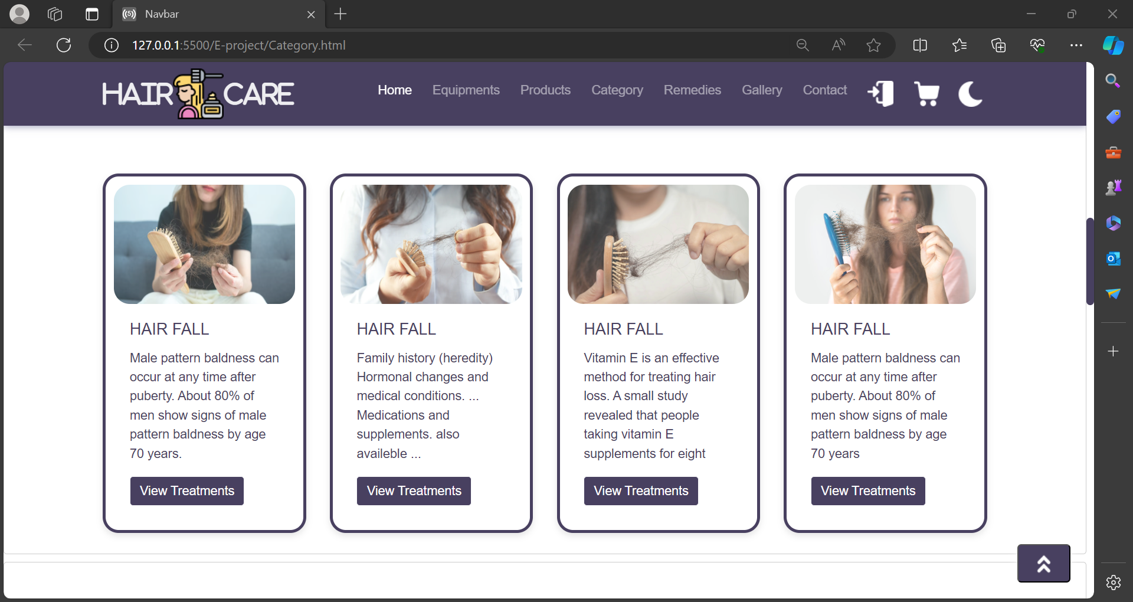

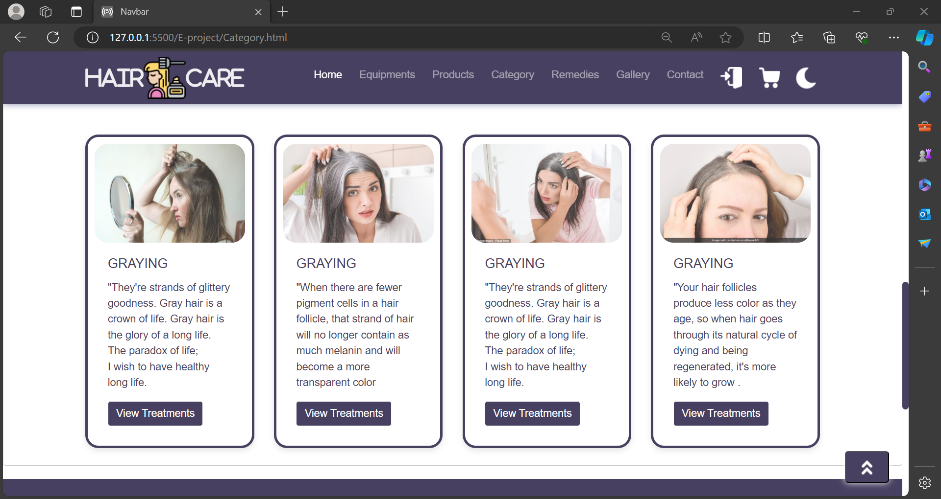

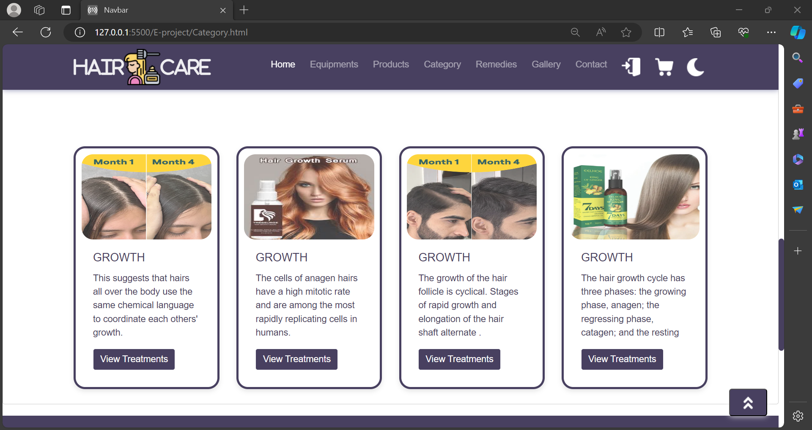

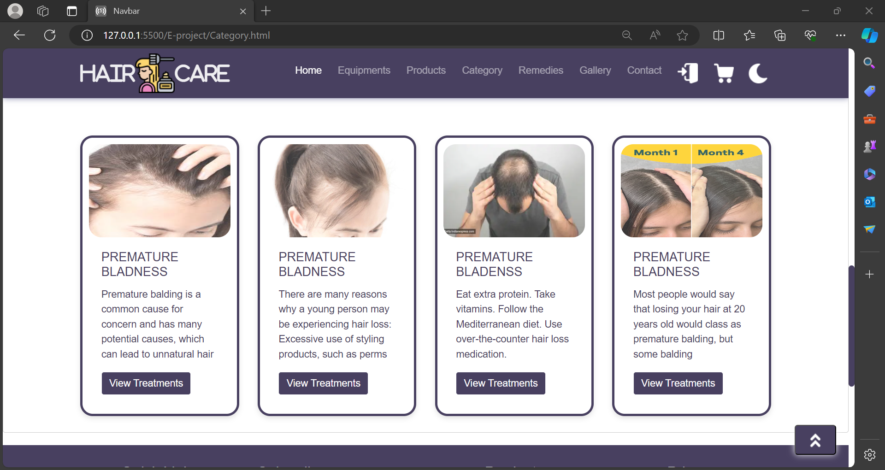

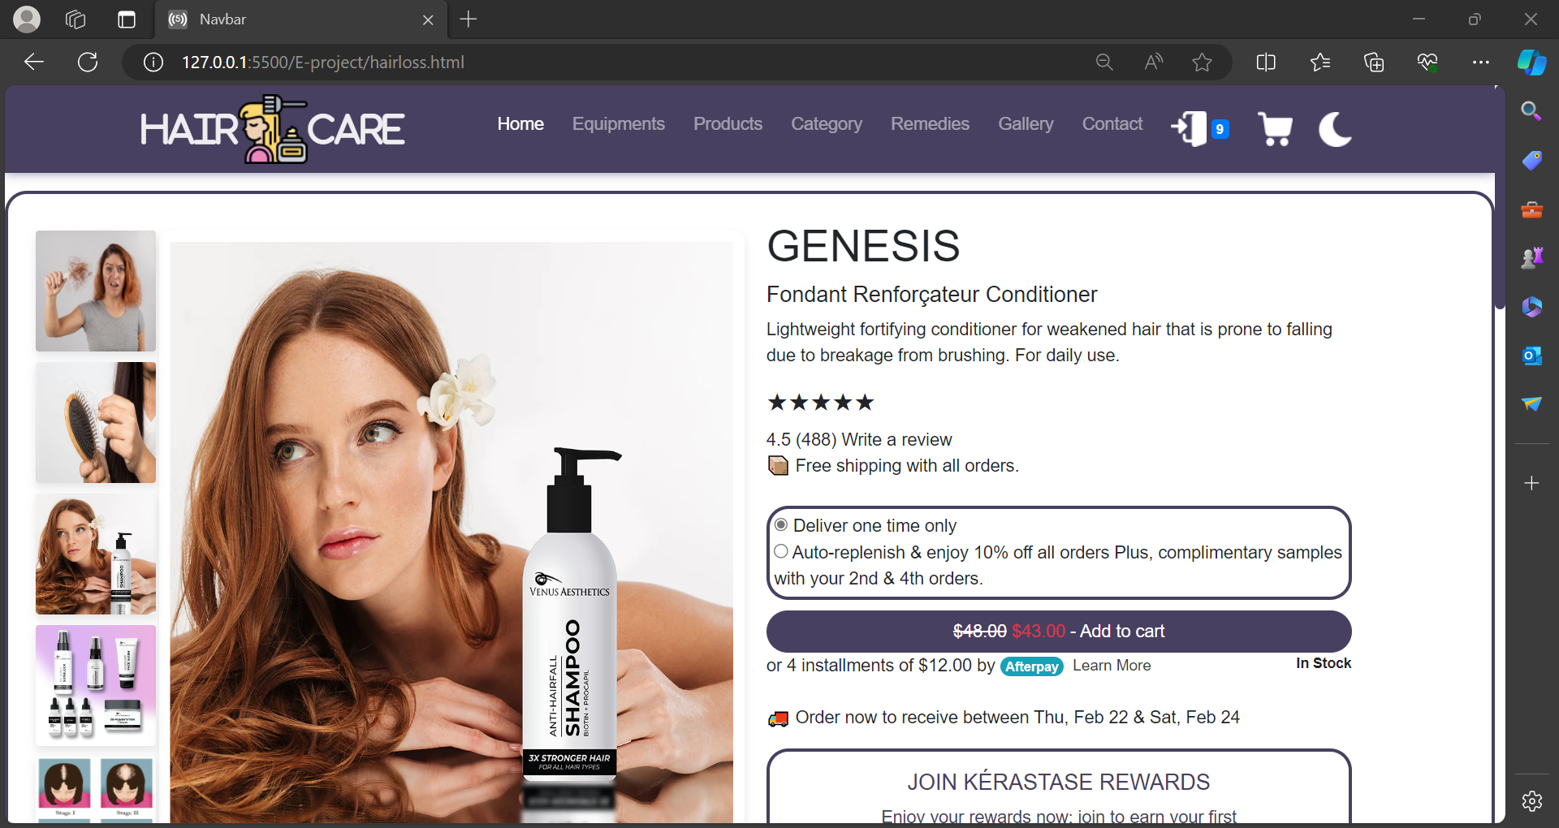

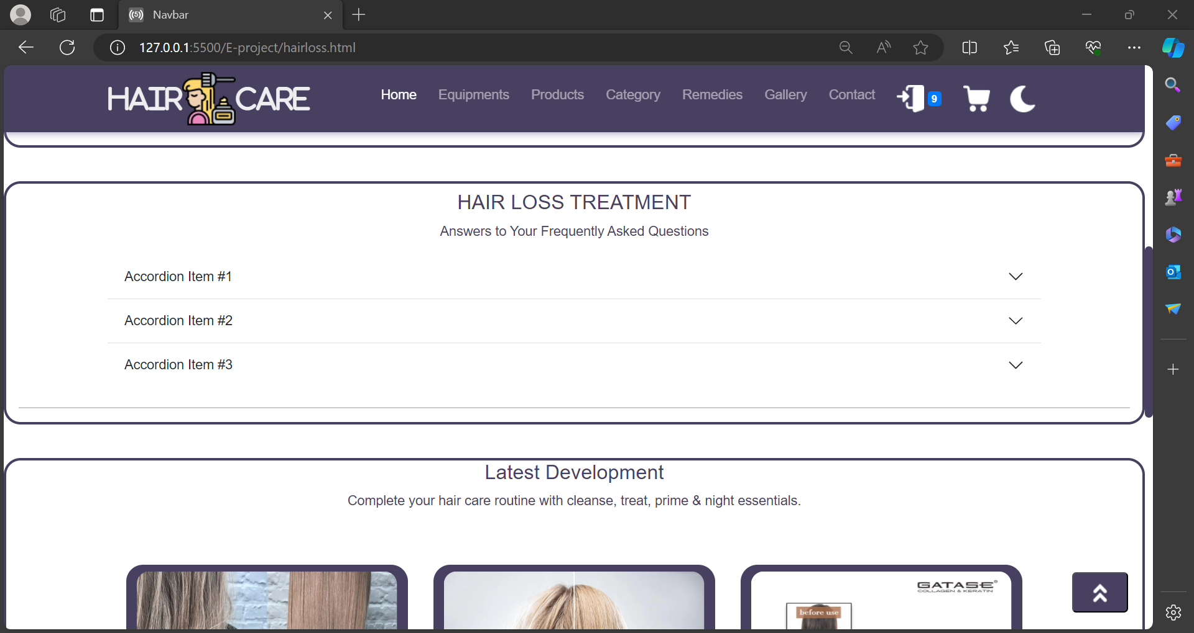

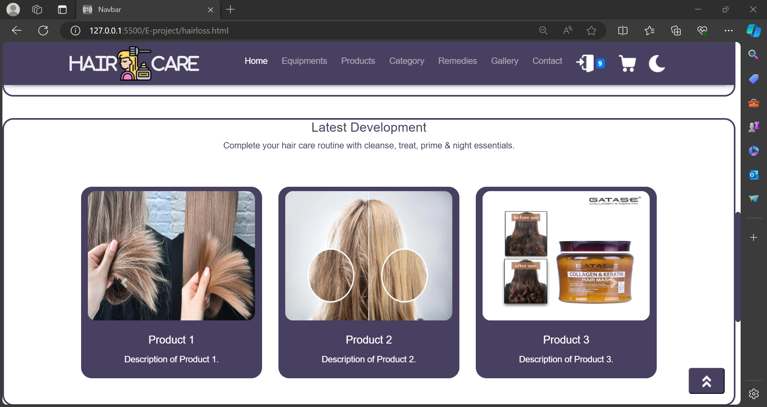

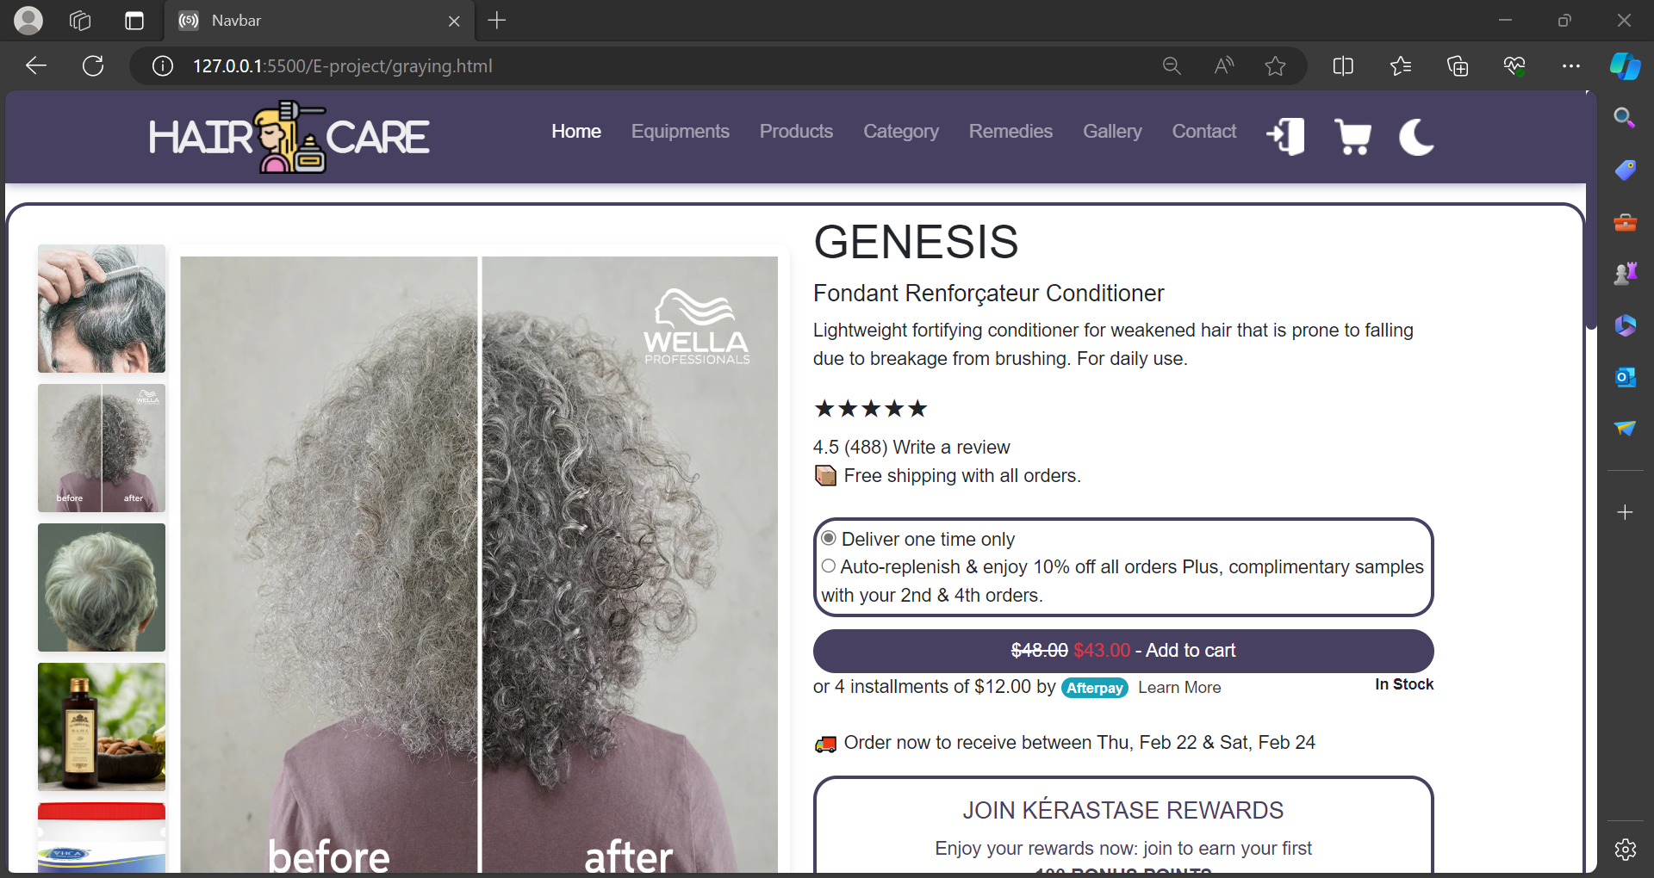

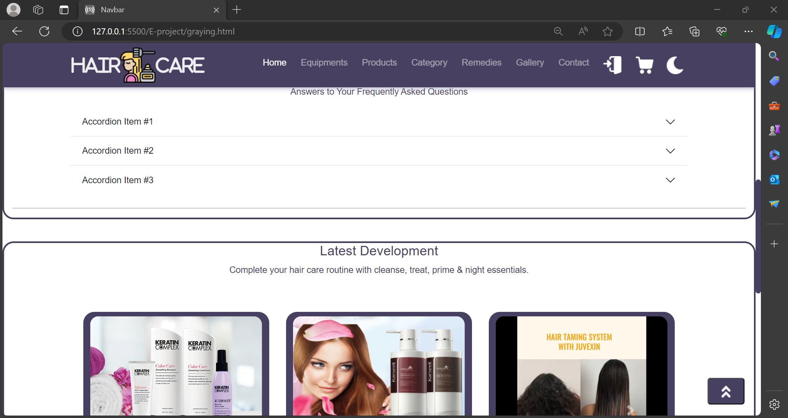

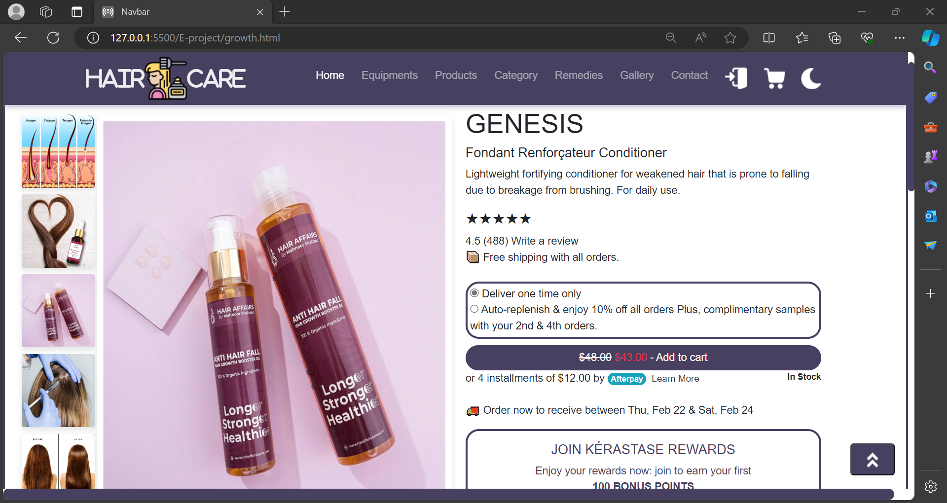

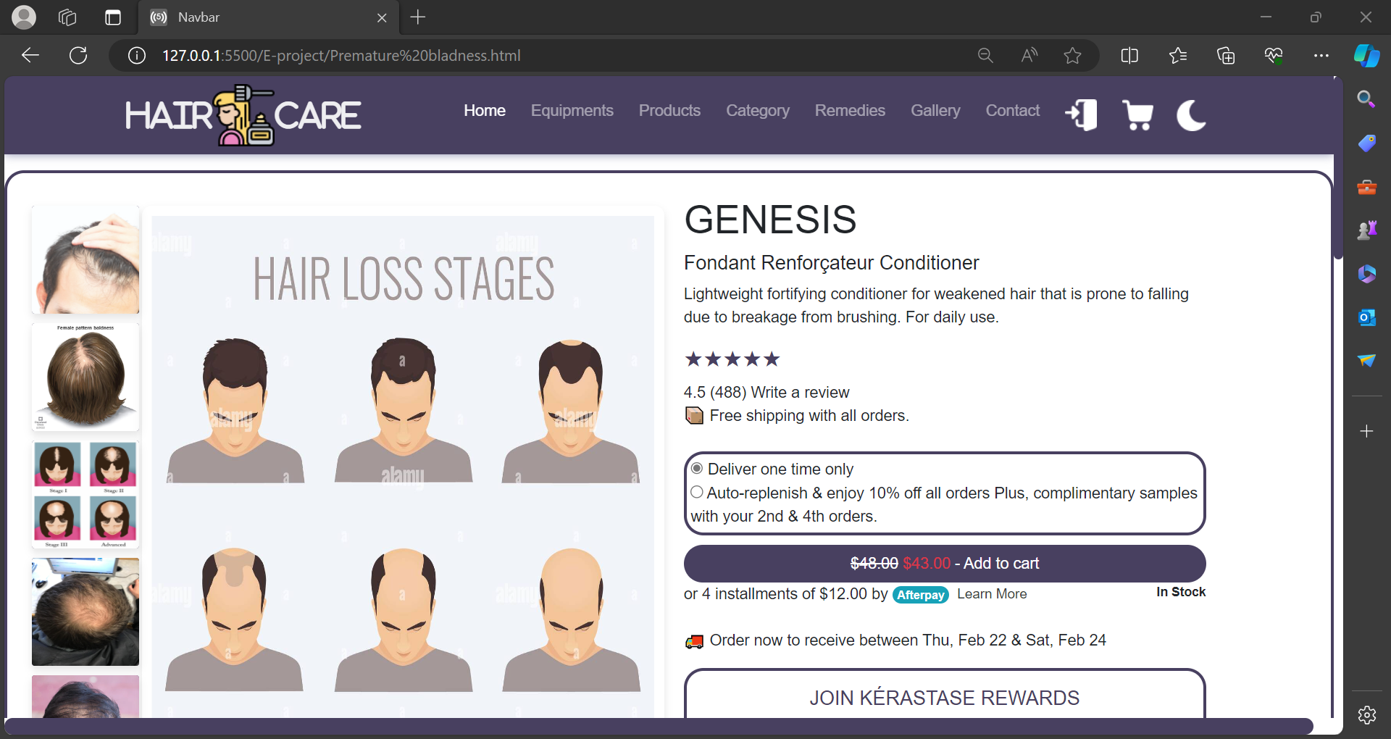

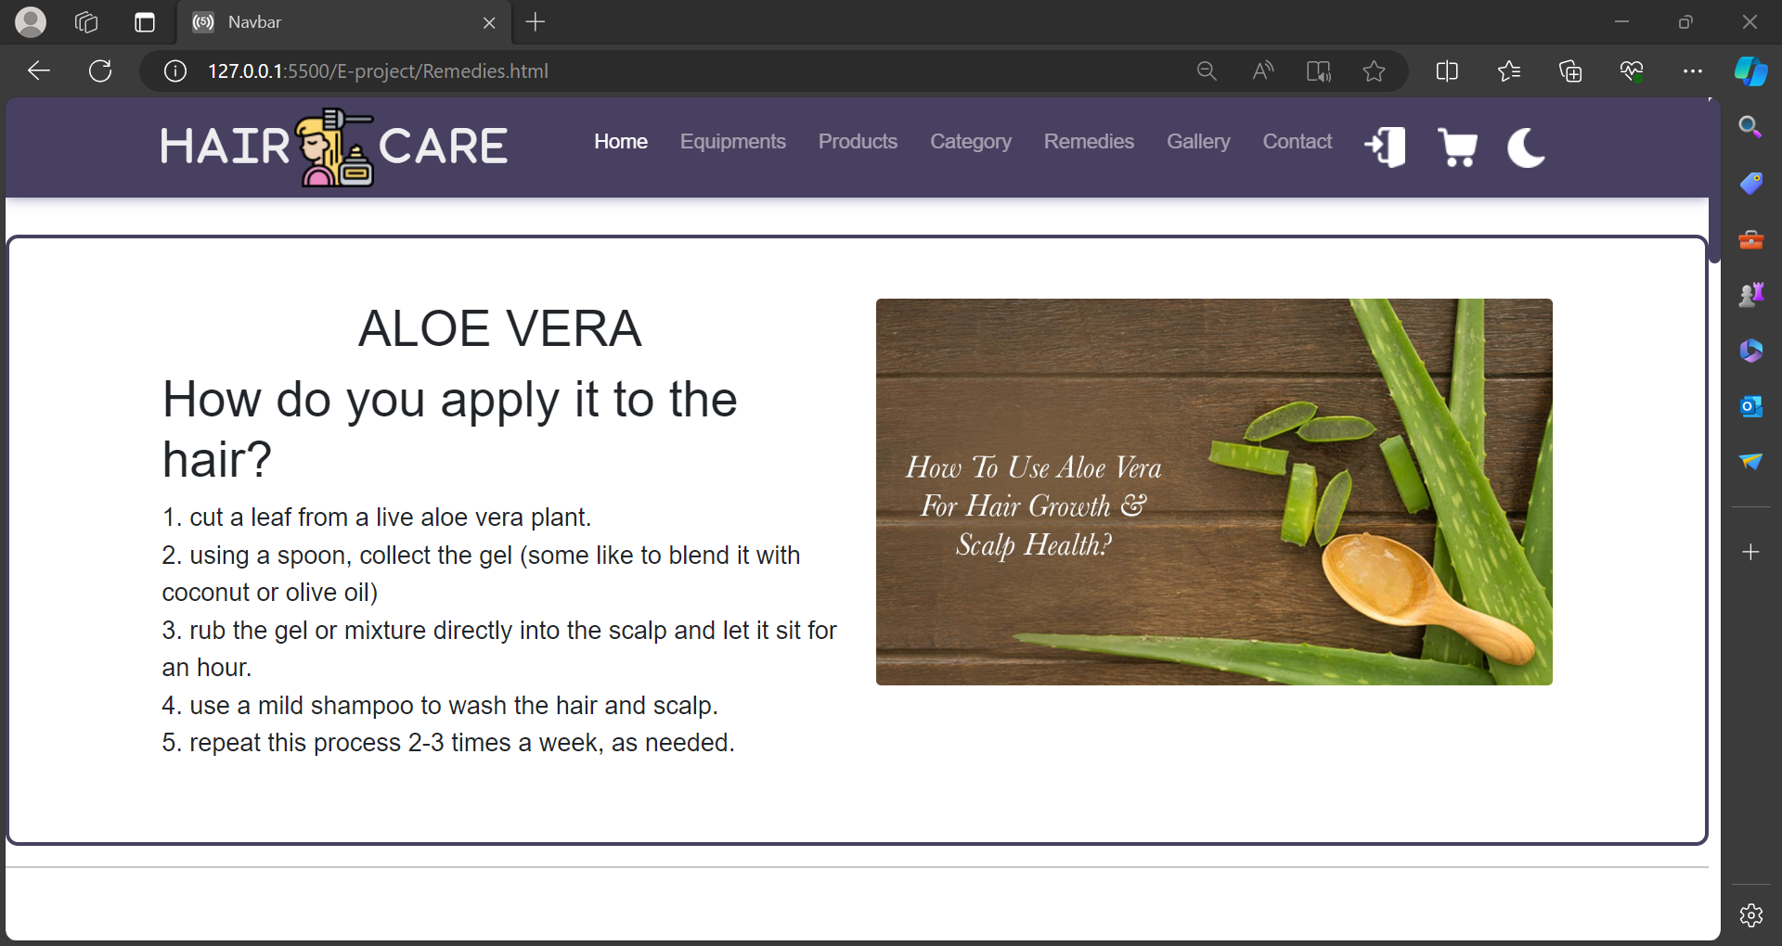

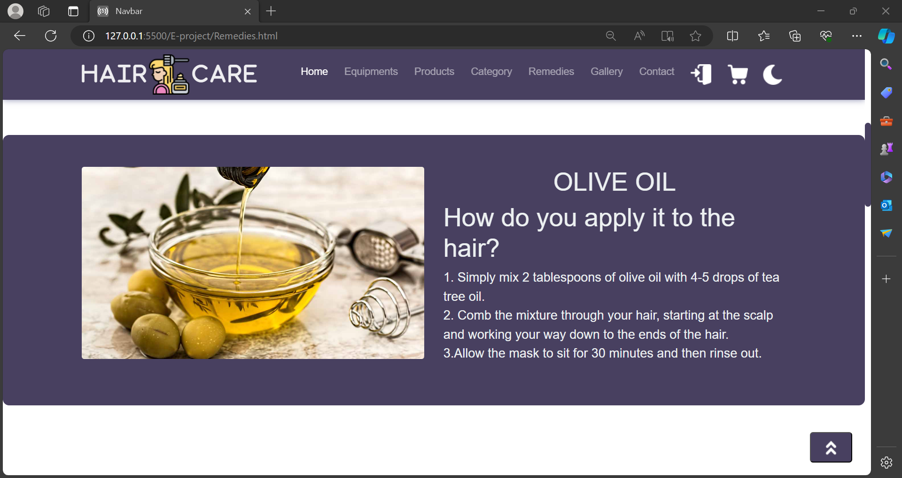

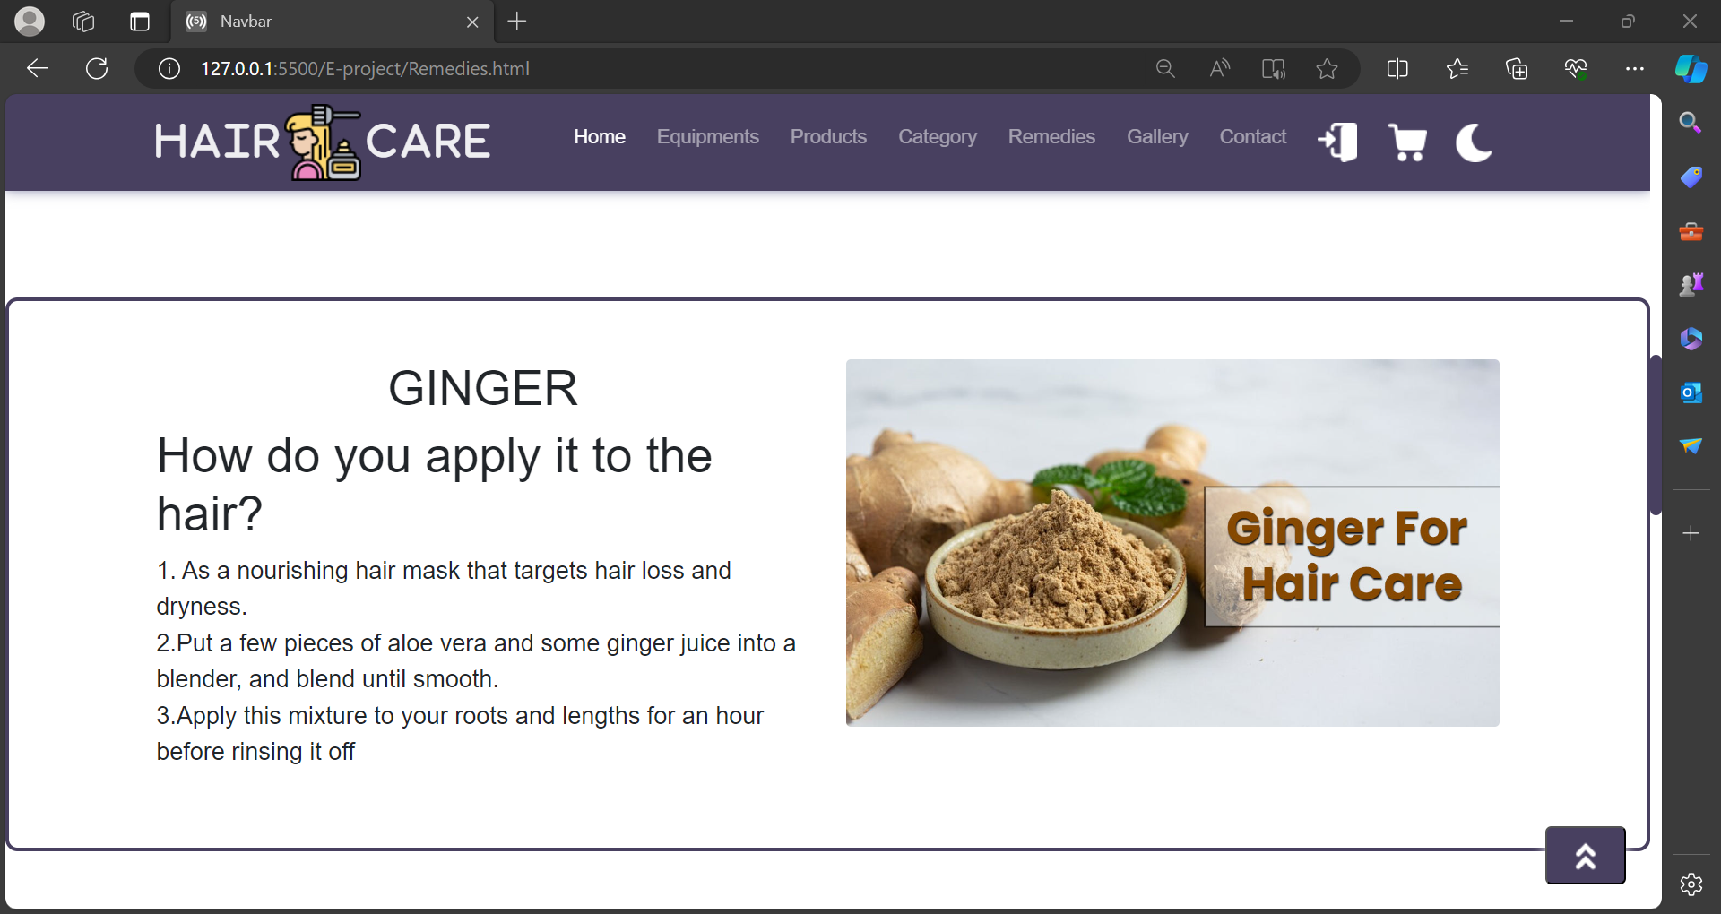



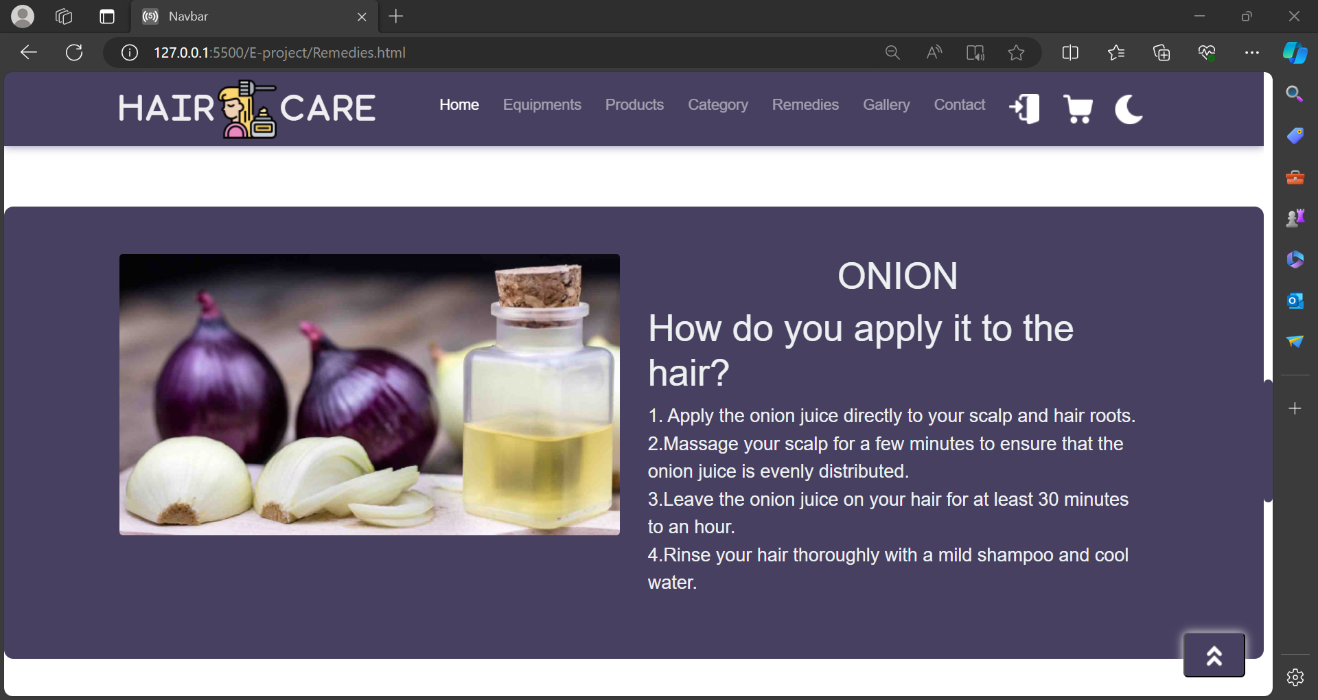

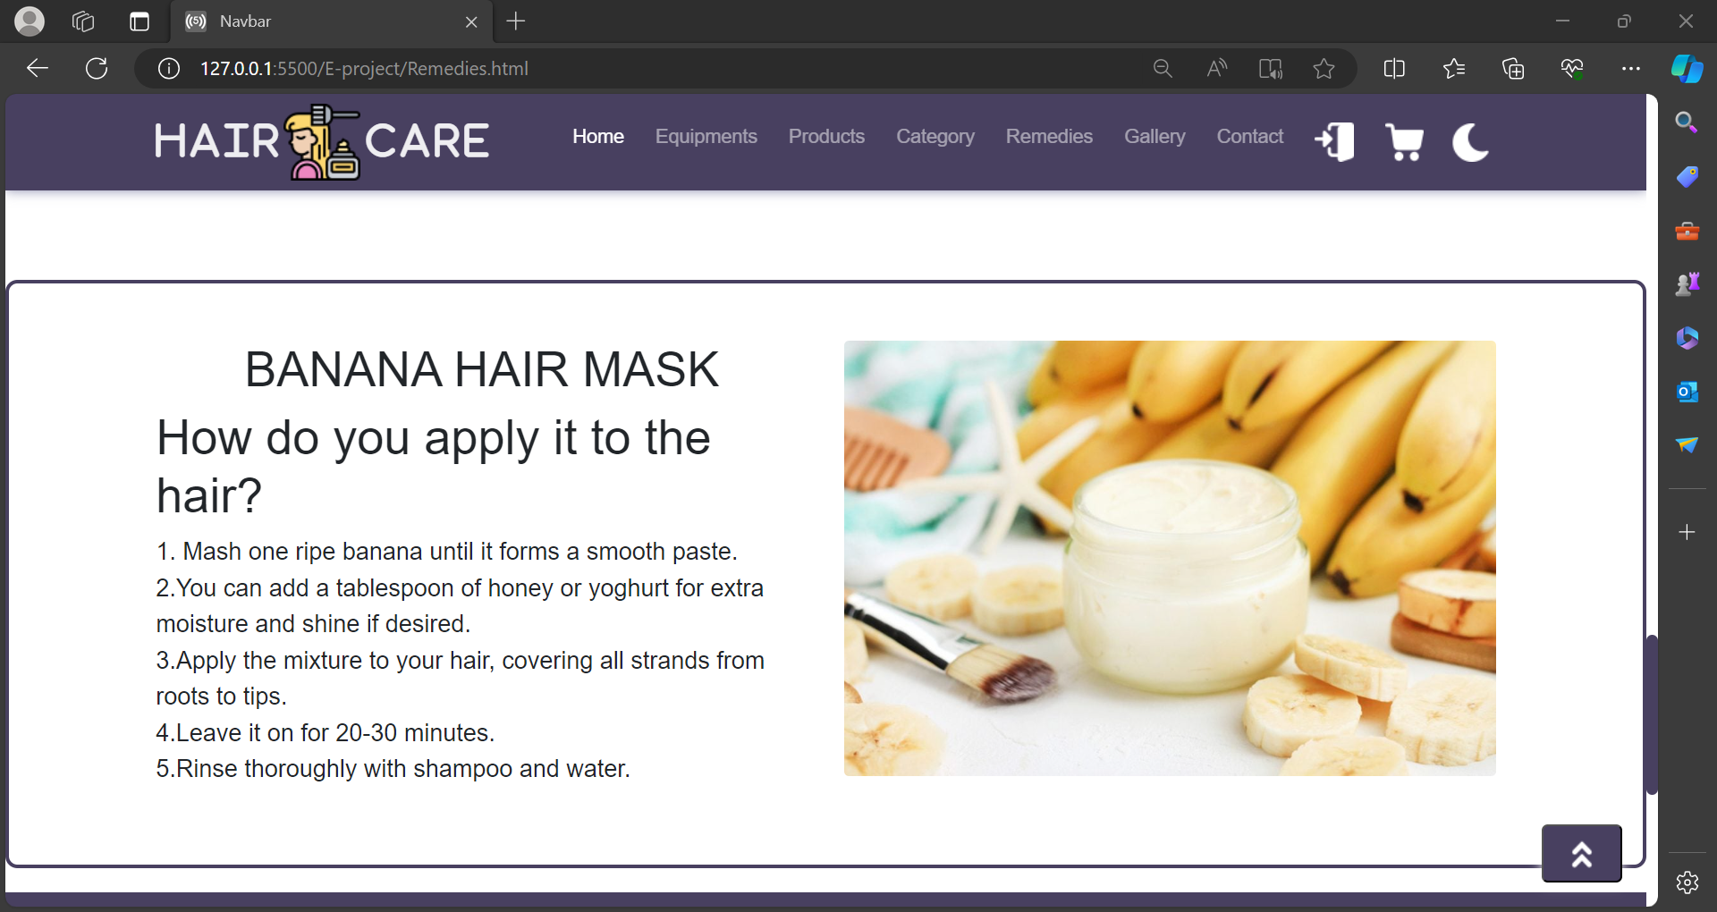

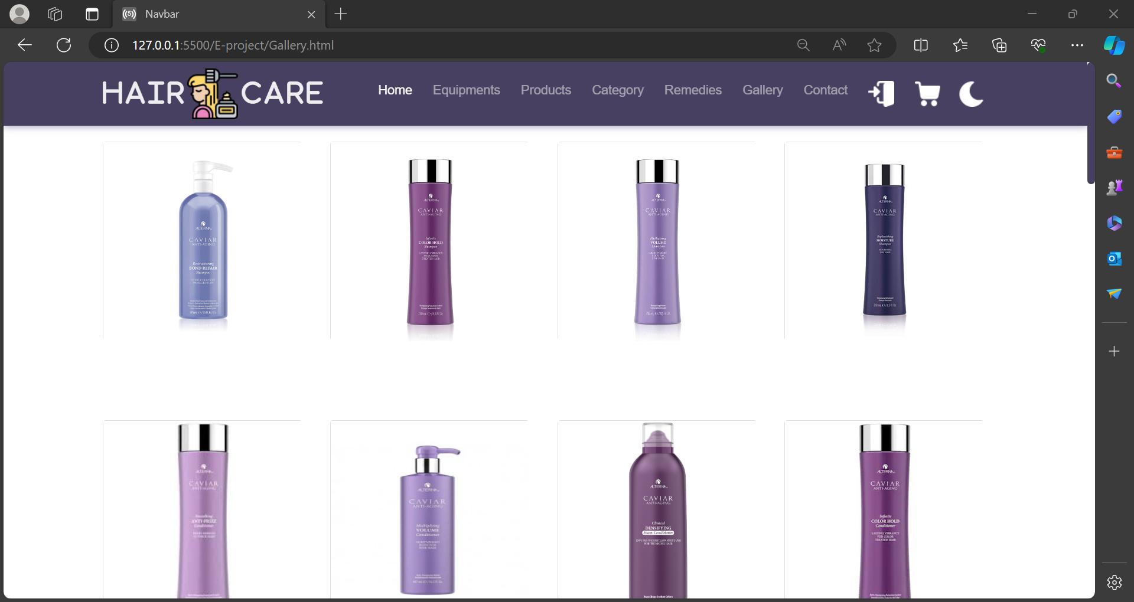

~~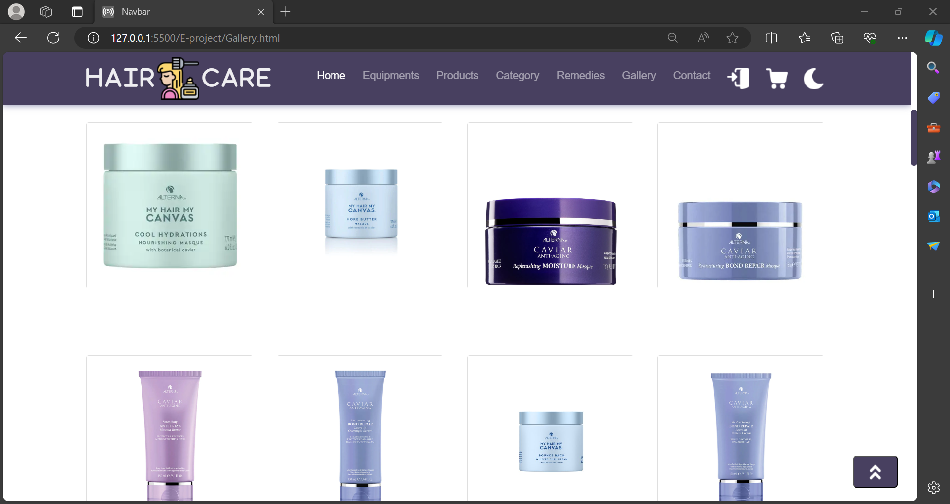~~

~~‏~~

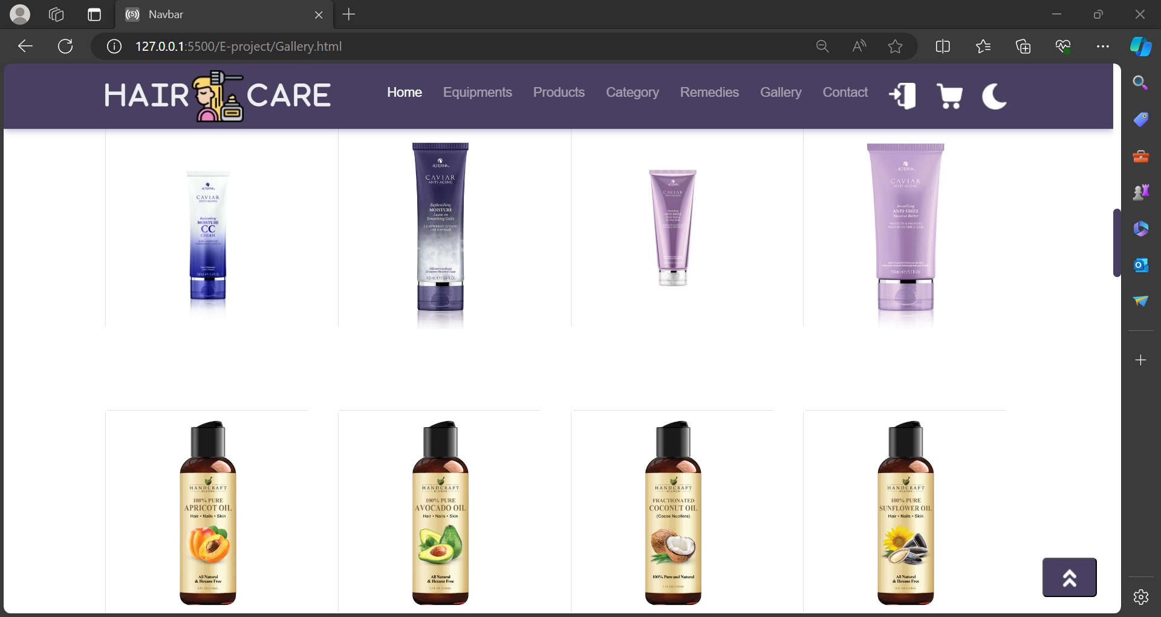

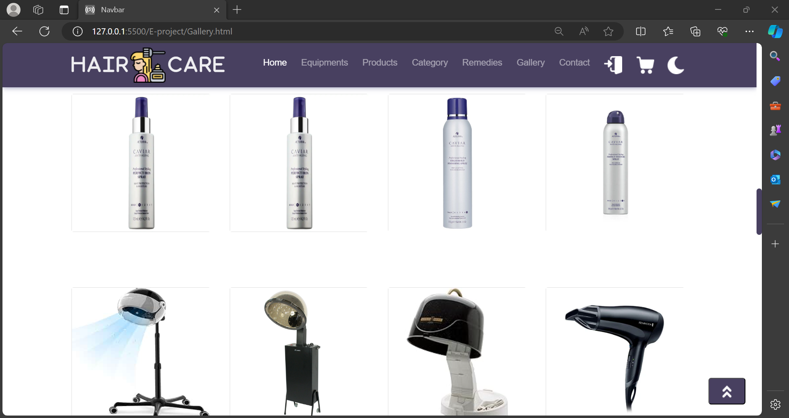

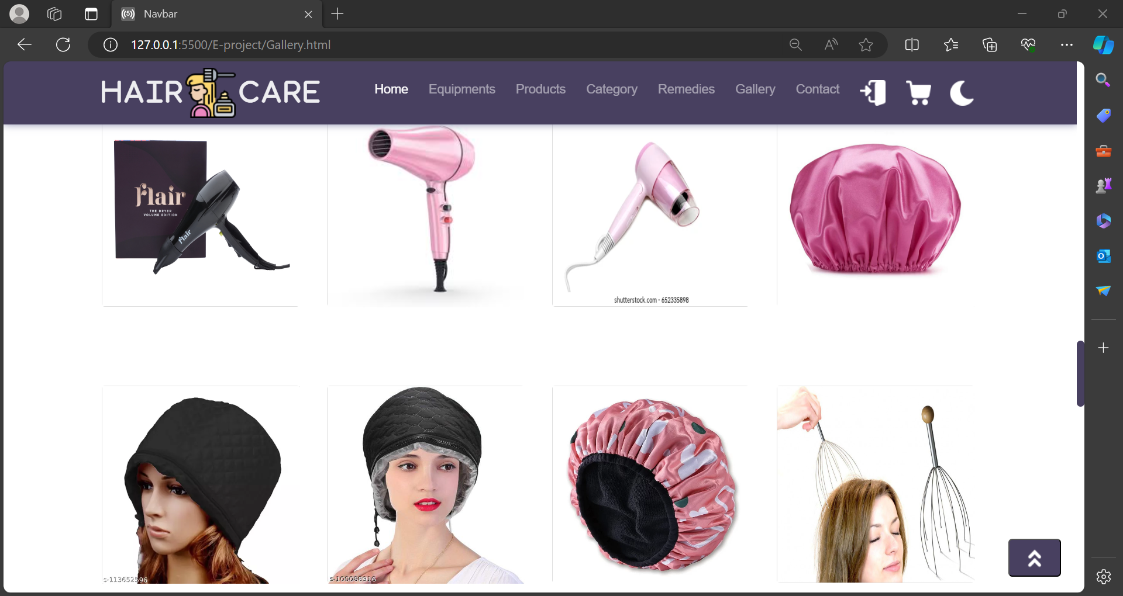

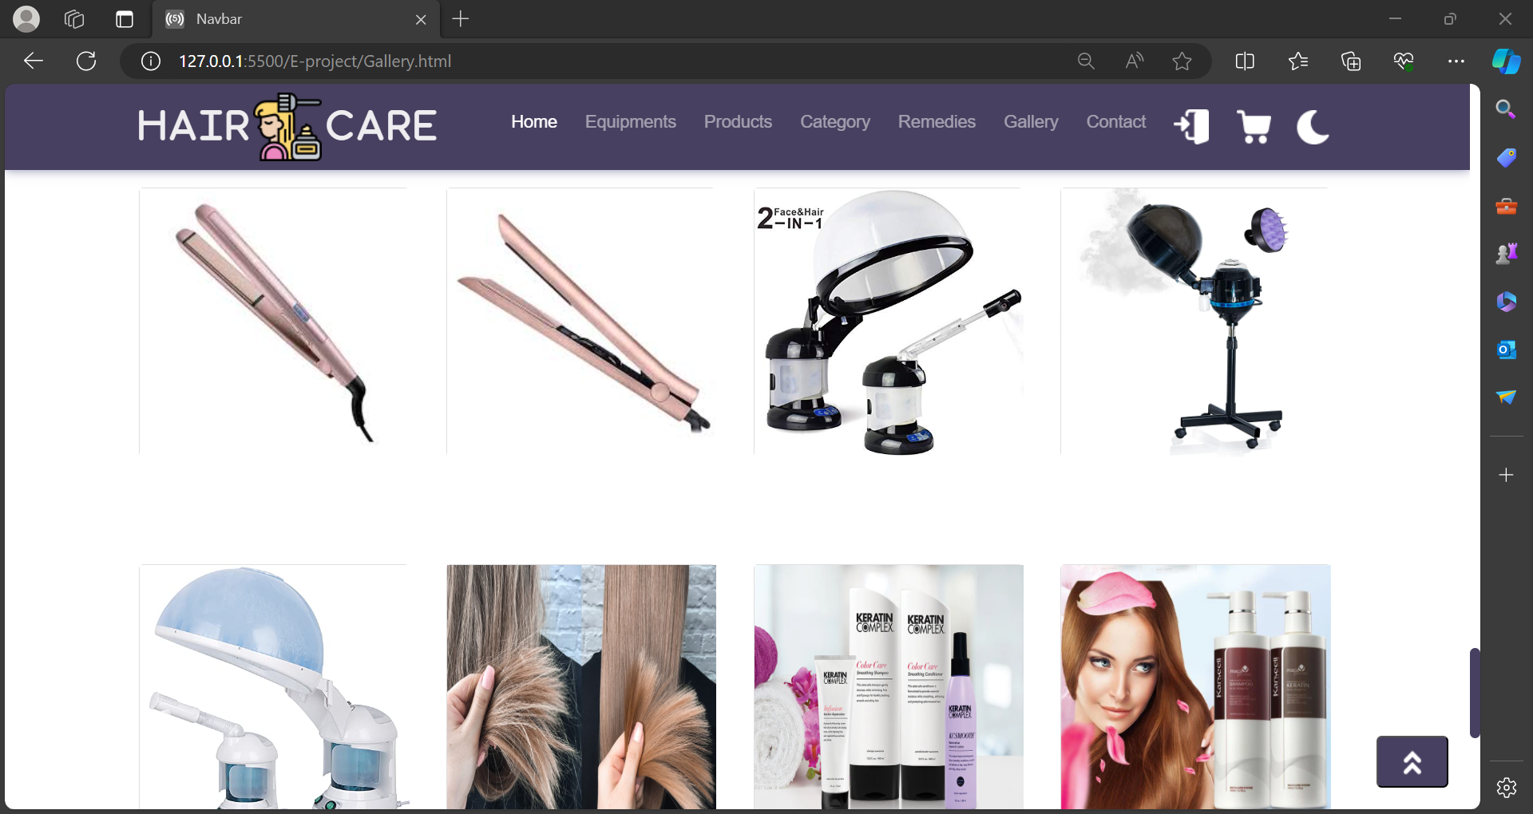

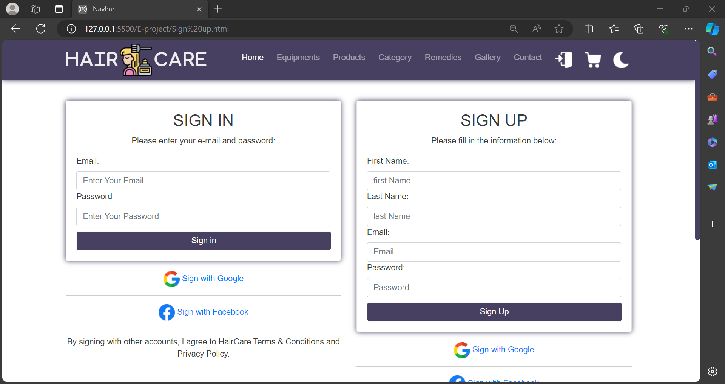

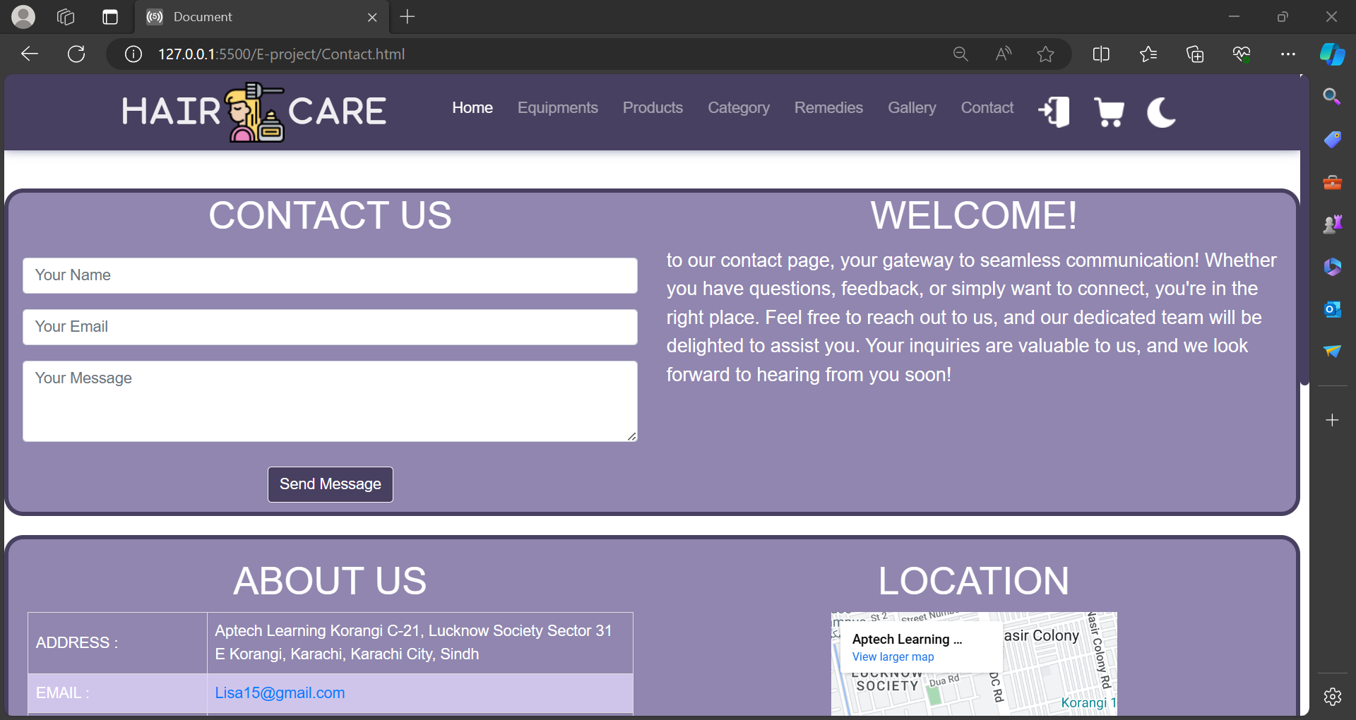

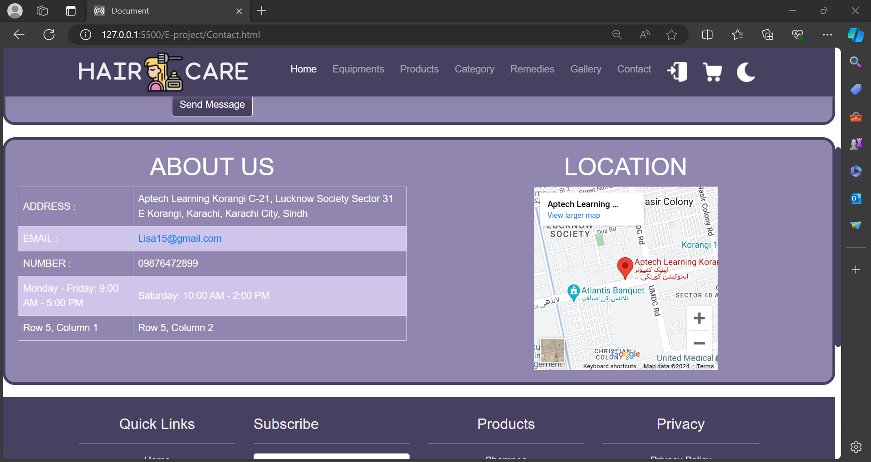

HOME PAGE[HTML + CSS]

<!DOCTYPE html>

<html lang="en">

<head>

<meta charset="UTF-8">

<meta name="viewport" content="width=device-width, initial-scale=1.0">

<title>Navbar</title>

<link rel="stylesheet" href="https://cdnjs.cloudflare.com/ajax/libs/font-awesome/6.4.2/css/all.min.css">

<link href="https://cdn.jsdelivr.net/npm/bootstrap@5.0.0/dist/css/bootstrap.min.css" rel="stylesheet">

<link href="product.css" rel="stylesheet">

<link href="https://maxcdn.bootstrapcdn.com/bootstrap/4.5.2/css/bootstrap.min.css" rel="stylesheet">

<!-- jQuery -->

<script src="https://ajax.googleapis.com/ajax/libs/jquery/3.5.1/jquery.min.js"></script>

<!-- Bootstrap JS -->

<script src="https://cdnjs.cloudflare.com/ajax/libs/popper.js/1.16.0/umd/popper.min.js"></script>

<script src="https://maxcdn.bootstrapcdn.com/bootstrap/4.5.2/js/bootstrap.min.js"></script>

<style>

body {

padding-top: 56x; /* Adjusted for the fixed navbar height */

background-color:#ffffff;/* Black background color */

color: white#fff; /* White text color */

transition: background-color 0.3s; /* Add a smooth transition effect */

}

nav {

box-shadow: 0 0 10px rgba(124, 126, 165, 0.911);

background: rgb(72, 64, 96);

}

.icons{

margin: 20px;

}

.navbar-brand {

font-weight: bold;

font-size: 3.5rem;

}

.navbar-nav .nav-item {

margin-right: 10px;

}

/* Responsive styles */

@media (max-width: 768px) {

body {

padding-top:70px; /* Adjusted for the fixed navbar height in mobile view */

}

.navbar-nav .nav-item {

margin-right: 0;

margin-bottom: 30px;

}

}

body {

margin: 0;

font-family: Arial, sans-serif;

transition: background-color 0.5s ease;

}

.light {

background-color: #ffb5bb;

color: #000000;

}

.dark {

background-color: rgb(179, 168, 210);

color: #ffffff;

}

.dark-icon{

background: rgb(72, 64, 96);

}

.dark-mode-toggle {

padding: 5px;

font-size: 20px;

cursor: pointer;

border: none;

background-color: transparent;

color: #ffffff;

transition: color 0.3s ease;

}

.dark-mode-toggle:hover {

color: #f8f9fa; /* slightly lighter shade on hover */

}

#back-to-top {

display: none;

position: fixed;

bottom: 20px;

right: 20px;

background-color: rgb(72, 64, 96);

box-shadow: 0 0 10px rgba(255, 255, 255, 0.911);

padding: 10px 20px;

border-radius: 5px;

cursor: pointer;

z-index: 1000;

}

.carousel {

width: 100%;

padding: 0;

margin-top: 20px;

}

.carousel-inner {

width: 100%;

}

.carousel-item img {

width: 100%;

height: 700px;

}

.category {

width: 120px;

height: 120px;

border-radius: 50%;

overflow: hidden;

margin: 10px;

position: relative;

display: flex;

align-items: center;

justify-content: center;

transition: transform 0.3s ease;

}

.category:hover {

transform: scale(1.1);

}

.category img {

width: 100%;

height: auto;

display: block;

}

.category a {

position: absolute;

top: 0;

left: 0;

width: 100%;

height: 100%;

text-align: center;

color: #fff;

text-decoration: none;

background: rgb(72, 64, 96);

display: flex;

align-items: center;

justify-content: center;

opacity: 0;

transition: opacity 0.3s ease;

}

.category:hover a {

opacity: 1;

}

.product-card {

border-radius: 10px;

overflow: hidden;

position: relative;

}

.product-card img {

width: 100%;

height: auto;

}

.product-card .card-body {

position: absolute;

bottom: 0;

width: 100%;

background: rgba(0, 0, 0, 0.5);

color: #fff;

padding: 10px;

}

.bg-custom{

background-color: rgb(72, 64, 96);

border-radius: 20px;

color: white;

border-radius: 20px;

opacity: 0,5;

}

.bg-card{

border-radius: 20px;

border: rgb(255, 255, 255) solid 8px;

padding: 20px;

}

.bg-cards{

border-radius: 20px;

border: rgb(72, 64, 96) solid 8px;

padding: 20px;

}

.para{

color: rgb(72, 64, 96);

}

.card {

margin-bottom: 20px;

overflow: hidden;

border: 2px white;

}

.card img {

max-width: 150px;

height: 140px;

}

.footer {

background-color:rgb(72, 64, 96);/* Footer background color */

color: #ecf0f1; /* Footer text color */

padding: 30px 0;

margin-top: 20px;

}

.footer a {

color: #ecf0f1; /* Footer link color */

}

.footer a:hover {

color: #ffffff; /* Footer link color on hover */

}

.footer-menu {

list-style: none;

padding: 0;

margin: 0;

}

.footer-menu li {

margin-bottom: 10px;

}

.footer-social {

list-style: none;

padding: 0;

margin: 0;

}

.btn{

background-color:rgb(72, 64, 96);

color: white;

}

.footer-social li {

display: inline-block;

margin-right: 10px;

margin-bottom: 10px;

}

.footer-contact-form {

margin-top: 20px;

}

.footer-custom{

background-color:rgb(72, 64, 96); /* Footer background color */

color: #ffffff; /* Footer text color */

padding: 30px 0;

}

::-webkit-scrollbar{

width: 10px;

}

::-webkit-scrollbar-thumb{

background-color:rgb(72, 64, 96);

width: 15px;

border-radius: 20px;

}

</style>

</head>

<body>

<header>

<div class="container-fluid w-100 clr">

<nav class="navbar navbar-expand-lg navbar-dark fixed-top">

<div class="container">

<i class="fa-solid fa-h fa-2xl" style="color: #ffffffe8;"></i>

<i class="fa-solid fa-a fa-2xl" style="color: #ffffffe8; "></i>

<i class="fa-solid fa-i fa-2xl" style="color: #ffffffe8; "></i>

<i class="fa-solid fa-r fa-2xl" style="color: #ffffffe8; "></i>

<img src="My Hair My Canvas img/hair (1).png" alt="">

<i class="fa-solid fa-c fa-2xl" style="color: #ffffffe8;"></i>

<i class="fa-solid fa-a fa-2xl" style="color: #ffffffe8; "></i>

<i class="fa-solid fa-r fa-2xl" style="color: #ffffffe8; "></i>

<i class="fa-solid fa-e fa-2xl" style="color: #ffffffe8; "></i>

<button class="navbar-toggler" type="button" data-bs-toggle="collapse" data-bs-target="#navbarNav" aria-controls="navbarNav" aria-expanded="false" aria-label="Toggle navigation">

<span class="navbar-toggler-icon"></span>

</button>

<div class="collapse navbar-collapse" id="navbarNav">

<ul class="navbar-nav ms-auto">

<li class="nav-item active">

<a class="nav-link" href="Home.html">Home</a>

</li>

<li class="nav-item">

<a class="nav-link" href="Equipments.html">Equipments</a>

</li>

<li class="nav-item">

<a class="nav-link" href="Products.html">Products</a>

</li>

<li class="nav-item">

<a class="nav-link" href="Category.html">Category</a>

</li>

<li class="nav-item">

<a class="nav-link" href="Remedies.html">Remedies</a>

</li>

<li class="nav-item">

<a class="nav-link" href="Gallery.html">Gallery</a>

</li>

<li class="nav-item">

<a class="nav-link" href="Contact.html">Contact</a>

</li>

<li class="nav-item">

<a class="nav-link" href="Sign up.html"><img src="My Hair My Canvas img/log-in.png" alt="Icon 1 "></a>

<!-- <a class="nav-link" href="Gallery.html">Gallery</a> -->

</li>

<li class="nav-item">

<a class="nav-link"href="page2.html"><img src="My Hair My Canvas img/shopping-cart (1).png" alt="Icon 2"></a>

<!-- <a class="nav-link" href="Gallery.html">Gallery</a> -->

</li>

</ul>

<button id="darkModeToggle" class="dark-mode-toggle">

<img src="logo image/night.png" class="dark-icon" alt="">

</button>

</div>

</div>

</nav>

</header>

<button id="back-to-top" onclick="scrollToTop()"><img src="logo image/up-arrow.png" alt=""></button>

<section>

<div id="myCarousel" class="carousel slide" data-ride="carousel">

<!-- Indicators -->

<ul class="carousel-indicators">

<li data-target="#myCarousel" data-slide-to="0" class="active"></li>

<li data-target="#myCarousel" data-slide-to="1"></li>

<li data-target="#myCarousel" data-slide-to="2"></li>

</ul>

<!-- Wrapper for slides -->

<div class="carousel-inner">

<div class="carousel-item active">

<img src="My Hair My Canvas img/images 5.jfif" alt="Slide 1">

<div class="carousel-caption">

<h3>All products are available feel free to buy </h3>

<p ></p>

</div>

</div>

<div class="carousel-item">

<img src="My Hair My Canvas img/equipments banner.jpg" alt="Slide 2">

<div class="carousel-caption">

<h3 class="para">Hair Equipments That Help You To Style Your Hairs </h3>

<p class="para"> </p>

</div>

</div>

<div class="carousel-item">

<img src="My Hair My Canvas img/treatment banner.jpg" alt="Slide 3">

<div class="carousel-caption">

<h3 class="para">Hair Treatment that help to solve your hair problems</h3>

<p class="para"></p>

</div>

</div>

</div>

<!-- Left and right controls -->

<a class="carousel-control-prev" href="#myCarousel" data-slide="prev">

<span class="carousel-control-prev-icon"></span>

</a>

<a class="carousel-control-next" href="#myCarousel" data-slide="next">

<span class="carousel-control-next-icon"></span>

</a>

</div>

</section>

<hr>

<section>

<div class="container">

<h2 class="mt-4 mb-3">Categories</h2>

<div class="row">

<div class="col-md-12">

<div class="d-flex justify-content-between">

<div class="category">

<img src="logo image/alopecia.png" alt="Category 1">

<a href="#"><h4>Hair loss</h4></a>

</div>

<div class="category">

<img src="logo image/steamer.png" alt="Category 2">

<a href="#"><h4>Steamer</h4></a>

</div>

<div class="category">

<img src="logo image/hair-dryer.png" alt="Category 3">

<a href="#"><h4>Dryer</h4></a>

</div>

<div class="category">

<img src="logo image/cream.png" alt="Category 4">

<a href="Cream.html"><h4>Cream</h4></a>

</div>

<div class="category">

<img src="logo image/curling-iron.png" alt="Category 5">

<a href="#"><h4>Irons</h4></a>

</div>

<div class="category">

<img src="logo image/liquid-drop.png" alt="Category 6">

<a href="Various oil.html"><h4>Hair Oils</h4></a>

</div>

<div class="category">

<img src="logo image/shampoo.png" alt="Category 7">

<a href="Shampoo.html"><h4>Shampoo</h4></a>

</div>

</div>

</div>

</div>

</div>

</section>

<hr>

<section class="py-5 bg-custom ">

<center><h2 class="mt-4 mb-3">Check Out These Products</h2></center>

<div class="container bg-card">

<div id="productCarousel" class="carousel slide" data-ride="carousel">

<div class="carousel-inner">

<div class="carousel-item active">

<div class="row">

<div class="col-md-4">

<div class="product-card">

<a href="Shampoo.html">

<img src="My Hair My Canvas img/Replenishing Moisture - Caviar Anti Aging Shampoo.jpg" class="card-img-top" alt="Product 1"></a>

<div class="card-body">

<h5 class="card-title">Replenishing Moisture - Caviar Anti Aging Shampoo</h5>

<p class="card-text">Price : $8.00</p>

</div>

</div>

</div>

<div class="col-md-4">

<div class="product-card">

<a href="spray.html">

<img src="My Hair My Canvas img/Caviar Anti-Aging PROFESSIONAL STYLING Working.jpg" class="card-img-top" alt="Product 2"></a>

<div class="card-body">

<h5 class="card-title">Caviar Anti-Aging professional styling Working</h5>

<p class="card-text">Price : $8.00</p>

</div>

</div>

</div>

<div class="col-md-4">

<div class="product-card">

<a href="conditioner.html">

<img src="My Hair My Canvas img/Caviar Anti-Aging Moisture Splash.jpg" class="card-img-top" alt="Product 3"></a>

<div class="card-body">

<h5 class="card-title">Caviar Anti-Aging Moisture <br> Splash</h5>

<p class="card-text">Price : $8.00</p>

</div>

</div>

</div>

</div>

</div>

<div class="carousel-item">

<div class="row">

<div class="col-md-4">

<div class="product-card">

<a href="">

<img src="My Hair My Canvas img/Replenishing Moisture - Caviar Anti Aging Gelee.jpg" class="card-img-top" alt="Product 4"></a>

<div class="card-body">

<h5 class="card-title">Replenishing Moisture - Caviar Anti Aging Gelee </h5>

<p class="card-text">Price : $8.00</p>

</div>

</div>

</div>

<div class="col-md-4">

<div class="product-card">

<a href="">

<img src="My Hair My Canvas img/Bond Repair - Caviar Anti Aging Hair Serum.jpg" class="card-img-top" alt="Product 5"></a>

<div class="card-body">

<h5 class="card-title">Bond Repair - Caviar Anti Aging Hair Serum</h5>

<p class="card-text">Price : $8.00</p>

</div>

</div>

</div>

<div class="col-md-4">

<div class="product-card">

<a href="Hair Mask.html">

<img src="My Hair My Canvas img/Alterna Caviar Anti-Aging Bond Repair Masque.webp" class="card-img-top" alt="Product 6"></a>

<div class="card-body">

<h5 class="card-title">Alterna Caviar Anti-Aging Bond Repair Masque </h5>

<p class="card-text">Price : $8.00</p>

</div>

</div>

</div>

</div>

</div>

</div>

<a class="carousel-control-prev" href="#productCarousel" role="button" data-slide="prev">

<span class="carousel-control-prev-icon" aria-hidden="true"></span>

<span class="sr-only">Previous</span>

</a>

<a class="carousel-control-next" href="#productCarousel" role="button" data-slide="next">

<span class="carousel-control-next-icon" aria-hidden="true"></span>

<span class="sr-only">Next</span>

</a>

</div>

</div>

</section>

<hr>

<section class="py-5 ">

<center><h2 class="mt-4 mb-3">These Product Are Available</h2></center>

<div class="container bg-cards">

<div id="productCarousell" class="carousel slide" data-ride="carousel">

<div class="carousel-inner">

<div class="carousel-item active">

<div class="row">

<div class="col-md-4">

<div class="product-card">

<img src="My Hair My Canvas img/dryer card.webp" class="card-img-top" alt="Product 1">

<div class="card-body">

<h5 class="card-title">Product 1</h5>

<p class="card-text">Description of Product 1.</p>

</div>

</div>

</div>

<div class="col-md-4">

<div class="product-card">

<img src="My Hair My Canvas img/hair straightner.jpg" class="card-img-top" alt="Product 2">

<div class="card-body">

<h5 class="card-title">Product 2</h5>

<p class="card-text">Description of Product 2.</p>

</div>

</div>

</div>

<div class="col-md-4">

<div class="product-card">

<img src="My Hair My Canvas img/massager card.jpg" class="card-img-top" alt="Product 3">

<div class="card-body">

<h5 class="card-title">Product 3</h5>

<p class="card-text">Description of Product 3.</p>

</div>

</div>

</div>

</div>

</div>

<div class="carousel-item">

<div class="row">

<div class="col-md-4">

<div class="product-card">

<img src="My Hair My Canvas img/steamer card.webp" class="card-img-top" alt="Product 4">

<div class="card-body">

<h5 class="card-title">Product 4</h5>

<p class="card-text">Description of Product 4.</p>

</div>

</div>

</div>

<div class="col-md-4">

<div class="product-card">

<img src="My Hair My Canvas img/spa cap card.webp" class="card-img-top" alt="Product 5">

<div class="card-body">

<h5 class="card-title">Product 5</h5>

<p class="card-text">Description of Product 5.</p>

</div>

</div>

</div>

<div class="col-md-4">

<div class="product-card">

<img src="My Hair My Canvas img/spray bottle.webp" class="card-img-top" alt="Product 6">

<div class="card-body">

<h5 class="card-title">Product 6</h5>

<p class="card-text">Description of Product 6.</p>

</div>

</div>

</div>

</div>

</div>

</div>

<a class="carousel-control-prev" href="#productCarousell" role="button" data-slide="prev">

<span class="carousel-control-prev-icon" aria-hidden="true"></span>

<span class="sr-only">Previous</span>

</a>

<a class="carousel-control-next" href="#productCarousell" role="button" data-slide="next">

<span class="carousel-control-next-icon" aria-hidden="true"></span>

<span class="sr-only">Next</span>

</a>

</div>

</div>

</section>

<section class=" py-5 bg-custom">

<div class="container">

<div class="row">

<div class="col-lg-6">

<img class="img-fluid rounded" src="logo image/hair loss.jpg" alt="">

</div>

<div class="col-lg-6">

<h2 class="display-8 text-light">HAIR TREATMENTS AND SOLUTION</h2>

<p class="lead text-light">These treatments may include medications such as minoxidil and finasteride,

which work to stimulate hair follicles and inhibit the production of dihydrotestosterone

(DHT), a hormone associated with hair loss. Additionally, procedures like platelet-rich

plasma (PRP) therapy and hair transplant surgery offer alternatives for those seeking

more advanced solutions. PRP therapy involves injecting concentrated platelets from the

patient's own blood into the scalp to stimulate hair growth, while hair transplant surgery

involves relocating healthy hair follicles to areas of thinning or balding. </p>

<a href="Treatments.html" class="btn btn-light btn ">View More Information</a>

</div>

</div>

</div>

</section>

<section class=" py-5">

<div class="container">

<div class="row">

<div class="col-lg-6">

<h2 class="display-8">BEST HAIR EQUIPMENTS</h2>

<p class="lead">Hair equipment products encompass a diverse array of tools and devices

designed to aid in styling, grooming, and caring for hair. This category includes

essentials like hair dryers, flat irons, curling wands, and hairbrushes, each serving

specific functions to achieve desired hairstyles. Hair dryers utilize airflow and heat

to dry damp hair efficiently, while flat irons and curling wands provide versatility in

straightening or curling hair with precision. Additionally, a variety of brushes, such

as paddle brushes, round brushes, and detangling brushes, cater to different hair types

and textures, facilitating smooth and manageable styling. Beyond styling tools, equipment

products also encompass accessories like hair clips, pins, and headbands, which aid in

creating intricate hairstyles or securing hair in place. </p>

<a href="Equipments.html" class="btn btn-light btn ">View Equipments</a>

</div>

<div class="col-lg-6">

<img class="img-fluid rounded" src="logo image/equipments logo.jpg" alt="">

</div>

</div>

</div>

</section>

<section>

<div class="container bg-cards text-dark">

<div class="row">

<div class="col-md-4">

<div class="card ">

<center>

<a href=""><img src="logo image/free-delivery.svg" class="card-img-top" alt="Image 1"></a>

<br>

<br>

<h5 class="card-title">Free Standard Shipping</h5>

<p class="card-text">On orders over $40</p>

</center>

</div>

</div>

<div class="col-md-4">

<div class="card">

<center>

<a href=""><img src="logo image/rewards.png" class="card-img-top" alt="Image 2"></a>

<br>

<br>

<h5 class="card-title">Rewards Program</h5>

<p class="card-text">Exchange points for member-only gifts</p>

</center>

</div>

</div>

<div class="col-md-4">

<div class="card">

<center>

<a href=""><img src="logo image/return.png" class="card-img-top" alt="Image 3"></a>

<div class="card-body">

<h5 class="card-title">7-Day Return Policy</h5>

<p class="card-text">No reason required</p>

</center>

</div>

</div>

</div>

</div>

</div>

</div>

</div>

</section>

<footer class="footer w-100 ">

<div class="container">

<div class="row">

<div class="col-lg-3 col-md-6">

<center>

<h4>Quick Links</h4>

<hr>

<ul class="footer-menu">

<li><a href="home.html">Home</a></li>

<li><a href="Equipments.html">Equipments</a></li>

<li><a href="Category.html">Category</a></li>

<li><a href="Remedies.html">Remedies</a></li>

<li><a href="Gallery.html">Gallery</a></li>

<li><a href="Contact.html">Contact Us</a></li>

<li><a href="Category.html">Category</a></li>

</ul>

</center>

</div>

<div class="col-lg-3 col-md-6">

<h4>Subscribe</h4>

<hr>

<div class="subscribe-container">

<input type="email" placeholder="Enter your email" class="form-control">

<input type="hidden" name="_captcha" value="false">

<button type="submit" class=" btn btn-light mt-2">subscribe now</button>

</div>

<br>

<h4>Follow Us</h4>

<ul class="footer-social">

<li><a href="https://www.google.com.pk"><img src="logo image/google.png" alt=""></a></li>

<li><a href="https://www.instagram.com"><img src="logo image/instagram.png" alt=""></a></li>

<li><a href="https://www.pinterest.com"><img src="logo image/pinterest.png" alt=""></a></li>

<li><a href="https://www.facebook.com"><img src="logo image/facebook.png" alt=""></a></li>

<li><a href="https://www.Twitter.com"><img src="logo image/twitter.png" alt=""></a></li>

</ul>

<br>

</div>

<div class="col-lg-3 col-md-6">

<center>

<h4>Products</h4>

<hr>

<ul class="footer-menu">

<li><a href="Shampoo.html">Shampoo</a></li>

<li><a href="conditioner.html">Conditioner</a></li>

<li><a href="Cream.html">Cream</a></li>

<li><a href="Hair Mask.html">Hair Mask</a></li>

<li><a href="Serum.html">Serum</a></li>

<li><a href="spray.html">Spray</a></li>

</ul>

</center>

</div>

<div class="col-lg-3">

<center>

<h4>Privacy</h4>

<hr>

<ul class="footer-menu">

<li><a href="">Privacy Policy</a></li>

<li><a href="">Terms of Service</a></li>

<li><a href="">Shipping Policy</a></li>

<li><a href="">Return & Refund Policy</a></li>

<li><a href="">Cookie Policy</a></li>

</ul>

</center>

</div>

</div>

</div>

</footer>

<footer class="py-5 footer-custom">

<div class="container">

<a href="Home.html"><p class="m-0 text-center text-light">© 2024 [HAIR CARE]</p></a>

</div>

</footer>

<script>

// Function to scroll to the top of the page

function scrollToTop() {

window.scrollTo({

top: 0,

behavior: 'smooth' // Smooth scrolling behavior

});

}

// Show/hide back to top button based on scroll position

window.onscroll = function() {

var button = document.getElementById('back-to-top');

if (document.body.scrollTop > 20 || document.documentElement.scrollTop > 20) {

button.style.display = "block";

} else {

button.style.display = "none";

}

};

</script>

<script>

document.addEventListener("DOMContentLoaded", function() {

const darkModeToggle = document.getElementById("darkModeToggle");

const body = document.body;

darkModeToggle.addEventListener("click", function() {

body.classList.toggle("dark");

body.classList.toggle("light");

});

});

</script>

<script src="https://code.jquery.com/jquery-3.5.1.slim.min.js"></script>

<script src="https://cdn.jsdelivr.net/npm/@popperjs/core@2.11.6/dist/umd/popper.min.js"></script>

<script src="https://cdn.jsdelivr.net/npm/bootstrap@5.0.0/dist/js/bootstrap.min.js"></script>

</body>

</html>

product PAGE[HTML + CSS]

<!DOCTYPE html>

<html lang="en">

<head>

<meta charset="UTF-8">

<meta name="viewport" content="width=device-width, initial-scale=1.0">

<title>Navbar</title>

<link rel="stylesheet" href="https://cdnjs.cloudflare.com/ajax/libs/font-awesome/6.4.2/css/all.min.css">

<link href="https://cdn.jsdelivr.net/npm/bootstrap@5.0.0/dist/css/bootstrap.min.css" rel="stylesheet">

<link href="product.css" rel="stylesheet">

<link href="https://maxcdn.bootstrapcdn.com/bootstrap/4.5.2/css/bootstrap.min.css" rel="stylesheet">

<!-- jQuery -->

<script src="https://ajax.googleapis.com/ajax/libs/jquery/3.5.1/jquery.min.js"></script>

<!-- Bootstrap JS -->

<script src="https://cdnjs.cloudflare.com/ajax/libs/popper.js/1.16.0/umd/popper.min.js"></script>

<script src="https://maxcdn.bootstrapcdn.com/bootstrap/4.5.2/js/bootstrap.min.js"></script>

<style>

body {

padding-top: 56x; /* Adjusted for the fixed navbar height */

background-color:#ffffff;/* Black background color */

color: white#fff; /* White text color */

transition: background-color 0.3s; /* Add a smooth transition effect */

}

nav {

box-shadow: 0 0 10px rgb(72, 64, 96);

background: rgb(72, 64, 96);

}

.icons{

margin: 20px;

}

.navbar-brand {

font-weight: bold;

font-size: 3.5rem;

}

.navbar-nav .nav-item {

margin-right: 10px;

}

/* Responsive styles */

@media (max-width: 768px) {

body {

padding-top:70px; /* Adjusted for the fixed navbar height in mobile view */

}

.navbar-nav .nav-item {

margin-right: 0;

margin-bottom: 30px;

}

}

body {

margin: 0;

font-family: Arial, sans-serif;

transition: background-color 0.5s ease;

}

.light {

background-color: #ffffff;

color: #000000;

}

.dark {

background-color: rgb(179, 168, 210);

color: #ffffff;

}

.dark-icon{

background: rgb(72, 64, 96);

}

.dark-mode-toggle {

padding: 5px;

font-size: 20px;

cursor: pointer;

border: none;

background-color: transparent;

color: #ffffff;

transition: color 0.3s ease;

}

.dark-mode-toggle:hover {

color: #f8f9fa; /* slightly lighter shade on hover */

}

#back-to-top {

display: none;

position: fixed;

bottom: 20px;

right: 20px;

background-color: rgb(72, 64, 96);

box-shadow: 0 0 10px rgba(255, 255, 255, 0.911);

padding: 10px 20px;

border-radius: 5px;

cursor: pointer;

z-index: 1000;

}

.product-customs img {

width: 250px;

height: 250px;

}

.btn {

background-color: rgb(72, 64, 96);

}

.custom-cards {

background-color: #484060;

border-radius: 20px;

color: white;

display: flex;

margin-top: 90px;

}

.custom-cards img {

border-radius: 20px;

opacity: 0.8;

}

.btn {

background-color: rgb(72, 64, 96);

color: white;

}

.custom-cards {

background-color: rgb(72, 64, 96);

border-radius: 20px;

color: white;

}

.custom-cards img {

height: 300px;

opacity: 0.8;

}

.category {

width: 120px;

height: 120px;

border-radius: 50%;

overflow: hidden;

margin: 10px;

position: relative;

display: flex;

align-items: center;

justify-content: center;

transition: transform 0.3s ease;

}

.category:hover {

transform: scale(1.1);

}

.category img {

width: 100%;

height: auto;

display: block;

}

.category a {

position: absolute;

top: 0;

left: 0;

width: 100%;

height: 100%;

text-align: center;

color: #fff;

text-decoration: none;

background: rgb(72, 64, 96);

display: flex;

align-items: center;

justify-content: center;

opacity: 0;

transition: opacity 0.3s ease;

}

.category:hover a {

opacity: 1;

}

body {

margin: 0;

font-family: Arial, sans-serif;

}

.footer {

background-color:rgb(72, 64, 96);/* Footer background color */

color: #ecf0f1; /* Footer text color */

padding: 30px 0;

}

.footer a {

color: #ecf0f1; /* Footer link color */

}

.footer a:hover {

color: #ffffff; /* Footer link color on hover */

}

.footer-menu {

list-style: none;

padding: 0;

margin: 0;

}

.footer-menu li {

margin-bottom: 10px;

}

.footer-social {

list-style: none;

padding: 0;

margin: 0;

}

.btn{

background-color:rgb(72, 64, 96);

color: white;

}

.footer-social li {

display: inline-block;

margin-right: 10px;

margin-bottom: 10px;

}

.footer-contact-form {

margin-top: 20px;

}

.footer-custom{

background-color:rgb(72, 64, 96); /* Footer background color */

color: #ffffff; /* Footer text color */

padding: 30px 0;

}

::-webkit-scrollbar{

width: 10px;

}

::-webkit-scrollbar-thumb{

background-color:rgb(72, 64, 96);

width: 15px;

border-radius: 20px;

}

</style>

</head>

<body>

<button id="back-to-top" onclick="scrollToTop()"><img src="logo image/up-arrow.png" alt=""></button>

<header>

<div class="container-fluid w-100 clr">

<nav class="navbar navbar-expand-lg navbar-dark fixed-top">

<div class="container">

<i class="fa-solid fa-h fa-2xl" style="color: #ffffffe8;"></i>

<i class="fa-solid fa-a fa-2xl" style="color: #ffffffe8; "></i>

<i class="fa-solid fa-i fa-2xl" style="color: #ffffffe8; "></i>

<i class="fa-solid fa-r fa-2xl" style="color: #ffffffe8; "></i>

<img src="My Hair My Canvas img/hair (1).png" alt="">

<i class="fa-solid fa-c fa-2xl" style="color: #ffffffe8;"></i>

<i class="fa-solid fa-a fa-2xl" style="color: #ffffffe8; "></i>

<i class="fa-solid fa-r fa-2xl" style="color: #ffffffe8; "></i>

<i class="fa-solid fa-e fa-2xl" style="color: #ffffffe8; "></i>

<button class="navbar-toggler" type="button" data-bs-toggle="collapse" data-bs-target="#navbarNav" aria-controls="navbarNav" aria-expanded="false" aria-label="Toggle navigation">

<span class="navbar-toggler-icon"></span>

</button>

<div class="collapse navbar-collapse" id="navbarNav">

<ul class="navbar-nav ms-auto">

<li class="nav-item active">

<a class="nav-link" href="Home.html">Home</a>

</li>

<li class="nav-item">

<a class="nav-link" href="Equipments.html">Equipments</a>

</li>

<li class="nav-item">

<a class="nav-link" href="Products.html">Products</a>

</li>

<li class="nav-item">

<a class="nav-link" href="Category.html">Category</a>

</li>

<li class="nav-item">

<a class="nav-link" href="Remedies.html">Remedies</a>

</li>

<li class="nav-item">

<a class="nav-link" href="Gallery.html">Gallery</a>

</li>

<li class="nav-item">

<a class="nav-link" href="Contact.html">Contact</a>

</li>

<li class="nav-item">

<a class="nav-link" href="Sign up.html"><img src="My Hair My Canvas img/log-in.png" alt="Icon 1 "></a>

<!-- <a class="nav-link" href="Gallery.html">Gallery</a> -->

</li>

<li class="nav-item">

<a class="nav-link" id="cart-icon"><img src="My Hair My Canvas img/shopping-cart (1).png" alt="Icon 2">

<span class="badge bg-primary " id="cart-quantity"></span>

</a>

<!-- <a class="nav-link" href="Gallery.html">Gallery</a> -->

</li>

</ul>

<button id="darkModeToggle" class="dark-mode-toggle">

<img src="logo image/night.png" class="dark-icon" alt="">

</button>

</div>

</div>

</nav>

</header>

<section>

<div class="container-fluid p-0">

<img src="My Hair My Canvas img/banner.webp" style="width: 1920px;margin-top: 20px;" class="img-fluid" alt="Responsive image">

</div>

</section>

<hr>

<section>

<div class="container">

<h2 class="mt-4 mb-3">Categories</h2>

<div class="row">

<div class="col-md-12">

<div class="d-flex justify-content-between">

<div class="category">

<img src="logo image/shampoo.png" alt="Category 2">

<a href="Shampoo.html"><h4>Shampoo</h4></a>

</div>

<div class="category">

<img src="logo image/hair-conditioner.png" alt="Category 1">

<a href="conditioner.html"><h4>Conditioner</h4></a>

</div>

<div class="category">

<img src="logo image/hair-treatment.png" alt="Category 4">

<a href="Hair Mask.html"><h4>Hair Mask</h4></a>

</div>

<div class="category">

<img src="logo image/cream.png" alt="Category 3">

<a href="Cream.html"><h4>Cream</h4></a>

</div>

<div class="category">

<img src="logo image/hair-care.png" alt="Category 5">

<a href="Serum.html"><h4>Hair Serum</h4></a>

</div>

<div class="category">

<img src="logo image/liquid-drop.png" alt="Category 6">

<a href="Various oil.html"><h4>Hair Oils</h4></a>

</div>

<div class="category">

<img src="logo image/hair-spray.png" alt="Category 7">

<a href="spray.html"><h4>Spray</h4></a>

</div>

</div>

</div>

</div>

</div>

</section>

<center class="mt-3">

<a href="Products.html">

<i class="fa-solid fa-p fa-2xl" style="color: rgb(72, 64, 96);"></i>

<i class="fa-solid fa-r fa-2xl" style="color: rgb(72, 64, 96); "></i>

<i class="fa-solid fa-o fa-2xl" style="color: rgb(72, 64, 96); "></i>

<i class="fa-solid fa-d fa-2xl" style="color: rgb(72, 64, 96); "></i>

<i class="fa-solid fa-u fa-2xl" style="color: rgb(72, 64, 96);"></i>

<i class="fa-solid fa-c fa-2xl" style="color: rgb(72, 64, 96); "></i>

<i class="fa-solid fa-t fa-2xl" style="color: rgb(72, 64, 96); "></i>

</a>

</center>

<hr>

<!--shampoo-->

<section>

<div class="container mt-3">

<div class="row">

<center class="mt-3">

<a href="Products.html">

<i class="fa-solid fa-s fa-2xl" style="color: rgb(72, 64, 96);"></i>

<i class="fa-solid fa-h fa-2xl" style="color: rgb(72, 64, 96); "></i>

<i class="fa-solid fa-a fa-2xl" style="color: rgb(72, 64, 96); "></i>

<i class="fa-solid fa-m fa-2xl" style="color: rgb(72, 64, 96); "></i>

<i class="fa-solid fa-p fa-2xl" style="color: rgb(72, 64, 96);"></i>

<i class="fa-solid fa-o fa-2xl" style="color: rgb(72, 64, 96); "></i>

<i class="fa-solid fa-o fa-2xl" style="color: rgb(72, 64, 96); "></i>

</a>

</center>

<!-- First Product Card -->

<div class="col-md-3 ">

<div class="card custom-cards">

<img src="My Hair My Canvas img/BondRepairShampoo.webp" class="card-img-top" alt="Product Image">

<div class="card-body">

<h5 class="card-title">RESTRUCTURING BOND REPAIR</h5>

<p class="card-text">$19.99</p>

<a href="#" class="btn btn-light" data-toggle="modal" data-target="#product1Modal">View Details</a>

</div>

</div>

</div>

<!-- Second Product Card -->

<div class="col-md-3 mb-3">

<div class="card custom-cards">

<img src="My Hair My Canvas img/VolumeShampoo.webp" class="card-img-top" alt="Product Image">

<div class="card-body">

<h5 class="card-title">MULTIPLYING VOLUME</h5>

<p class="card-text">$08.99</p>

<a href="#" class="btn btn-light" data-toggle="modal" data-target="#product2Modal">View Details</a>

</div>

</div>

</div>

<!-- Third Product Card -->

<div class="col-md-3 mb-3">

<div class="card custom-cards">

<img src="My Hair My Canvas img/REPLENISHING MOISTURE.jfif" class="card-img-top" alt="Product Image">

<div class="card-body">

<h5 class="card-title">REPLENISHING MOISTURE</h5>

<p class="card-text">$09.99</p>

<a href="#" class="btn btn-light" data-toggle="modal" data-target="#product3Modal">View Details</a>

</div>

</div>

</div>

<!--forth product card -->

<div class="col-md-3 mb-3">

<div class="card custom-cards">

<img src="My Hair My Canvas img/ColourHoldShampoo.webp" class="card-img-top" alt="Product Image">

<div class="card-body">

<h5 class="card-title">REPLENISHING MOISTURE</h5>

<p class="card-text">$09.99</p>

<a href="#" class="btn btn-light" data-toggle="modal" data-target="#product4Modal">View Details</a>

</div>

</div>

</div>

</div>

</div>

<!-- First Modal -->

<div class="modal fade" id="product1Modal" tabindex="-1" role="dialog" aria-labelledby="product1ModalLabel"

aria-hidden="true">

<div class="modal-dialog" role="document">

<div class="modal-content">

<div class="modal-header">

<h5 class="modal-title" id="product1ModalLabel">Product 1 Details</h5>

<button type="button" class="close" data-dismiss="modal" aria-label="Close">

<span aria-hidden="true">&times;</span>

</button>

</div>

<div class="modal-body">

<h2>RESTRUCTURING BOND REPAIR</h2>

<hr>

<p>A color safe shampoo that gently cleanses the hair, removes daily build up and adds shine

with each use. Perfect for straight, wavy, curly, coiled and tightly coiled hair.

<hr>

* US products and claims. Please check your local ingredient labels.</p>

</div>

<div class="modal-footer">

<button type="button" class="btn btn-secondary" data-dismiss="modal">Close</button>

<button type="button" class="btn btn-primary add-to-cart" data-id="1">Add to Cart</button>

</div>

</div>

</div>

</div>

<!-- Second Modal -->

<div class="modal fade" id="product2Modal" tabindex="-1" role="dialog" aria-labelledby="product2ModalLabel"

aria-hidden="true">

<div class="modal-dialog" role="document">

<div class="modal-content">

<div class="modal-header">

<h5 class="modal-title" id="product2ModalLabel">Product 2 Details</h5>

<button type="button" class="close" data-dismiss="modal" aria-label="Close">

<span aria-hidden="true">&times;</span>

</button>

</div>

<div class="modal-body">

<h2>MULTIPLYING VOLUME</h2>

<hr>

<p>A gentle, daily, volumizing cleanser that boosts hair’s fullness and volume while

retaining moisture. Perfect for straight, wavy, curly, coiled and tightly coiled hair.

<hr>

* US products and claims. Please check your local ingredient labels.</p>

</div>

<div class="modal-footer">

<button type="button" class="btn btn-secondary" data-dismiss="modal">Close</button>

<button type="button" class="btn btn-primary add-to-cart" data-id="2">Add to Cart</button>

</div>

</div>

</div>

</div>

<!-- Third Modal -->

<div class="modal fade" id="product3Modal" tabindex="-1" role="dialog" aria-labelledby="product3ModalLabel"

aria-hidden="true">

<div class="modal-dialog" role="document">

<div class="modal-content">

<div class="modal-header">

<h5 class="modal-title" id="product3ModalLabel">Product 3 Details</h5>

<button type="button" class="close" data-dismiss="modal" aria-label="Close">

<span aria-hidden="true">&times;</span>

</button>

</div>

<div class="modal-body">

<h2>REPLENISHING MOISTURE</h2>

<hr>

<p>A luxurious cleanser that works to restore moisture while protecting hair from

color fade, daily stresses and future damage. Perfect for straight, wavy, curly,

coiled and tightly coiled hair.

<hr>

* US products and claims. Please check your local ingredient labels.</p>

</div>

<div class="modal-footer">

<button type="button" class="btn btn-secondary" data-dismiss="modal">Close</button>

<button type="button" class="btn btn-primary add-to-cart" data-id="3">Add to Cart</button>

</div>

</div>

</div>

</div>

<!-- forth Modal -->

<div class="modal fade" id="product4Modal" tabindex="-1" role="dialog" aria-labelledby="product3ModalLabel"

aria-hidden="true">

<div class="modal-dialog" role="document">

<div class="modal-content">

<div class="modal-header">

<h5 class="modal-title" id="product3ModalLabel">Product 3 Details</h5>

<button type="button" class="close" data-dismiss="modal" aria-label="Close">

<span aria-hidden="true">&times;</span>

</button>

</div>

<div class="modal-body">

<h2>REPLENISHING MOISTURE</h2>

<hr>

<p>A luxurious cleanser that works to restore moisture while protecting hair from

color fade, daily stresses and future damage. Perfect for straight, wavy, curly,

coiled and tightly coiled hair.

<hr>

* US products and claims. Please check your local ingredient labels.</p>

</div>

<div class="modal-footer">

<button type="button" class="btn btn-secondary" data-dismiss="modal">Close</button>

<button type="button" class="btn btn-primary add-to-cart" data-id="4">Add to Cart</button>

</div>

</div>

</div>

</section>

<!--conditioner-->

<section>

<div class="container mt-3">

<div class="row">

<center class="mt-3">

<a href="Products.html">

<i class="fa-solid fa-c fa-2xl" style="color: rgb(72, 64, 96);"></i>

<i class="fa-solid fa-o fa-2xl" style="color: rgb(72, 64, 96); "></i>

<i class="fa-solid fa-n fa-2xl" style="color: rgb(72, 64, 96); "></i>

<i class="fa-solid fa-d fa-2xl" style="color: rgb(72, 64, 96); "></i>

<i class="fa-solid fa-i fa-2xl" style="color: rgb(72, 64, 96);"></i>

<i class="fa-solid fa-t fa-2xl" style="color: rgb(72, 64, 96); "></i>

<i class="fa-solid fa-i fa-2xl" style="color: rgb(72, 64, 96); "></i>

<i class="fa-solid fa-o fa-2xl" style="color: rgb(72, 64, 96);"></i>

<i class="fa-solid fa-n fa-2xl" style="color: rgb(72, 64, 96); "></i>

<i class="fa-solid fa-e fa-2xl" style="color: rgb(72, 64, 96); "></i>

<i class="fa-solid fa-r fa-2xl" style="color: rgb(72, 64, 96); "></i>

</a>

</center>

<!-- First Product Card -->

<div class="col-md-3 ">

<div class="card custom-cards">

<img src="My Hair My Canvas img/volume conditioner.jpg" class="card-img-top" alt="Product Image">

<div class="card-body">

<h5 class="card-title">MULTIPLYING VOLUME CONDITIONER</h5>

<p class="card-text">$19.99</p>

<a href="#" class="btn btn-light" data-toggle="modal" data-target="#product1Modal">View Details</a>

</div>

</div>

</div>

<!-- Second Product Card -->

<div class="col-md-3 mb-3">

<div class="card custom-cards">

<img src="My Hair My Canvas img/CLINICAL DENSIFYING conditioner.jpg" class="card-img-top" alt="Product Image">

<div class="card-body">

<h5 class="card-title">CLINICAL DENSIFYING CONDITIONER</h5>

<p class="card-text">$08.99</p>

<a href="#" class="btn btn-light" data-toggle="modal" data-target="#product2Modal">View Details</a>

</div>

</div>

</div>

<!-- Third Product Card -->

<div class="col-md-3 mb-3">

<div class="card custom-cards">

<img src="My Hair My Canvas img/INFINITE COLOR HOLD conditioner.webp" class="card-img-top" alt="Product Image">

<div class="card-body">

<h5 class="card-title">INFINITE COLOR HOLD <br>CONDITIONER</h5>

<p class="card-text">$09.99</p>

<a href="#" class="btn btn-light" data-toggle="modal" data-target="#product3Modal">View Details</a>

</div>

</div>

</div>

<!--forth product card -->

<div class="col-md-3 mb-3">

<div class="card custom-cards">

<img src="My Hair My Canvas img/SMOOTHING ANTI-FRIZZ conditioner.jfif" class="card-img-top" alt="Product Image">

<div class="card-body">

<h5 class="card-title">SMOOTHING <br>ANTI-FRIZZ CONDITIONER</h5>

<p class="card-text">$09.99</p>

<a href="#" class="btn btn-light" data-toggle="modal" data-target="#product4Modal">View Details</a>

</div>

</div>

</div>

</div>

</div>

<!-- First Modal -->

<div class="modal fade" id="product1Modal" tabindex="-1" role="dialog" aria-labelledby="product1ModalLabel"

aria-hidden="true">

<div class="modal-dialog" role="document">

<div class="modal-content">

<div class="modal-header">

<h5 class="modal-title" id="product1ModalLabel">Product 1 Details</h5>

<button type="button" class="close" data-dismiss="modal" aria-label="Close">

<span aria-hidden="true">&times;</span>

</button>

</div>

<div class="modal-body">

<h2>MULTIPLYING VOLUME CONDITIONER</h2>

<hr>

<p>A gentle, daily, volumizing conditioner that boosts hair’s fullness and volume while

retaining moisture. Perfect for straight, wavy, curly, coiled and tightly coiled hair.

<hr>

* US products and claims. Please check your local ingredient labels.</p>

</div>

<div class="modal-footer">

<button type="button" class="btn btn-secondary" data-dismiss="modal">Close</button>

<button type="button" class="btn btn-primary add-to-cart">Add to Cart</button>

</div>

</div>

</div>

</div>

<!-- Second Modal -->

<div class="modal fade" id="product2Modal" tabindex="-1" role="dialog" aria-labelledby="product2ModalLabel"

aria-hidden="true">

<div class="modal-dialog" role="document">

<div class="modal-content">

<div class="modal-header">

<h5 class="modal-title" id="product2ModalLabel">Product 2 Details</h5>

<button type="button" class="close" data-dismiss="modal" aria-label="Close">

<span aria-hidden="true">&times;</span>

</button>

</div>

<div class="modal-body">

<h2>CLINICAL DENSIFYING CONDITIONER</h2>

<hr>

<p>A gentle self-foaming conditioner that infuses weightless, nourishing moisture to delicate,

thinning hair for healthy body and movement.

<br>

Perfect for fine hair.

<hr>

* US products and claims. Please check your local ingredient labels.</p>

</div>

<div class="modal-footer">

<button type="button" class="btn btn-secondary" data-dismiss="modal">Close</button>

<button type="button" class="btn btn-primary add-to-cart">Add to Cart</button>

</div>

</div>

</div>

</div>

<!-- Third Modal -->

<div class="modal fade" id="product3Modal" tabindex="-1" role="dialog" aria-labelledby="product3ModalLabel"

aria-hidden="true">

<div class="modal-dialog" role="document">

<div class="modal-content">

<div class="modal-header">

<h5 class="modal-title" id="product3ModalLabel">Product 3 Details</h5>

<button type="button" class="close" data-dismiss="modal" aria-label="Close">

<span aria-hidden="true">&times;</span>

</button>

</div>

<div class="modal-body">

<h2>INFINITE COLOR HOLD</h2>

<hr>

<p>A gentle conditioner that uses Dual-Capture Complex to minimize color-fade and replenish

moisture. Perfect for straight, wavy, curly, coiled and tightly coiled hair

<hr>

* US products and claims. Please check your local ingredient labels.</p>

</div>

<div class="modal-footer">

<button type="button" class="btn btn-secondary" data-dismiss="modal">Close</button>

<button type="button" class="btn btn-primary add-to-cart">Add to Cart</button>

</div>

</div>

</div>

</div>

<!-- forth Modal -->

<div class="modal fade" id="product4Modal" tabindex="-1" role="dialog" aria-labelledby="product3ModalLabel"

aria-hidden="true">

<div class="modal-dialog" role="document">

<div class="modal-content">

<div class="modal-header">

<h5 class="modal-title" id="product3ModalLabel">Product 3 Details</h5>

<button type="button" class="close" data-dismiss="modal" aria-label="Close">

<span aria-hidden="true">&times;</span>

</button>

</div>

<div class="modal-body">

<h2>SMOOTHING ANTI-FRIZZ CONDITIONER</h2>

<hr>

<p>A frizz-controlling conditioner that nourishes, conditions and helps block humidity.

Perfect for straight, wavy, curly, coiled and tightly coiled hair.

<hr>

* US products and claims. Please check your local ingredient labels.</p>

</div>

<div class="modal-footer">

<button type="button" class="btn btn-secondary" data-dismiss="modal">Close</button>

<button type="button" class="btn btn-primary add-to-cart">Add to Cart</button>

</div>

</div>

</div>

</section>

<!--hair mask-->

<section>

<div class="container mt-3">

<div class="row">

<center class="mt-3">

<a href="Products.html">

<i class="fa-solid fa-h fa-2xl" style="color: rgb(72, 64, 96);"></i>

<i class="fa-solid fa-a fa-2xl" style="color: rgb(72, 64, 96); "></i>

<i class="fa-solid fa-i fa-2xl" style="color: rgb(72, 64, 96); "></i>

<i class="fa-solid fa-r fa-2xl" style="color: rgb(72, 64, 96); "></i>

<i class="fa-solid fa-m fa-2xl" style="color: rgb(72, 64, 96); "></i>

<i class="fa-solid fa-a fa-2xl" style="color: rgb(72, 64, 96); "></i>

<i class="fa-solid fa-s fa-2xl" style="color: rgb(72, 64, 96);"></i>

<i class="fa-solid fa-k fa-2xl" style="color: rgb(72, 64, 96); "></i>

</a>

</center>

<!-- First Product Card -->

<div class="col-md-3 ">

<div class="card custom-cards">

<img src="My Hair My Canvas img/more butter masque.webp" class="card-img-top" alt="Product Image">

<div class="card-body">

<h5 class="card-title">MORE <br> BUTTER <br>MASQUE</h5>

<p class="card-text">$19.99</p>

<a href="#" class="btn btn-light" data-toggle="modal" data-target="#product1Modal">View Details</a>

</div>

</div>

</div>

<!-- Second Product Card -->

<div class="col-md-3 mb-3">

<div class="card custom-cards">

<img src="My Hair My Canvas img/RESTRUCTURING BOND REPAIR masque.webp" class="card-img-top" alt="Product Image">

<div class="card-body">

<h5 class="card-title">RESTRUCTURING BOND REPAIR MASQUE</h5>

<p class="card-text">$08.99</p>

<a href="#" class="btn btn-light" data-toggle="modal" data-target="#product2Modal">View Details</a>

</div>

</div>

</div>

<!-- Third Product Card -->

<div class="col-md-3 mb-3">

<div class="card custom-cards">

<img src="My Hair My Canvas img/REPLENISHING MOISTURE MASQUE.webp" class="card-img-top" alt="Product Image">

<div class="card-body">

<h5 class="card-title">REPLENISHING MOISTURE <br>MASQUE</h5>

<p class="card-text">$09.99</p>

<a href="#" class="btn btn-light" data-toggle="modal" data-target="#product3Modal">View Details</a>

</div>

</div>

</div>

<!--forth product card -->

<div class="col-md-3 mb-3">

<div class="card custom-cards">

<img src="My Hair My Canvas img/cool hydration masque.webp " class="card-img-top" alt="Product Image">

<div class="card-body">

<h5 class="card-title">COOL <br>HYDRATIONS <br>MASQUE</h5>

<p class="card-text">$09.99</p>

<a href="#" class="btn btn-light" data-toggle="modal" data-target="#product4Modal">View Details</a>

</div>

</div>

</div>

</div>

</div>

<!-- First Modal -->

<div class="modal fade" id="product1Modal" tabindex="-1" role="dialog" aria-labelledby="product1ModalLabel"

aria-hidden="true">

<div class="modal-dialog" role="document">

<div class="modal-content">

<div class="modal-header">

<h5 class="modal-title" id="product1ModalLabel">Product 1 Details</h5>

<button type="button" class="close" data-dismiss="modal" aria-label="Close">

<span aria-hidden="true">&times;</span>

</button>

</div>

<div class="modal-body">

<h2>MORE BUTTER MASQUE</h2>

<hr>

<p>This intensive masque is formulated with Alterna's signature Caviar Extract and

Marine Healing Complex to help restore hair's natural moisture balance and improve

elasticity. It also contains Shea Butter, which helps to deeply nourish and hydrate

hair, leaving it feeling soft and smooth. The masque also helps to protect hair from

environmental damage and heat styling.

<hr>

* US products and claims. Please check your local ingredient labels.</p>

</div>

<div class="modal-footer">

<button type="button" class="btn btn-secondary" data-dismiss="modal">Close</button>

<button type="button" class="btn btn-primary">Add to Cart</button>

</div>

</div>

</div>

</div>

<!-- Second Modal -->

<div class="modal fade" id="product2Modal" tabindex="-1" role="dialog" aria-labelledby="product2ModalLabel"

aria-hidden="true">

<div class="modal-dialog" role="document">

<div class="modal-content">

<div class="modal-header">

<h5 class="modal-title" id="product2ModalLabel">Product 2 Details</h5>

<button type="button" class="close" data-dismiss="modal" aria-label="Close">

<span aria-hidden="true">&times;</span>

</button>

</div>

<div class="modal-body">

<h2>RESTRUCTURING BOND REPAIR MASQUE</h2>

<hr>

<p>A deeply moisturizing reparative treatment masque that repairs damaged hair, mends

split ends, prevents breakage, and leaves hair healthier, shinier, softer, and less frizzy.

<br>

Perfect for straight, wavy, curly, coiled and tightly coiled hair.

<hr>

* US products and claims. Please check your local ingredient labels.</p>

</div>

<div class="modal-footer">

<button type="button" class="btn btn-secondary" data-dismiss="modal">Close</button>

<button type="button" class="btn btn-primary">Add to Cart</button>

</div>

</div>

</div>

</div>

<!-- Third Modal -->

<div class="modal fade" id="product3Modal" tabindex="-1" role="dialog" aria-labelledby="product3ModalLabel"

aria-hidden="true">

<div class="modal-dialog" role="document">

<div class="modal-content">

<div class="modal-header">

<h5 class="modal-title" id="product3ModalLabel">Product 3 Details</h5>

<button type="button" class="close" data-dismiss="modal" aria-label="Close">

<span aria-hidden="true">&times;</span>

</button>

</div>

<div class="modal-body">

<h2>REPLENISHING MOISTURE MASQUE</h2>

<hr>

<p>An intensive moisturizing treatment that replenishes moisture-starved strands,

leaving hair smooth, silky and youthfully restored.

<hr>

* US products and claims. Please check your local ingredient labels.</p>

</div>

<div class="modal-footer">

<button type="button" class="btn btn-secondary" data-dismiss="modal">Close</button>

<button type="button" class="btn btn-primary">Add to Cart</button>

</div>

</div>

</div>

</div>

<!-- forth Modal -->

<div class="modal fade" id="product4Modal" tabindex="-1" role="dialog" aria-labelledby="product3ModalLabel"

aria-hidden="true">

<div class="modal-dialog" role="document">

<div class="modal-content">

<div class="modal-header">

<h5 class="modal-title" id="product3ModalLabel">Product 3 Details</h5>

<button type="button" class="close" data-dismiss="modal" aria-label="Close">

<span aria-hidden="true">&times;</span>

</button>

</div>

<div class="modal-body">

<h2>COOL HYDRATIONS MASQUE</h2>

<hr>

<p>A vegan moisturizing masque that provides deep hydration for replenished strands,

reduces breakage, frizz and static, and improves the overall look and feel of hair.

For most hair types

<hr>

* US products and claims. Please check your local ingredient labels.</p>

</div>

<div class="modal-footer">

<button type="button" class="btn btn-secondary" data-dismiss="modal">Close</button>

<button type="button" class="btn btn-primary">Add to Cart</button>

</div>

</div>

</div>

</section>

<!--cream-->

<section>

<div class="container mt-3">

<div class="row">

<center>

<a href="Products.html">

<i class="fa-solid fa-c fa-2xl" style="color: rgb(72, 64, 96);"></i>

<i class="fa-solid fa-r fa-2xl" style="color: rgb(72, 64, 96); "></i>

<i class="fa-solid fa-e fa-2xl" style="color: rgb(72, 64, 96); "></i>

<i class="fa-solid fa-a fa-2xl" style="color: rgb(72, 64, 96); "></i>

<i class="fa-solid fa-m fa-2xl" style="color: rgb(72, 64, 96);"></i>

</a>

</center>

<!-- First Product Card -->

<div class="col-md-3 ">

<div class="card custom-cards">

<img src="My Hair My Canvas img/SMOOTHING ANTI-FRIZZ cream.webp" class="card-img-top" alt="Product Image">

<div class="card-body">

<h5 class="card-title">SMOOTHING <br> ANTI <br>FRIZZ</h5>

<p class="card-text">$19.99</p>

<a href="#" class="btn btn-light" data-toggle="modal" data-target="#product1Modal">View Details</a>

</div>

</div>

</div>

<!-- Second Product Card -->

<div class="col-md-3 mb-3">

<div class="card custom-cards">

<img src="My Hair My Canvas img/LEAVE-IN SMOOTHING CREAM.webp" class="card-img-top" alt="Product Image">

<div class="card-body">

<h5 class="card-title">LEAVE-IN <br>SMOOTHING <br> GELÉE</h5>

<p class="card-text">$08.99</p>

<a href="#" class="btn btn-light" data-toggle="modal" data-target="#product2Modal">View Details</a>

</div>

</div>

</div>

<!-- Third Product Card -->

<div class="col-md-3 mb-3">

<div class="card custom-cards">

<img src="My Hair My Canvas img/MULTI-STYLING AIR-DRY BALM.avif" class="card-img-top" alt="Product Image">

<div class="card-body">

<h5 class="card-title">MULTI-STYLING <br>AIR-DRY <br> BALM</h5>

<p class="card-text">$09.99</p>

<a href="#" class="btn btn-light" data-toggle="modal" data-target="#product3Modal">View Details</a>

</div>

</div>

</div>

<!--forth product card -->

<div class="col-md-3 mb-3">

<div class="card custom-cards">

<img src="My Hair My Canvas img/REPLENISHING MOISTURE cc.jpg" class="card-img-top" alt="Product Image">

<div class="card-body">

<h5 class="card-title">REPLENISHING MOISTURE <br> CC CREAM</h5>

<p class="card-text">$09.99</p>

<a href="#" class="btn btn-light" data-toggle="modal" data-target="#product4Modal">View Details</a>

</div>

</div>

</div>

</div>

</div>

<!-- First Modal -->

<div class="modal fade" id="product1Modal" tabindex="-1" role="dialog" aria-labelledby="product1ModalLabel"

aria-hidden="true">

<div class="modal-dialog" role="document">

<div class="modal-content">

<div class="modal-header">

<h5 class="modal-title" id="product1ModalLabel">Product 1 Details</h5>

<button type="button" class="close" data-dismiss="modal" aria-label="Close">

<span aria-hidden="true">&times;</span>

</button>

</div>

<div class="modal-body">

<h2>SMOOTHING ANTI-FRIZZ

MULTI-STYLING AIR-DRY BALM</h2>

<hr>

<p>A texture-enhancing, air dry styling cream.

<hr>

* US products and claims. Please check your local ingredient labels.</p>

</div>

<div class="modal-footer">

<button type="button" class="btn btn-secondary" data-dismiss="modal">Close</button>

<button type="button" class="btn btn-primary">Add to Cart</button>

</div>

</div>

</div>

</div>

<!-- Second Modal -->

<div class="modal fade" id="product2Modal" tabindex="-1" role="dialog" aria-labelledby="product2ModalLabel"

aria-hidden="true">

<div class="modal-dialog" role="document">

<div class="modal-content">

<div class="modal-header">

<h5 class="modal-title" id="product2ModalLabel">Product 2 Details</h5>

<button type="button" class="close" data-dismiss="modal" aria-label="Close">

<span aria-hidden="true">&times;</span>

</button>

</div>

<div class="modal-body">

<h2>LEAVE-IN SMOOTHING GELÉE</h2>

<hr>

<p>A lightweight, versatile gelée that is infused with oils and instantly

smoothes dry, unruly strands. Unlike traditional gels, this formula is

alcohol-free and infused with Caviar Extract and thirst-quenching marine

botanicals to deliver transformative, smoothing benefits with light conditioning,

definition and high shine.

<hr>

* US products and claims. Please check your local ingredient labels.</p>

</div>

<div class="modal-footer">

<button type="button" class="btn btn-secondary" data-dismiss="modal">Close</button>

<button type="button" class="btn btn-primary">Add to Cart</button>

</div>

</div>

</div>

</div>

<!-- Third Modal -->

<div class="modal fade" id="product3Modal" tabindex="-1" role="dialog" aria-labelledby="product3ModalLabel"

aria-hidden="true">

<div class="modal-dialog" role="document">

<div class="modal-content">

<div class="modal-header">

<h5 class="modal-title" id="product3ModalLabel">Product 3 Details</h5>

<button type="button" class="close" data-dismiss="modal" aria-label="Close">

<span aria-hidden="true">&times;</span>

</button>

</div>

<div class="modal-body">

<h2>MULTI-STYLING AIR-DRY BALM</h2>

<hr>

<p>A luxurious cleanser that works to restore moisture while protecting hair from

color fade, daily stresses and future damage. Perfect for straight, wavy, curly,

coiled and tightly coiled hair.

<hr>

* US products and claims. Please check your local ingredient labels.</p>

</div>

<div class="modal-footer">

<button type="button" class="btn btn-secondary" data-dismiss="modal">Close</button>

<button type="button" class="btn btn-primary">Add to Cart</button>

</div>

</div>

</div>

</div>

<!-- forth Modal -->

<div class="modal fade" id="product4Modal" tabindex="-1" role="dialog" aria-labelledby="product3ModalLabel"

aria-hidden="true">

<div class="modal-dialog" role="document">

<div class="modal-content">

<div class="modal-header">

<h5 class="modal-title" id="product3ModalLabel">Product 3 Details</h5>

<button type="button" class="close" data-dismiss="modal" aria-label="Close">

<span aria-hidden="true">&times;</span>

</button>

</div>

<div class="modal-body">

<h2>REPLENISHING MOISTURE CC CREAM</h2>

<hr>

<p>This “Complete Correction” leave-in treatment and styling cream delivers

10 benefits in 1 easy step for beautiful, healthy-looking styles. It can be

used alone as a quick fix or as a foundation for the layering of other styling

products.

<hr>

* US products and claims. Please check your local ingredient labels.</p>

</div>

<div class="modal-footer">

<button type="button" class="btn btn-secondary" data-dismiss="modal">Close</button>

<button type="button" class="btn btn-primary">Add to Cart</button>

</div>

</div>

</div>

</section>

<!--serum-->

<section>

<div class="container mt-3">

<div class="row">

<center class="mt-3">

<a href="Products.html">

<i class="fa-solid fa-s fa-2xl" style="color: rgb(72, 64, 96);"></i>

<i class="fa-solid fa-e fa-2xl" style="color: rgb(72, 64, 96); "></i>

<i class="fa-solid fa-r fa-2xl" style="color: rgb(72, 64, 96); "></i>

<i class="fa-solid fa-u fa-2xl" style="color: rgb(72, 64, 96); "></i>

<i class="fa-solid fa-m fa-2xl" style="color: rgb(72, 64, 96);"></i>

</a>

</center>

<!-- First Product Card -->

<div class="col-md-3 ">

<div class="card custom-cards">

<img src="My Hair My Canvas img/INFINITE COLOR HOLD SERUM.webp" class="card-img-top" alt="Product Image">

<div class="card-body">

<h5 class="card-title">INFINITE COLOR HOLD <br> SERUM</h5>

<p class="card-text">$19.99</p>

<a href="#" class="btn btn-light" data-toggle="modal" data-target="#product1Modal">View Details</a>

</div>

</div>

</div>

<!-- Second Product Card -->

<div class="col-md-3 mb-3">

<div class="card custom-cards">

<img src="My Hair My Canvas img/RESTRUCTURING BOND REPAIR SERUM.webp" class="card-img-top" alt="Product Image">

<div class="card-body">

<h5 class="card-title">RESTRUCTURING BOND REPAIR SERUM</h5>

<p class="card-text">$08.99</p>

<a href="#" class="btn btn-light" data-toggle="modal" data-target="#product2Modal">View Details</a>

</div>

</div>

</div>

<!-- Third Product Card -->

<div class="col-md-3 mb-3">

<div class="card custom-cards">

<img src="My Hair My Canvas img/RESTRUCTURING BOND REPAIR 3in 1Serum.webp" class="card-img-top" alt="Product Image">

<div class="card-body">

<h5 class="card-title">RESTRUCTURING BOND REPAIR 3-IN-1 <br> SEALING SERUMS</h5>

<p class="card-text">$09.99</p>

<a href="#" class="btn btn-light" data-toggle="modal" data-target="#product3Modal">View Details</a>

</div>

</div>

</div>

<!--forth product card -->

<div class="col-md-3 mb-3">

<div class="card custom-cards">

<img src="My Hair My Canvas img/SMOOTHING ANTI-FRIZZ conditioner.jfif" class="card-img-top" alt="Product Image">

<div class="card-body">

<h5 class="card-title">SMOOTHING <br>ANTI-FRIZZ CONDITIONER</h5>

<p class="card-text">$09.99</p>

<a href="#" class="btn btn-light" data-toggle="modal" data-target="#product4Modal">View Details</a>

</div>

</div>

</div>

</div>

</div>

<!-- First Modal -->

<div class="modal fade" id="product1Modal" tabindex="-1" role="dialog" aria-labelledby="product1ModalLabel"

aria-hidden="true">

<div class="modal-dialog" role="document">

<div class="modal-content">

<div class="modal-header">

<h5 class="modal-title" id="product1ModalLabel">Product 1 Details</h5>

<button type="button" class="close" data-dismiss="modal" aria-label="Close">

<span aria-hidden="true">&times;</span>

</button>

</div>

<div class="modal-body">

<h2>INFINITE COLOR HOLD SERUM</h2>

<hr>

<p>A powerful dual-serum that provides color rejuvenation and shine. Perfect for straight,

wavy, curly, coiled and tightly coiled hair.

<hr>

* US products and claims. Please check your local ingredient labels.</p>

</div>

<div class="modal-footer">

<button type="button" class="btn btn-secondary" data-dismiss="modal">Close</button>

<button type="button" class="btn btn-primary">Add to Cart</button>

</div>

</div>

</div>

</div>

<!-- Second Modal -->

<div class="modal fade" id="product2Modal" tabindex="-1" role="dialog" aria-labelledby="product2ModalLabel"

aria-hidden="true">

<div class="modal-dialog" role="document">

<div class="modal-content">

<div class="modal-header">

<h5 class="modal-title" id="product2ModalLabel">Product 2 Details</h5>

<button type="button" class="close" data-dismiss="modal" aria-label="Close">

<span aria-hidden="true">&times;</span>

</button>

</div>

<div class="modal-body">

<h2>RESTRUCTURING BOND REPAIR SERUM</h2>

<hr>

<p>This unique treatment absorbs quickly to provide a deep level of repair and moisture

overnight. Caviar Bond Enforcing Technology strengthens each strand and helps to

reconstruct damaged hair while you sleep.

<br>

Perfect for fine hair.

<hr>

* US products and claims. Please check your local ingredient labels.</p>

</div>

<div class="modal-footer">

<button type="button" class="btn btn-secondary" data-dismiss="modal">Close</button>

<button type="button" class="btn btn-primary">Add to Cart</button>

</div>

</div>

</div>

</div>

<!-- Third Modal -->

<div class="modal fade" id="product3Modal" tabindex="-1" role="dialog" aria-labelledby="product3ModalLabel"

aria-hidden="true">

<div class="modal-dialog" role="document">

<div class="modal-content">

<div class="modal-header">

<h5 class="modal-title" id="product3ModalLabel">Product 3 Details</h5>

<button type="button" class="close" data-dismiss="modal" aria-label="Close">

<span aria-hidden="true">&times;</span>

</button>

</div>

<div class="modal-body">

<h2>RESTRUCTURING BOND REPAIR SERUM 3-IN-1 SEALING SERUM</h2>

<hr>

<p>A powerful, triple-action and triple-use concentrate. This 3-in-1 serum repairs, protects

and seals in one step that can be used at different points during the haircare routine.

<hr>

* US products and claims. Please check your local ingredient labels.</p>

</div>

<div class="modal-footer">

<button type="button" class="btn btn-secondary" data-dismiss="modal">Close</button>

<button type="button" class="btn btn-primary">Add to Cart</button>

</div>

</div>

</div>

</div>

<!-- forth Modal -->

<div class="modal fade" id="product4Modal" tabindex="-1" role="dialog" aria-labelledby="product3ModalLabel"

aria-hidden="true">

<div class="modal-dialog" role="document">

<div class="modal-content">

<div class="modal-header">

<h5 class="modal-title" id="product3ModalLabel">Product 3 Details</h5>

<button type="button" class="close" data-dismiss="modal" aria-label="Close">

<span aria-hidden="true">&times;</span>

</button>

</div>

<div class="modal-body">

<h2>SMOOTHING ANTI-FRIZZ CONDITIONER</h2>

<hr>

<p>A frizz-controlling conditioner that nourishes, conditions and helps block humidity.

Perfect for straight, wavy, curly, coiled and tightly coiled hair.

<hr>

* US products and claims. Please check your local ingredient labels.</p>

</div>

<div class="modal-footer">

<button type="button" class="btn btn-secondary" data-dismiss="modal">Close</button>

<button type="button" class="btn btn-primary">Add to Cart</button>

</div>

</div>

</div>

</section>

<!--oil-->

<section>

<div class="container mt-3">

<div class="row">

<center class="mt-3">

<a href="Products.html">

<i class="fa-solid fa-v fa-2xl" style="color: rgb(72, 64, 96);"></i>

<i class="fa-solid fa-a fa-2xl" style="color: rgb(72, 64, 96); "></i>

<i class="fa-solid fa-r fa-2xl" style="color: rgb(72, 64, 96); "></i>

<i class="fa-solid fa-i fa-2xl" style="color: rgb(72, 64, 96); "></i>

<i class="fa-solid fa-o fa-2xl" style="color: rgb(72, 64, 96);"></i>

<i class="fa-solid fa-u fa-2xl" style="color: rgb(72, 64, 96);"></i>

<i class="fa-solid fa-s fa-2xl" style="color: rgb(72, 64, 96); "></i>

<br>

<br>

<i class="fa-solid fa-o fa-2xl" style="color: rgb(72, 64, 96); "></i>

<i class="fa-solid fa-i fa-2xl" style="color: rgb(72, 64, 96); "></i>

<i class="fa-solid fa-l fa-2xl" style="color: rgb(72, 64, 96);"></i>

</a>

</center>

<!-- First Product Card -->

<div class="col-md-3 ">

<div class="card custom-cards">

<img src="My Hair My Canvas img/apricot hair oil.webp" class="card-img-top" alt="Product Image">

<div class="card-body">

<h5 class="card-title">Handcraft Apricot <br> Kernel Oil - 100% Pure <br> And Natural</h5>

<p class="card-text">$19.99</p>

<a href="#" class="btn btn-light" data-toggle="modal" data-target="#product1Modal">View Details</a>

</div>

</div>

</div>

<!-- Second Product Card -->

<div class="col-md-3 mb-3">

<div class="card custom-cards">

<img src="My Hair My Canvas img/Avocado hair oil.webp" class="card-img-top" alt="Product Image">

<div class="card-body">

<h5 class="card-title">Handcraft Avocado Oil - 100% Pure and Natural - Hair Oil</h5>

<p class="card-text">$08.99</p>

<a href="#" class="btn btn-light" data-toggle="modal" data-target="#product2Modal">View Details</a>

</div>

</div>

</div>

<!-- Third Product Card -->

<div class="col-md-3 mb-3">

<div class="card custom-cards">

<img src="My Hair My Canvas img/Sunflower hair oil.webp" class="card-img-top" alt="Product Image">

<div class="card-body">

<h5 class="card-title">Handcraft Sunflower Oil – 100% Pure and Natural</h5>

<p class="card-text">$09.99</p>

<a href="#" class="btn btn-light" data-toggle="modal" data-target="#product3Modal">View Details</a>

</div>

</div>

</div>

<!--forth product card -->

<div class="col-md-3 mb-3">

<div class="card custom-cards">

<img src="My Hair My Canvas img/coconut hair oil.webp" class="card-img-top" alt="Product Image">

<div class="card-body">

<h5 class="card-title">Handcraft Fractionated Coconut Oil - 100% Pure and Natural</h5>

<p class="card-text">$09.99</p>

<a href="#" class="btn btn-light" data-toggle="modal" data-target="#product4Modal">View Details</a>

</div>

</div>

</div>

</div>

</div>

<!-- First Modal -->

<div class="modal fade" id="product1Modal" tabindex="-1" role="dialog" aria-labelledby="product1ModalLabel"

aria-hidden="true">

<div class="modal-dialog" role="document">

<div class="modal-content">

<div class="modal-header">

<h5 class="modal-title" id="product1ModalLabel">Product 1 Details</h5>

<button type="button" class="close" data-dismiss="modal" aria-label="Close">

<span aria-hidden="true">&times;</span>

</button>

</div>

<div class="modal-body">

<h2>Handcraft Apricot Kernel Oil - 100% Pure And Natural</h2>

<hr>

<p>The Snigdha (oily) property of Apricot Kernel Oil reduces excess dryness

of scalp and promotes hair growth and strength so as to maintain healthy

hair and prevent hair fall. It is a wonderful natural hair conditioner

when applied to the strands of hair.

<hr>

* US products and claims. Please check your local ingredient labels.</p>

</div>

<div class="modal-footer">

<button type="button" class="btn btn-secondary" data-dismiss="modal">Close</button>

<button type="button" class="btn btn-primary">Add to Cart</button>

</div>

</div>

</div>

</div>

<!-- Second Modal -->

<div class="modal fade" id="product2Modal" tabindex="-1" role="dialog" aria-labelledby="product2ModalLabel"

aria-hidden="true">

<div class="modal-dialog" role="document">

<div class="modal-content">

<div class="modal-header">

<h5 class="modal-title" id="product2ModalLabel">Product 2 Details</h5>

<button type="button" class="close" data-dismiss="modal" aria-label="Close">

<span aria-hidden="true">&times;</span>

</button>

</div>

<div class="modal-body">

<h2>Handcraft Avocado Oil - 100% Pure and Natural - Hair Oil</h2>

<hr>

<p>100% PURE & NATURAL AVOCADO OIL unfiltered, undiluted without any additives or

fillers. Rich in vitamins and fatty acids it is truly a wonder carrier oil.

Avocado Oil can be used for skin care, aromatherapy, hair, natural lubricant,

moisturizer, and much more.

<br>

Perfect for fine hair.

<hr>

* US products and claims. Please check your local ingredient labels.</p>

</div>

<div class="modal-footer">

<button type="button" class="btn btn-secondary" data-dismiss="modal">Close</button>

<button type="button" class="btn btn-primary">Add to Cart</button>

</div>

</div>

</div>

</div>

<!-- Third Modal -->

<div class="modal fade" id="product3Modal" tabindex="-1" role="dialog" aria-labelledby="product3ModalLabel"

aria-hidden="true">

<div class="modal-dialog" role="document">

<div class="modal-content">

<div class="modal-header">

<h5 class="modal-title" id="product3ModalLabel">Product 3 Details</h5>

<button type="button" class="close" data-dismiss="modal" aria-label="Close">

<span aria-hidden="true">&times;</span>

</button>

</div>

<div class="modal-body">

<h2>Handcraft Sunflower Oil – 100% Pure and Natural</h2>

<hr>

<p>100% PURE & NATURAL SUNFLOWER OIL unfiltered, undiluted without any

additives or fillers. Rich in vitamins, fatty acids and antioxidants,

it is truly a wonder carrier oil. From skin care to hair care and way

beyond, this amazing oil has endless uses

<hr>

* US products and claims. Please check your local ingredient labels.</p>

</div>

<div class="modal-footer">

<button type="button" class="btn btn-secondary" data-dismiss="modal">Close</button>

<button type="button" class="btn btn-primary">Add to Cart</button>

</div>

</div>

</div>

</div>

<!-- forth Modal -->

<div class="modal fade" id="product4Modal" tabindex="-1" role="dialog" aria-labelledby="product3ModalLabel"

aria-hidden="true">

<div class="modal-dialog" role="document">

<div class="modal-content">

<div class="modal-header">

<h5 class="modal-title" id="product3ModalLabel">Product 3 Details</h5>

<button type="button" class="close" data-dismiss="modal" aria-label="Close">

<span aria-hidden="true">&times;</span>

</button>

</div>

<div class="modal-body">

<h2>Handcraft Fractionated Coconut Oil - 100% Pure and Natural</h2>

<hr>

<p>100% PURE & NATURAL FRACTIONATED COCONUT OIL is one of the most versatile carrier

oils and has endless uses. It is most commonly used for aromatherapy, essential oils,

massage, for dogs and other pets, and as a hair & skin moisturizer. Our premium quality

coconut oil Fragrance Free, Hexane Free, Preservative Free, Chemical Free, and 100% Vegan.

<hr>

* US products and claims. Please check your local ingredient labels.</p>

</div>

<div class="modal-footer">

<button type="button" class="btn btn-secondary" data-dismiss="modal">Close</button>

<button type="button" class="btn btn-primary">Add to Cart</button>

</div>

</div>

</div>

</section>

<!--spray-->

<section>

<div class="container mt-3">

<div class="row">

<center class="mt-3">

<a href="Products.html">

<i class="fa-solid fa-s fa-2xl" style="color: rgb(72, 64, 96);"></i>

<i class="fa-solid fa-p fa-2xl" style="color: rgb(72, 64, 96); "></i>

<i class="fa-solid fa-r fa-2xl" style="color: rgb(72, 64, 96); "></i>

<i class="fa-solid fa-a fa-2xl" style="color: rgb(72, 64, 96); "></i>

<i class="fa-solid fa-y fa-2xl" style="color: rgb(72, 64, 96);"></i>

</a>

</center>

<!-- First Product Card -->

<div class="col-md-3 ">

<div class="card custom-cards">

<img src="My Hair My Canvas img/PROFESSIONAL STYLING SPRAY.webp" class="card-img-top" alt="Product Image">

<div class="card-body">

<h5 class="card-title">PROFESSIONAL STYLING<br>SPRAY</h5>

<p class="card-text">$19.99</p>

<a href="#" class="btn btn-light" data-toggle="modal" data-target="#product1Modal">View Details</a>

</div>

</div>

</div>

<!-- Second Product Card -->

<div class="col-md-3 mb-3">

<div class="card custom-cards">

<img src="My Hair My Canvas img/PERFECT IRON SPRAY.webp" class="card-img-top" alt="Product Image">

<div class="card-body">

<h5 class="card-title">PERFECT <br> IRON <br> SPRAY</h5>

<p class="card-text">$08.99</p>

<a href="#" class="btn btn-light" data-toggle="modal" data-target="#product2Modal">View Details</a>

</div>

</div>

</div>

<!-- Third Product Card -->

<div class="col-md-3 mb-3">

<div class="card custom-cards">

<img src="My Hair My Canvas img/TEXTURE SPRAY.webp" class="card-img-top" alt="Product Image">

<div class="card-body">

<h5 class="card-title">PERFECT <br> TEXTURE <br> SPRAY </h5>

<p class="card-text">$09.99</p>

<a href="#" class="btn btn-light" data-toggle="modal" data-target="#product3Modal">View Details</a>

</div>

</div>

</div>

<!--forth product card -->

<div class="col-md-3 mb-3">

<div class="card custom-cards">

<img src="My Hair My Canvas img/HIGH HOLD FINISHING SPRAY.jpg" class="card-img-top" alt="Product Image">

<div class="card-body">

<h5 class="card-title">HIGH HOLD <br> FINISHING <br> SPRAY</h5>

<p class="card-text">$09.99</p>

<a href="#" class="btn btn-light" data-toggle="modal" data-target="#product4Modal">View Details</a>

</div>

</div>

</div>

</div>

</div>

<!-- First Modal -->

<div class="modal fade" id="product1Modal" tabindex="-1" role="dialog" aria-labelledby="product1ModalLabel"

aria-hidden="true">

<div class="modal-dialog" role="document">

<div class="modal-content">

<div class="modal-header">

<h5 class="modal-title" id="product1ModalLabel">Product 1 Details</h5>

<button type="button" class="close" data-dismiss="modal" aria-label="Close">

<span aria-hidden="true">&times;</span>

</button>

</div>

<div class="modal-body">

<h2>PROFESSIONAL STYLING SPRAY</h2>

<hr>

<p>A high shine finishing spray. Perfect for straight, wavy, curly, coiled and tightly coiled hair.

<hr>

* US products and claims. Please check your local ingredient labels.</p>

</div>

<div class="modal-footer">

<button type="button" class="btn btn-secondary" data-dismiss="modal">Close</button>

<button type="button" class="btn btn-primary">Add to Cart</button>

</div>

</div>

</div>

</div>

<!-- Second Modal -->

<div class="modal fade" id="product2Modal" tabindex="-1" role="dialog" aria-labelledby="product2ModalLabel"

aria-hidden="true">

<div class="modal-dialog" role="document">

<div class="modal-content">

<div class="modal-header">

<h5 class="modal-title" id="product2ModalLabel">Product 2 Details</h5>

<button type="button" class="close" data-dismiss="modal" aria-label="Close">

<span aria-hidden="true">&times;</span>

</button>

</div>

<div class="modal-body">

<h2>PERFECT IRON SPRAY</h2>

<hr>

<p>A heat protection spray. Perfect for straight, wavy, curly, coiled and tightly coiled hair.

<br>

Perfect for fine hair.

<hr>

* US products and claims. Please check your local ingredient labels.</p>

</div>

<div class="modal-footer">

<button type="button" class="btn btn-secondary" data-dismiss="modal">Close</button>

<button type="button" class="btn btn-primary">Add to Cart</button>

</div>

</div>

</div>

</div>

<!-- Third Modal -->

<div class="modal fade" id="product3Modal" tabindex="-1" role="dialog" aria-labelledby="product3ModalLabel"

aria-hidden="true">

<div class="modal-dialog" role="document">

<div class="modal-content">

<div class="modal-header">

<h5 class="modal-title" id="product3ModalLabel">Product 3 Details</h5>

<button type="button" class="close" data-dismiss="modal" aria-label="Close">

<span aria-hidden="true">&times;</span>

</button>

</div>

<div class="modal-body">

<h2>PERFECT TEXTURE SPRAY</h2>

<hr>

<p>A non-flaky texturizer that provides lightweight hold, adds body and volume to the hair and creates 42% more volume.

<hr>

* US products and claims. Please check your local ingredient labels.</p>

</div>

<div class="modal-footer">

<button type="button" class="btn btn-secondary" data-dismiss="modal">Close</button>

<button type="button" class="btn btn-primary">Add to Cart</button>

</div>

</div>

</div>

</div>

<!-- forth Modal -->

<div class="modal fade" id="product4Modal" tabindex="-1" role="dialog" aria-labelledby="product3ModalLabel"

aria-hidden="true">

<div class="modal-dialog" role="document">

<div class="modal-content">

<div class="modal-header">

<h5 class="modal-title" id="product3ModalLabel">Product 3 Details</h5>

<button type="button" class="close" data-dismiss="modal" aria-label="Close">

<span aria-hidden="true">&times;</span>

</button>

</div>

<div class="modal-body">

<h2>HIGH HOLD FINISHING SPRAY</h2>

<hr>

<p>A quick drying hold spray that seals styles with matte shine and long-lasting humidity resistance without stickiness or flaking.

<hr>

* US products and claims. Please check your local ingredient labels.</p>

</div>

<div class="modal-footer">

<button type="button" class="btn btn-secondary" data-dismiss="modal">Close</button>

<button type="button" class="btn btn-primary">Add to Cart</button>

</div>

</div>

</div>

</section>

<footer class="footer w-100 ">

<div class="container">

<div class="row">

<div class="col-lg-3 col-md-6">

<center>

<h4>Quick Links</h4>

<hr>

<ul class="footer-menu">

<li><a href="home.html">Home</a></li>

<li><a href="Equipments.html">Equipments</a></li>

<li><a href="Category.html">Category</a></li>

<li><a href="Remedies.html">Remedies</a></li>

<li><a href="Gallery.html">Gallery</a></li>

<li><a href="Contact.html">Contact Us</a></li>

<li><a href="Category.html">Category</a></li>

</ul>

</center>

</div>

<div class="col-lg-3 col-md-6">

<h4>Subscribe</h4>

<hr>

<div class="subscribe-container">

<input type="email" placeholder="Enter your email" class="form-control">

<input type="hidden" name="_captcha" value="false">

<button type="submit" class=" btn btn-light mt-2">subscribe now</button>

</div>

<br>

<h4>Follow Us</h4>

<ul class="footer-social">

<li><a href="https://www.google.com.pk"><img src="logo image/google.png" alt=""></a></li>

<li><a href="https://www.instagram.com"><img src="logo image/instagram.png" alt=""></a></li>

<li><a href="https://www.pinterest.com"><img src="logo image/pinterest.png" alt=""></a></li>

<li><a href="https://www.facebook.com"><img src="logo image/facebook.png" alt=""></a></li>

<li><a href="https://www.Twitter.com"><img src="logo image/twitter.png" alt=""></a></li>

</ul>

<br>

</div>

<div class="col-lg-3 col-md-6">

<center>

<h4>Products</h4>

<hr>

<ul class="footer-menu">

<li><a href="Shampoo.html">Shampoo</a></li>

<li><a href="conditioner.html">Conditioner</a></li>

<li><a href="Cream.html">Cream</a></li>

<li><a href="Hair Mask.html">Hair Mask</a></li>

<li><a href="Serum.html">Serum</a></li>

<li><a href="spray.html">Spray</a></li>

</ul>

</center>

</div>

<div class="col-lg-3">

<center>

<h4>Privacy</h4>

<hr>

<ul class="footer-menu">

<li><a href="">Privacy Policy</a></li>

<li><a href="">Terms of Service</a></li>

<li><a href="">Shipping Policy</a></li>

<li><a href="">Return & Refund Policy</a></li>

<li><a href="">Cookie Policy</a></li>

</ul>

</center>

</div>

</div>

</div>

</footer>

<footer class="py-5 footer-custom">

<div class="container">

<a href="Home.html"><p class="m-0 text-center text-light">© 2024 [HAIR CARE]</p></a>

</div>

</footer>

<script>

document.querySelectorAll('.add-to-cart').forEach(b =>{

b.addEventListener('click' , addToCart);

});

function addToCart(event){

event.preventDefault();

const productId = event.target.dataset.id;

let cart = JSON.parse(localStorage.getItem('cart'))|| {};

cart[productId] = (cart[productId]|| 0) + 1;

updatecartQuantity(cart);

localStorage.setItem('cart', JSON.stringify(cart));

}

function updatecartQuantity(cart){

const cartQuantity = Object.values(cart).reduce((acc,val)=>acc+ val,0);

document.getElementById('cart-quantity').textContent = cartQuantity;

}

document.getElementById('cart-icon').addEventListener('click' , showcart);

function showcart() {

const cart = JSON.parse(localStorage.getItem('cart')) || {};

const cartModalBody = document.getElementById('cart-modal-body');

// Clear previous modal content

cartModalBody.innerHTML = '';

// Loop through each item in the cart and generate HTML

for (const productId in cart) {

const quantity = cart[productId];

const productHTML = `

<div class="row border-bottom py-2">

<div class="col-2">

<img src="My Hair My Canvas img/BondRepairShampoo.webp" height="50px" alt="product image">

</div>

<div class="col-6">

<h5 class="card-title">RESTRUCTURING BOND REPAIR</h5>

<p class="card-text">$19.99</p>

<p>Quantity: ${quantity}</p>

</div>

<div class="col-4 align-self-center">

<button class="btn btn-danger delete-from-cart" data-id="${productId}">Delete</button>

</div>

</div>`;

cartModalBody.innerHTML += productHTML;

}

// Attach event listeners to delete buttons

cartModalBody.querySelectorAll('.delete-from-cart').forEach(btn => {

btn.addEventListener('click', removeFromCart);

});

// Show the modal

const myModal = new bootstrap.Modal(document.getElementById('cart-modal'));

myModal.show();

}

const initCart = JSON.parse(localStorage.getItem('cart'))||{};

updatecartQuantity(initCart);

</script>

<script>

// Add event listener to delete buttons

document.querySelectorAll('.delete-from-cart').forEach(btn => {

btn.addEventListener('click', removeFromCart);

});

function removeFromCart(event) {

const productId = event.target.dataset.id;

let cart = JSON.parse(localStorage.getItem('cart')) || {};

// Remove the product from the cart

delete cart[productId];

// Update the cart quantity and display

updatecartQuantity(cart);

// Update the localStorage

localStorage.setItem('cart', JSON.stringify(cart));

// Update the modal display

showcart();

}

</script>

<div class="modal fade" id="cart-modal" >

<div class="modal-dialog modal-dialog-centered">

<div class="modal-content">

<div class="modal-header">

<h5 class="modal-title" id="cart-modal-label">Your Card</h5>

<button type="button" class="btn-close" data-bs-dismiss="modal"></button>

</div>

<div class="modal-body" id="cart-modal-body">

</div>

<div class="modal-footer">

<button type="button" class="btn btn-secondary" data-bs-dismiss="modal"> Close</button>

</div>

</div>

</div>

</div>

<script>

document.addEventListener("DOMContentLoaded", function() {

const darkModeToggle = document.getElementById("darkModeToggle");

const body = document.body;

darkModeToggle.addEventListener("click", function() {

body.classList.toggle("dark");

body.classList.toggle("light");

});

});

</script>

<script>

// Function to scroll to the top of the page

function scrollToTop() {

window.scrollTo({

top: 0,

behavior: 'smooth' // Smooth scrolling behavior

});

}

// Show/hide back to top button based on scroll position

window.onscroll = function() {

var button = document.getElementById('back-to-top');

if (document.body.scrollTop > 20 || document.documentElement.scrollTop > 20) {

button.style.display = "block";

} else {

button.style.display = "none";

}

};

</script>

<script src="https://code.jquery.com/jquery-3.5.1.slim.min.js"></script>

<script src="https://cdn.jsdelivr.net/npm/@popperjs/core@2.11.6/dist/umd/popper.min.js"></script>

<script src="https://cdn.jsdelivr.net/npm/bootstrap@5.0.0/dist/js/bootstrap.min.js"></script>

</body>

</html>

CATEGORY PAGE[HTML + CSS]

<!DOCTYPE html>

<html lang="en">

<head>

<meta charset="UTF-8">

<meta name="viewport" content="width=device-width, initial-scale=1.0">

<title>Navbar</title>

<link rel="stylesheet" href="https://cdnjs.cloudflare.com/ajax/libs/font-awesome/6.4.2/css/all.min.css">

<link href="https://cdn.jsdelivr.net/npm/bootstrap@5.0.0/dist/css/bootstrap.min.css" rel="stylesheet">

<link href="product.css" rel="stylesheet">

<link href="https://maxcdn.bootstrapcdn.com/bootstrap/4.5.2/css/bootstrap.min.css" rel="stylesheet">

<!-- jQuery -->

<script src="https://ajax.googleapis.com/ajax/libs/jquery/3.5.1/jquery.min.js"></script>

<!-- Bootstrap JS -->

<script src="https://cdnjs.cloudflare.com/ajax/libs/popper.js/1.16.0/umd/popper.min.js"></script>

<script src="https://maxcdn.bootstrapcdn.com/bootstrap/4.5.2/js/bootstrap.min.js"></script>

<style>

body {

padding-top: 56x; /* Adjusted for the fixed navbar height */

background-color:#ffffff;/* Black background color */

color: white#fff; /* White text color */

transition: background-color 0.3s; /* Add a smooth transition effect */

}

nav {

box-shadow: 0 0 10px rgba(124, 126, 165, 0.911);

background: rgb(72, 64, 96);

}

.icons{

margin: 20px;

}

.navbar-brand {

font-weight: bold;

font-size: 3.5rem;

}

.navbar-nav .nav-item {

margin-right: 10px;

}

/* Responsive styles */

@media (max-width: 768px) {

body {

padding-top:70px; /* Adjusted for the fixed navbar height in mobile view */

}

.navbar-nav .nav-item {

margin-right: 0;

margin-bottom: 30px;

}

}

body {

margin: 0;

font-family: Arial, sans-serif;

transition: background-color 0.5s ease;

}

.light {

background-color: #ffb5bb;

color: #000000;

}

.dark {

background-color: rgb(179, 168, 210);

color: #ffffff;

}

.dark-icon{

background: rgb(72, 64, 96);

}

.dark-mode-toggle {

padding: 5px;

font-size: 20px;

cursor: pointer;

border: none;

background-color: transparent;

color: #ffffff;

transition: color 0.3s ease;

}

.dark-mode-toggle:hover {

color: #f8f9fa; /* slightly lighter shade on hover */

}

#back-to-top {

display: none;

position: fixed;

bottom: 20px;

right: 20px;

background-color: rgb(72, 64, 96);

box-shadow: 0 0 10px rgba(255, 255, 255, 0.911);

padding: 10px 20px;

border-radius: 5px;

cursor: pointer;

z-index: 1000;

}

.dropdown-btn {

cursor: pointer;

padding: 16px;

font-size: 16px;

border: none;

background-color: inherit;

color: white;

transition: background-color 0.3s;

}

.dropdown-btn:hover {

background-color: rgb(72, 64, 96);

}

/* Dropdown content (hidden by default) */

.dropdown-content {

display: none;

position: absolute;

background-color: rgb(72, 64, 96);

min-width: 160px;

box-shadow: 0px 8px 16px 0px rgba(124, 126, 165, 0.911);

z-index: 1;

opacity: 0;

transition: opacity 0.3s;

}

/* Links inside the dropdown */

.dropdown-content a {

color: white;

padding: 12px 16px;

text-decoration: none;

display: block;

}

/* Change color of dropdown links on hover */

.dropdown-content a:hover {

background-color:rgba(124, 126, 165, 0.911);

}

/* Show the dropdown menu on hover */

.dropdown:hover .dropdown-content {

display: block;

opacity: 1;

}

.banner-custom img{

height: 50px;

margin-top: 0;

}

body {

margin: 0;

font-family: Arial, sans-serif;

transition: background-color 0.5s ease;

}

.light {

background-color: #ffb5bb;

color: #000000;

}

.dark {

background-color: rgb(179, 168, 210);

color: #ffffff;

}

.dark-icon{

background: rgb(72, 64, 96);

}

.dark-mode-toggle {

padding: 5px;

font-size: 20px;

cursor: pointer;

border: none;

background-color: transparent;

color: #ffffff;

transition: color 0.3s ease;

}

.dark-mode-toggle:hover {

color: #f8f9fa; /* slightly lighter shade on hover */

}

.card-banner {

display: flex;

justify-content: space-between;

flex-wrap: wrap;

}

.small-banner {

width: calc(33.33% - 20px); /* Adjust as needed */

margin-bottom: 20px;

box-shadow: 0 4px 8px rgba(0, 0, 0, 0.1);

transition: box-shadow 0.3s ease;

margin: 10px;

}

.small-banner img {

width: 100%;

height: 150px;

}

.small-banner:hover {

box-shadow: 0 8px 16px rgb(72, 64, 96);

}

.btn{

background-color: rgb(72, 64, 96);

}

.circle {

width: 200px;

height: 200px;

border-radius: 50%;

overflow: hidden;

display: inline-block;

margin: 60px;

cursor: pointer;

box-shadow: 0 4px 8px rgba(0, 0, 0, 0.1);

transition: box-shadow 0.3s ease;

}

.circle:hover{

box-shadow: 0 8px 16px rgb(72, 64, 96);

}

.circle a {

background-color:rgb(72, 64, 96);

color: white;

transition: opacity 0.3s ease;

}

.circle:hover a {

opacity: 1;

}

.circle img{

width: 100%;

height: 100%;

}

.card {

display: none;

border: 1px solid #ccc;

padding: 10px;

margin-top: 10px;

}

.active {

display: block;

}

.custom-cards {

border:4px solid rgb(72, 64, 96);

border-radius: 20px;

color:rgb(72, 64, 96);

display: flex;

margin-top: 90px;

box-shadow: 0 4px 8px rgba(0, 0, 0, 0.1);

transition: box-shadow 0.3s ease;

}

.custom-cards:hover {

box-shadow: 0 8px 16px rgb(72, 64, 96);

}

.custom-cards img {

border-radius: 20px;

height: 150px;

opacity: 0.8;

}

.footer {

background-color:rgb(72, 64, 96);/* Footer background color */

color: #ecf0f1; /* Footer text color */

padding: 30px 0;

margin-top: 20px;

}

.footer a {

color: #ecf0f1; /* Footer link color */

}

.footer a:hover {

color: #ffffff; /* Footer link color on hover */

}

.footer-menu {

list-style: none;

padding: 0;

margin: 0;

}

.footer-menu li {

margin-bottom: 10px;

}

.footer-social {

list-style: none;

padding: 0;

margin: 0;

}

.btn{

background-color:rgb(72, 64, 96);

color: white;

}

.footer-social li {

display: inline-block;

margin-right: 10px;

margin-bottom: 10px;

}

.footer-contact-form {

margin-top: 20px;

}

.footer-custom{

background-color:rgb(72, 64, 96); /* Footer background color */

color: #ffffff; /* Footer text color */

padding: 30px 0;

}

::-webkit-scrollbar{

width: 10px;

}

::-webkit-scrollbar-thumb{

background-color:rgb(72, 64, 96);

width: 15px;

border-radius: 20px;

}

</style>

</head>

<body>

<button id="back-to-top" onclick="scrollToTop()"><img src="logo image/up-arrow.png" alt=""></button>

<header>

<div class="container-fluid w-100 clr mb-3">

<nav class="navbar navbar-expand-lg navbar-dark fixed-top">

<div class="container">

<i class="fa-solid fa-h fa-2xl" style="color: #ffffffe8;"></i>

<i class="fa-solid fa-a fa-2xl" style="color: #ffffffe8; "></i>

<i class="fa-solid fa-i fa-2xl" style="color: #ffffffe8; "></i>

<i class="fa-solid fa-r fa-2xl" style="color: #ffffffe8; "></i>

<img src="My Hair My Canvas img/hair (1).png" alt="">

<i class="fa-solid fa-c fa-2xl" style="color: #ffffffe8;"></i>

<i class="fa-solid fa-a fa-2xl" style="color: #ffffffe8; "></i>

<i class="fa-solid fa-r fa-2xl" style="color: #ffffffe8; "></i>

<i class="fa-solid fa-e fa-2xl" style="color: #ffffffe8; "></i>

<button class="navbar-toggler" type="button" data-bs-toggle="collapse" data-bs-target="#navbarNav" aria-controls="navbarNav" aria-expanded="false" aria-label="Toggle navigation">

<span class="navbar-toggler-icon"></span>

</button>

<div class="collapse navbar-collapse" id="navbarNav">

<ul class="navbar-nav ms-auto">

<li class="nav-item active">

<a class="nav-link" href="Home.html">Home</a>

</li>

<li class="nav-item">

<a class="nav-link" href="Equipments.html">Equipments</a>

</li>

<li class="nav-item">

<a class="nav-link" href="Products.html">Products</a>

</li>

<li class="nav-item">

<a class="nav-link" href="Category.html">Category</a>

</li>

<li class="nav-item">

<a class="nav-link" href="Remedies.html">Remedies</a>

</li>

<li class="nav-item">

<a class="nav-link" href="Gallery.html">Gallery</a>

</li>

<li class="nav-item">

<a class="nav-link" href="Contact.html">Contact</a>

</li>

<li class="nav-item">

<a class="nav-link" href="Sign up.html"><img src="My Hair My Canvas img/log-in.png" alt="Icon 1 "></a>

<!-- <a class="nav-link" href="Gallery.html">Gallery</a> -->

</li>

<li class="nav-item">

<a class="nav-link"href="page2.html"><img src="My Hair My Canvas img/shopping-cart (1).png" alt="Icon 2"></a>

<!-- <a class="nav-link" href="Gallery.html">Gallery</a> -->

</li>

</ul>

<button id="darkModeToggle" class="dark-mode-toggle">

<img src="logo image/night.png" class="dark-icon" alt="">

</button>

</div>

</div>

</nav>

</header>

<section class="py-5">

<div class="container-fluid p-0">

<img src="hair care images/treatment banner.jpg" style="width: 1920px;margin-top: 18px;" class="img-fluid" alt="Responsive image">

</div>

</section>

<section>

<div class="card-banner">

<!-- Image Card 1 -->

<div class="small-banner">

<img src="hair care images/b2.webp" alt="Image 1">

</div>

<!-- Image Card 2 -->

<div class="small-banner">

<img src="hair care images/catagory.webp" alt="Image 2">

</div>

<!-- Image Card 3 -->

<div class="small-banner">

<img src="hair care images/baner.jpeg" alt="Image 3">

</div>

</div>

</section>

<br>

<center>

<a href="">

<i class="fa-solid fa-h fa-2xl" style="color: rgb(72, 64, 96);"></i>

<i class="fa-solid fa-a fa-2xl" style="color: rgb(72, 64, 96); "></i>

<i class="fa-solid fa-i fa-2xl" style="color: rgb(72, 64, 96); "></i>

<i class="fa-solid fa-r fa-2xl" style="color: rgb(72, 64, 96); "></i>

<i class="fa-solid fa- fa-2xl" style="color: rgb(72, 64, 96);"></i>

<i class="fa-solid fa-l fa-2xl" style="color: rgb(72, 64, 96); "></i>

<i class="fa-solid fa-o fa-2xl" style="color: rgb(72, 64, 96); "></i>

<i class="fa-solid fa-s fa-2xl" style="color: rgb(72, 64, 96); "></i>

<i class="fa-solid fa-s fa-2xl" style="color: rgb(72, 64, 96); "></i>

</a>

</center>

<div class="circle-container">

<div class="circle" onclick="toggleCard(1)"><img src="logo image/hair loss.png" alt=""></div>

<div class="circle" onclick="toggleCard(2)"><img src="logo image/greying hair.png" alt=""></div>

<div class="circle" onclick="toggleCard(3)"><img src="logo image/growth logo.png" alt=""></div>

<div class="circle" onclick="toggleCard(4)"><img src="logo image/p bladness logo.png" alt=""></div>

</div>

<!-- Hair loss -->

<div id="card1" class="card">

<div class="container mt-3">

<div class="row">

<!-- First Product Card -->

<div class="col-md-3 ">

<div class="card custom-cards">

<img src="hair care images/hl1.avif" class="card-img-top" alt="Product Image">

<div class="card-body">

<h5 class="card-title">HAIR FALL</h5>

<p class="card-text">Male pattern baldness can occur at any time after puberty. About

80% of men show signs of male pattern baldness by age 70 years.</p>

<a href="hairloss.html" class="btn btn-light" >View Treatments</a>

</div>

</div>

</div>

<!-- Second Product Card -->

<div class="col-md-3 mb-3">

<div class="card custom-cards">

<img src="hair care images/hl2.webp" class="card-img-top" alt="Product Image">

<div class="card-body">

<h5 class="card-title">HAIR FALL</h5>

<p class="card-text">Family history (heredity)

Hormonal changes and medical conditions. ...

Medications and supplements. also availeble ...</p>

<a href="hairloss.html" class="btn btn-light" >View Treatments</a>

</div>

</div>

</div>

<!-- Third Product Card -->

<div class="col-md-3 mb-3">

<div class="card custom-cards">

<img src="hair care images/hl6.webp" class="card-img-top" alt="Product Image">

<div class="card-body">

<h5 class="card-title">HAIR FALL</h5>

<p class="card-text">Vitamin E is an effective method for treating hair loss. A small

study revealed that people taking vitamin E supplements for eight</p>

<a href="hairloss.html" class="btn btn-light" >View Treatments</a>

</div>

</div>

</div>

<!--forth product card -->

<div class="col-md-3 mb-3">

<div class="card custom-cards">

<img src="hair care images/hl5.jpg" class="card-img-top" alt="Product Image">

<div class="card-body">

<h5 class="card-title">HAIR FALL</h5>

<p class="card-text">Male pattern baldness can occur at any time after puberty. About

80% of men show signs of male pattern baldness by age 70 years</p>

<a href="hairloss.html" class="btn btn-light" >View Treatments</a>

</div>

</div>

</div>

</div>

</div>

</div>

<!-- Graying -->

<div id="card2" class="card">

<div class="container mt-3">

<div class="row">

<!-- First Product Card -->

<div class="col-md-3 ">

<div class="card custom-cards">

<img src="hair care images/gh1.jpeg" class="card-img-top" alt="Product Image">

<div class="card-body">

<h5 class="card-title">GRAYING</h5>

<p class="card-text">"They're strands of glittery goodness. Gray hair is a crown of

life. Gray hair is the glory of a long life. <br> The paradox of life; <br> I wish to have

healthy long life.</p>

<a href="graying.html" class="btn btn-light" >View Treatments</a>

</div>

</div>

</div>

<!-- Second Product Card -->

<div class="col-md-3 mb-3">

<div class="card custom-cards">

<img src="hair care images/gh2.jpg" class="card-img-top" alt="Product Image">

<div class="card-body">

<h5 class="card-title">GRAYING</h5>

<p class="card-text">"When there are fewer pigment cells in a hair follicle, that

strand of hair will no longer contain as much melanin and will become a more

transparent color</p>

<a href="graying.html" class="btn btn-light" >View Treatments</a>

</div>

</div>

</div>

<!-- Third Product Card -->

<div class="col-md-3 mb-3">

<div class="card custom-cards">

<img src="hair care images/gh3.avif" class="card-img-top" alt="Product Image">

<div class="card-body">

<h5 class="card-title">GRAYING</h5>

<p class="card-text">"They're strands of glittery goodness. Gray hair is a crown of

life. Gray hair is the glory of a long life. <br> The paradox of life; <br>I wish to have

healthy long life.</p>

<a href="graying.html" class="btn btn-light" >View Treatments</a>

</div>

</div>

</div>

<!--forth product card -->

<div class="col-md-3 mb-3">

<div class="card custom-cards">

<img src="hair care images/gh4.webp" class="card-img-top" alt="Product Image">

<div class="card-body">

<h5 class="card-title">GRAYING</h5>

<p class="card-text">"Your hair follicles produce less color as they age, so when hair

goes through its natural cycle of dying and being regenerated, it's more likely

to grow .</p>

<a href="graying.html" class="btn btn-light" >View Treatments</a>

</div>

</div>

</div>

</div>

</div>

</div>

<!-- Growth -->

<div id="card3" class="card">

<div class="container mt-3">

<div class="row">

<!-- First Product Card -->

<div class="col-md-3 mb-3">

<div class="card custom-cards">

<img src="hair care images/cgr4.webp" class="card-img-top" alt="Product Image">

<div class="card-body">

<h5 class="card-title">GROWTH</h5>

<p class="card-text">This suggests that hairs all over the body use the same chemical

language to coordinate each others' growth.</p>

<a href="growth.html" class="btn btn-light" >View Treatments</a>

</div>

</div>

</div>

<!-- Second Product Card -->

<div class="col-md-3 mb-3">

<div class="card custom-cards">

<img src="hair care images/cgr2.jpg" class="card-img-top" alt="Product Image">

<div class="card-body">

<h5 class="card-title">GROWTH</h5>

<p class="card-text">The cells of anagen hairs have a high mitotic rate and are among

the most rapidly replicating cells in humans.</p>

<a href="growth.html" class="btn btn-light" >View Treatments</a>

</div>

</div>

</div>

<!-- Third Product Card -->

<div class="col-md-3 mb-3">

<div class="card custom-cards">

<img src="hair care images/cgr3.webp" class="card-img-top" alt="Product Image">

<div class="card-body">

<h5 class="card-title">GROWTH</h5>

<p class="card-text">The growth of the hair follicle is cyclical. Stages of rapid growth

and elongation of the hair shaft alternate .</p>

<a href="growth.html" class="btn btn-light" >View Treatments</a>

</div>

</div>

</div>

<!--forth product card -->

<div class="col-md-3 ">

<div class="card custom-cards">

<img src="hair care images/cgr1.webp" class="card-img-top" alt="Product Image">

<div class="card-body">

<h5 class="card-title">GROWTH</h5>

<p class="card-text">The hair growth cycle has three phases: the growing phase, anagen; the regressing phase,

catagen; and the resting</p>

<a href="growth.html" class="btn btn-light" >View Treatments</a>

</div>

</div>

</div>

</div>

</div>

</div>

<!-- premature bleedess -->

<div id="card4" class="card">

<div class="container mt-3">

<div class="row">

<!-- First Product Card -->

<div class="col-md-3 ">

<div class="card custom-cards">

<img src="hair care images/cp.1.jpg" class="card-img-top" alt="Product Image">

<div class="card-body">

<h5 class="card-title">PREMATURE BLADNESS</h5>

<p class="card-text">Premature balding is a common cause for concern and has many

potential causes, which can lead to unnatural hair</p>

<a href="Premature bladness.html" class="btn btn-light" >View Treatments</a>

</div>

</div>

</div>

<!-- Second Product Card -->

<div class="col-md-3 mb-3">

<div class="card custom-cards">

<img src="hair care images/cp2.webp" class="card-img-top" alt="Product Image">

<div class="card-body">

<h5 class="card-title">PREMATURE BLADNESS</h5>

<p class="card-text">There are many reasons why a young person may be experiencing hair

loss: Excessive use of styling products, such as perms</p>

<a href="Premature bladness.html" class="btn btn-light" >View Treatments</a>

</div>

</div>

</div>

<!-- Third Product Card -->

<div class="col-md-3 mb-3">

<div class="card custom-cards">

<img src="hair care images/cp3.webp" class="card-img-top" alt="Product Image">

<div class="card-body">

<h5 class="card-title">PREMATURE BLADENSS</h5>

<p class="card-text">Eat extra protein.

Take vitamins.

Follow the Mediterranean diet.

Use over-the-counter hair loss medication.</p>

<a href="Premature bladness.html" class="btn btn-light" >View Treatments</a>

</div>

</div>

</div>

<!--forth product card -->

<div class="col-md-3 mb-3">

<div class="card custom-cards">

<img src="hair care images/cgr4.webp" class="card-img-top" alt="Product Image">

<div class="card-body">

<h5 class="card-title">PREMATURE BLADNESS</h5>

<p class="card-text">Most people would say that losing your hair at 20 years old

would class as premature balding, but some balding</p>

<a href="Premature bladness.html" class="btn btn-light" >View Treatments</a>

</div>

</div>

</div>

</div>

</div>

</div>

<footer class="footer w-100 ">

<div class="container">

<div class="row">

<div class="col-lg-3 col-md-6">

<center>

<h4>Quick Links</h4>

<hr>

<ul class="footer-menu">

<li><a href="home.html">Home</a></li>

<li><a href="Equipments.html">Equipments</a></li>

<li><a href="Category.html">Category</a></li>

<li><a href="Remedies.html">Remedies</a></li>

<li><a href="Gallery.html">Gallery</a></li>

<li><a href="Contact.html">Contact Us</a></li>

<li><a href="Category.html">Category</a></li>

</ul>

</center>

</div>

<div class="col-lg-3 col-md-6">

<h4>Subscribe</h4>

<hr>

<div class="subscribe-container">

<input type="email" placeholder="Enter your email" class="form-control">

<input type="hidden" name="_captcha" value="false">

<button type="submit" class=" btn btn-light mt-2">subscribe now</button>

</div>

<br>

<h4>Follow Us</h4>

<ul class="footer-social">

<li><a href="https://www.google.com.pk"><img src="logo image/google.png" alt=""></a></li>

<li><a href="https://www.instagram.com"><img src="logo image/instagram.png" alt=""></a></li>

<li><a href="https://www.pinterest.com"><img src="logo image/pinterest.png" alt=""></a></li>

<li><a href="https://www.facebook.com"><img src="logo image/facebook.png" alt=""></a></li>

<li><a href="https://www.Twitter.com"><img src="logo image/twitter.png" alt=""></a></li>

</ul>

<br>

</div>

<div class="col-lg-3 col-md-6">

<center>

<h4>Products</h4>

<hr>

<ul class="footer-menu">

<li><a href="Shampoo.html">Shampoo</a></li>

<li><a href="conditioner.html">Conditioner</a></li>

<li><a href="Cream.html">Cream</a></li>

<li><a href="Hair Mask.html">Hair Mask</a></li>

<li><a href="Serum.html">Serum</a></li>

<li><a href="spray.html">Spray</a></li>

</ul>

</center>

</div>

<div class="col-lg-3">

<center>

<h4>Privacy</h4>

<hr>

<ul class="footer-menu">

<li><a href="">Privacy Policy</a></li>

<li><a href="">Terms of Service</a></li>

<li><a href="">Shipping Policy</a></li>

<li><a href="">Return & Refund Policy</a></li>

<li><a href="">Cookie Policy</a></li>

</ul>

</center>

</div>

</div>

</div>

</footer>

<footer class="py-5 footer-custom">

<div class="container">

<a href="Home.html"><p class="m-0 text-center text-light">© 2024 [HAIR CARE]</p></a>

</div>

</footer>

<script>

// Function to scroll to the top of the page

function scrollToTop() {

window.scrollTo({

top: 0,

behavior: 'smooth' // Smooth scrolling behavior

});

}

// Show/hide back to top button based on scroll position

window.onscroll = function() {

var button = document.getElementById('back-to-top');

if (document.body.scrollTop > 20 || document.documentElement.scrollTop > 20) {

button.style.display = "block";

} else {

button.style.display = "none";

}

};

</script>

<script>

document.addEventListener("DOMContentLoaded", function() {

const darkModeToggle = document.getElementById("darkModeToggle");

const body = document.body;

darkModeToggle.addEventListener("click", function() {

body.classList.toggle("dark");

body.classList.toggle("light");

});

});

</script>

<script>

function toggleCard(cardNumber) {

var card = document.getElementById('card' + cardNumber);

card.classList.toggle('active');

}

</script>

<script src="https://code.jquery.com/jquery-3.5.1.slim.min.js"></script>

<script src="https://cdn.jsdelivr.net/npm/@popperjs/core@2.11.6/dist/umd/popper.min.js"></script>

<script src="https://cdn.jsdelivr.net/npm/bootstrap@5.0.0/dist/js/bootstrap.min.js"></script>

</body>

</html>

DETAIL PAGE[HTML + CSS]

body {

background-color:white;

}

.detail-custom{

margin-top:60px ;

border-radius: 20px;

border: 3px solid rgb(72, 64, 96);

}

.smallimage img {

height: 110px;

width: 110px;

display: block;

margin: 10px;

border-radius: 3px;

background: rgb(72, 64, 96);

box-shadow: 0 4px 8px rgba(0, 0, 0, 0.1);

transition: box-shadow 0.3s ease;

}

.smallimage img:hover{

box-shadow: 0 8px 16px rgb(72, 64, 96);

}

.lgimg img{

margin: 10px;

padding: 10px;

height: 600px;

width: 550px;

border-radius: 10px;

box-shadow: 0 4px 8px rgba(0, 0, 0, 0.1);

transition: box-shadow 0.3s ease;

}

.lgimg img:hover{

box-shadow: 0 8px 16px rgb(72, 64, 96);

}

.dtlBtn{

border: none;

background-color: aliceblue;

}

.box{

border-radius: 20px;

border: 3px solid rgb(72, 64, 96);

padding: 4px;

}

.box2{

border-radius: 20px;

border: 3px solid rgb(72, 64, 96);

padding: 4px;

color: rgb(72, 64, 96) ;

}

.btncrt{

width: 100%;

background-color: rgb(72, 64, 96);

border-radius: 20px;

border: 3px solid rgb(72, 64, 96);

color: white;

margin-top: 10px;

border: none;

padding: 7px;

}

.btncrt:hover{

background-color: white;

color: rgb(72, 64, 96);

border: 3px solid rgb(72, 64, 96);

}

.treat-sec{

border: 3px solid rgb(72, 64, 96);

margin-top: 40px;

border-radius: 20px;

}

.treat-style{

color:rgb(72, 64, 96); ;

}

.treat-sec2{

border: 3px solid rgb(72, 64, 96);

margin-top: 40px;

border-radius: 20px;

color:rgb(72, 64, 96) ;

}

.treat-sec2 img{

width: 320px;

height: 250px;

padding: 5px;

border-radius: 20px;

}

.treat-sec2 .product-card{

border: 3px solid rgb(72, 64, 96);

border-radius: 20px;

background-color: rgb(72, 64, 96);

color: white;

}

<section>

<div class="container-fluid mt-5 detail-custom ">

<div class="row">

<div class="col-6">

<div class="row">

<div class="col-2 smallimage mt-4">

<img src="hair care images/hl3.avif" onclick="myFunction(this)" alt="">

<img src="hair care images/dh2.webp" onclick="myFunction(this)" alt="">

<img src="hair care images/dh3.webp" width="50px" onclick="myFunction(this)" alt="">

<img src="hair care images/dh4.webp" onclick="myFunction(this)" alt="">

<img src="hair care images/dh5.jpg" onclick="myFunction(this)" alt="">

</div>

<div class="col-10 mt-4 lgimg">

<img id="imgBox" src="hair care images/dh6.jpg" class="img-fluid" alt="">

</div>

</div>

</div>

<div class="col-5 mt-4">

<h1>GENESIS</h1>

<h5>Fondant Renforçateur Conditioner</h5>

<p>Lightweight fortifying conditioner for weakened hair that is prone to falling due to breakage from brushing.

For daily use.</p>

<h4>★★★★★</h4><span>4.5 (488) Write a review</span> <br>

<span>📦 Free shipping with all orders.</span><br><br>

<div class="box">

<input type="radio" checked>

Deliver one time only

<br>

<input type="radio">

Auto-replenish & enjoy 10% off all orders

Plus, complimentary samples with your 2nd & 4th orders.

</div>

<button class="btncrt add-to-cart" data-id="1"><del>$48.00</del> <span class="text-danger">$43.00</span> - Add

to cart</button>

<span style="float: right; font-weight: bold;

font-size: 13px;">In Stock</span>

<span>or 4 installments of $12.00 by <span class="badge bg-info rounded-pill"> Afterpay</span></span><a href=""

class="text-dark btn-sm">Learn More</a>

<br><br>

<span>🚚 Order now to receive between Thu, Feb 22 & Sat, Feb 24</span><br>

<div class="text-center p-3 mt-3 box2">

<h5>JOIN KÉRASTASE REWARDS</h5>

<p>Enjoy your rewards now: join to earn your first

<br> <b>100 BONUS POINTS</b>

</p>

<a href="hairloss.html" class="btn btn-light btn ">SIGN IN TO JOIN</a>

</div>

</div>

</div>

<hr>

</div>

</section>

<!-- Treatments section -->

<section>

<div class="container-fluid treat-sec">

<div class="row">

<div class="col-10 m-auto text-center p-2 treat-style">

<h4>HAIR LOSS TREATMENT</h4>

<p>Answers to Your Frequently Asked Questions</p>

<div class="accordion accordion-flush" id="accordionFlushExample">

<div class="accordion-item">

<h2 class="accordion-header" id="flush-headingOne">

<button class="accordion-button collapsed" type="button" data-bs-toggle="collapse"

data-bs-target="#flush-collapseOne" aria-expanded="false" aria-controls="flush-collapseOne">

Accordion Item #1

</button>

</h2>

<div id="flush-collapseOne" class="accordion-collapse collapse" aria-labelledby="flush-headingOne"

data-bs-parent="#accordionFlushExample">

<div class="accordion-body">

<h1>How to prevent hair loss and improve hair health</h1>

Avoid hairstyles that pull on the hair.<br> ...

Avoid high-heat hair styling tools.<br> ...

Don't chemically treat or bleach your hair.<br> ...

Use a shampoo that's mild and suited for your hair.<br> ...

Use a soft brush made from natural fibers.<br> ...

Try low-level light therapy.x<code>.accordion-flush</code> class. This is the first item's accordion

body.

</div>

</div>

</div>

<div class="accordion-item">

<h2 class="accordion-header" id="flush-headingTwo">

<button class="accordion-button collapsed" type="button" data-bs-toggle="collapse"

data-bs-target="#flush-collapseTwo" aria-expanded="false" aria-controls="flush-collapseTwo">

Accordion Item #2

</button>

</h2>

<div id="flush-collapseTwo" class="accordion-collapse collapse" aria-labelledby="flush-headingTwo"

data-bs-parent="#accordionFlushExample">

<div class="accordion-body">

<h3>How can I stop my hair falling out female?</h3><br>

A proven treatment for female-pattern baldness is a hair lotion containing minoxidil. After using it,

many women see improvements, including a slowing or stopping altogether of balding, as well as thicker

hair

</div>

</div>

</div>

<div class="accordion-item">

<h2 class="accordion-header" id="flush-headingThree">

<button class="accordion-button collapsed" type="button" data-bs-toggle="collapse"

data-bs-target="#flush-collapseThree" aria-expanded="false" aria-controls="flush-collapseThree">

Accordion Item #3

</button>

</h2>

<div id="flush-collapseThree" class="accordion-collapse collapse" aria-labelledby="flush-headingThree"

data-bs-parent="#accordionFlushExample">

<div class="accordion-body">

<h1>men tratment</h1>

<p>The most common options include:

<hr>

Minoxidil (Rogaine). Over-the-counter (nonprescription) minoxidil comes in liquid, foam and shampoo

forms.

<hr> ...

Finasteride (Propecia). This is a prescription drug for men. ..

<hr>.

Other medications. Other oral options include spironolactone (Carospir, Aldactone) and oral

dutasteride (Avodart)

<hr>.

</p>

</div>

</div>

</div>

</div>

</div>

</div>

<hr>

</div>

</section>

<div class="container-fluid treat-sec2 ">

<div class="row">

<div class="col-10 m-auto text-center">

<h4>Latest Development</h4>

<p>Complete your hair care routine with cleanse, treat, prime & night essentials.</p>

<section class="py-5 bg-custom">

<div class="container bg-card">

<!-- <h2 class="mt-4 mb-3">Product Card Slider with Background Shade</h2> -->

<div id="productCarousel" class="carousel slide" data-ride="carousel">

<div class="carousel-inner">

<div class="carousel-item active">

<div class="row">

<div class="col-md-4">

<div class="product-card">

<img src="hair care images/slider 1.jpg" height="220px" class="card-img-top" alt="Product 1">

<div class="card-body">

<h5 class="card-title">Product 1</h5>

<p class="card-text">Description of Product 1.</p>

</div>

</div>

</div>

<div class="col-md-4">

<div class="product-card">

<img src="hair care images/slider2.webp" height="220px class=" card-img-top" alt="Product 2">

<div class="card-body">

<h5 class="card-title">Product 2</h5>

<p class="card-text">Description of Product 2.</p>

</div>

</div>

</div>

<div class="col-md-4">

<div class="product-card">

<img src="hair care images/slider3.webp" height="220px class=" card-img-top" alt="Product 3">

<div class="card-body">

<h5 class="card-title">Product 3</h5>

<p class="card-text">Description of Product 3.</p>

</div>

</div>

</div>

</div>

</div>

<div class="carousel-item">

<div class="row">

<div class="col-md-4">

<div class="product-card">

<img src="hair care images/slider4.webp" height="220px class=" card-img-top" alt="Product 4">

<div class="card-body">

<h5 class="card-title">Product 4</h5>

<p class="card-text">Description of Product 4.</p>

</div>

</div>

</div>

<div class="col-md-4">

<div class="product-card">

<img src="hair care images/slider5.webp" height="220px class=" card-img-top" alt="Product 5">

<div class="card-body">

<h5 class="card-title">Product 5</h5>

<p class="card-text">Description of Product 5.</p>

</div>

</div>

</div>

<div class="col-md-4">

<div class="product-card">

<img src="hair care images/slider6.webp" height="220px" class="card-img-top" alt="Product 6">

<div class="card-body">

<h5 class="card-title">Product 6</h5>

<p class="card-text">Description of Product 6.</p>

</div>

</div>

</div>

</div>

</div>

</div>

<a class="carousel-control-prev" href="#productCarousel" role="button" data-slide="prev">

<span class="carousel-control-prev-icon" aria-hidden="true"></span>

<span class="sr-only">Previous</span>

</a>

<a class="carousel-control-next" href="#productCarousel" role="button" data-slide="next">

<span class="carousel-control-next-icon" aria-hidden="true"></span>

<span class="sr-only">Next</span>

</a>

</div>

</div>

</section>

</div>

</div>

</div>